ﻓﻬﺭﺱ ﺃﺛﻣﺎﻥ: )ﻣﺻﺣﻑ ﺍﻟﺩﺍﻧﻲ( ﺑﺭﻭﺍﻳﺔ ﻗﺎﻟﻭﻥ ﻋﻥ ﻧﺎﻓﻊ

[1] ﺳﻭﺭﺓ ﺍﻟﻔﺎﺗﺣﺔ

ﺍﻟﺛﻣﻥ 1 ﻓﻲ ﺳﻭﺭﺓ ﺍﻟﻔﺎﺗﺣﺔ | ﺻﻔﺣﺔ 1 | 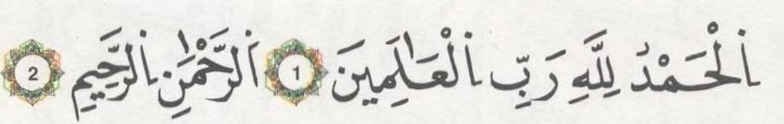 | ﺛﻣﻥ 1 | ﺣﺯﺏ 1 | ﻧﻘﺯﺓ 1
[2] ﺳﻭﺭﺓ ﺍﻟﺑﻘﺭﺓ

ﺍﻟﺛﻣﻥ 1 ﻓﻲ ﺳﻭﺭﺓ ﺍﻟﺑﻘﺭﺓ | ﺻﻔﺣﺔ 3 | 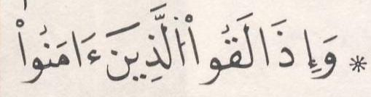 | ﺛﻣﻥ 2
ﺍﻟﺛﻣﻥ 2 ﻓﻲ ﺳﻭﺭﺓ ﺍﻟﺑﻘﺭﺓ | ﺻﻔﺣﺔ 5 | 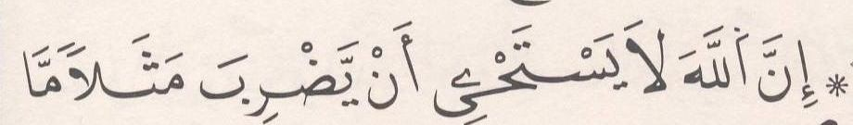 | ﺛﻣﻥ 3
ﺍﻟﺛﻣﻥ 3 ﻓﻲ ﺳﻭﺭﺓ ﺍﻟﺑﻘﺭﺓ | ﺻﻔﺣﺔ 6 | 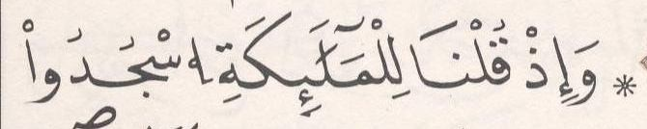 | ﺛﻣﻥ 4
ﺍﻟﺛﻣﻥ 4 ﻓﻲ ﺳﻭﺭﺓ ﺍﻟﺑﻘﺭﺓ | ﺻﻔﺣﺔ 7 | 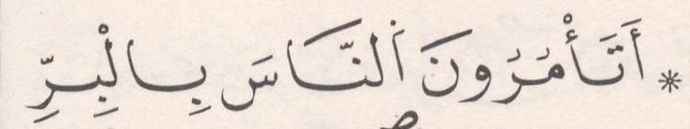 | ﺛﻣﻥ 5
ﺍﻟﺛﻣﻥ 5 ﻓﻲ ﺳﻭﺭﺓ ﺍﻟﺑﻘﺭﺓ | ﺻﻔﺣﺔ 8 | 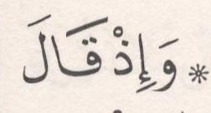 | ﺛﻣﻥ 6
ﺍﻟﺛﻣﻥ 6 ﻓﻲ ﺳﻭﺭﺓ ﺍﻟﺑﻘﺭﺓ | ﺻﻔﺣﺔ 9 | 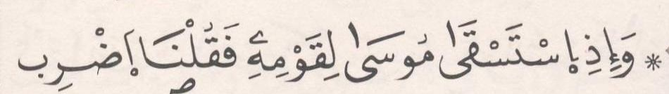 | ﺛﻣﻥ 7
ﺍﻟﺛﻣﻥ 7 ﻓﻲ ﺳﻭﺭﺓ ﺍﻟﺑﻘﺭﺓ | ﺻﻔﺣﺔ 10 | 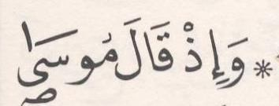 | ﺛﻣﻥ 8
ﺍﻟﺛﻣﻥ 8 ﻓﻲ ﺳﻭﺭﺓ ﺍﻟﺑﻘﺭﺓ | ﺻﻔﺣﺔ 11 | 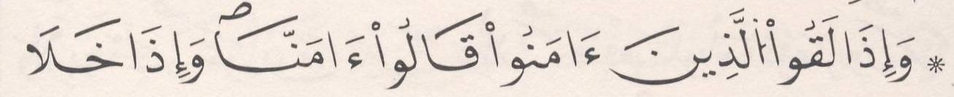 | ﺛﻣﻥ 1 | ﺣﺯﺏ 2
ﺍﻟﺛﻣﻥ 9 ﻓﻲ ﺳﻭﺭﺓ ﺍﻟﺑﻘﺭﺓ | ﺻﻔﺣﺔ 13 | 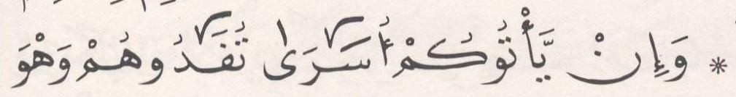 | ﺛﻣﻥ 2
ﺍﻟﺛﻣﻥ 10 ﻓﻲ ﺳﻭﺭﺓ ﺍﻟﺑﻘﺭﺓ | ﺻﻔﺣﺔ 14 |  | ﺛﻣﻥ 3
ﺍﻟﺛﻣﻥ 11 ﻓﻲ ﺳﻭﺭﺓ ﺍﻟﺑﻘﺭﺓ | ﺻﻔﺣﺔ 16 |  | ﺛﻣﻥ 4
ﺍﻟﺛﻣﻥ 12 ﻓﻲ ﺳﻭﺭﺓ ﺍﻟﺑﻘﺭﺓ | ﺻﻔﺣﺔ 17 | 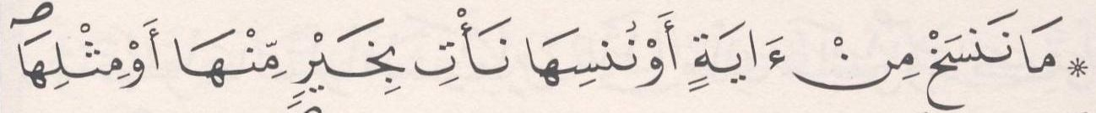 | ﺛﻣﻥ 5
ﺍﻟﺛﻣﻥ 13 ﻓﻲ ﺳﻭﺭﺓ ﺍﻟﺑﻘﺭﺓ | ﺻﻔﺣﺔ 18 | 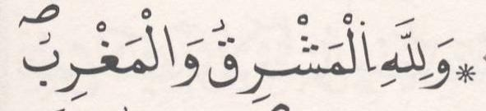 | ﺛﻣﻥ 6
ﺍﻟﺛﻣﻥ 14 ﻓﻲ ﺳﻭﺭﺓ ﺍﻟﺑﻘﺭﺓ | ﺻﻔﺣﺔ 19 | 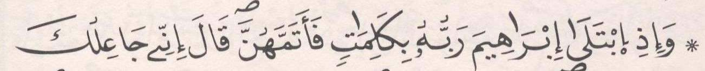 | ﺛﻣﻥ 7
ﺍﻟﺛﻣﻥ 15 ﻓﻲ ﺳﻭﺭﺓ ﺍﻟﺑﻘﺭﺓ | ﺻﻔﺣﺔ 20 |  | ﺛﻣﻥ 8
ﺍﻟﺛﻣﻥ 16 ﻓﻲ ﺳﻭﺭﺓ ﺍﻟﺑﻘﺭﺓ | ﺻﻔﺣﺔ 22 |  | ﺛﻣﻥ 1 | ﺣﺯﺏ 3
ﺍﻟﺛﻣﻥ 17 ﻓﻲ ﺳﻭﺭﺓ ﺍﻟﺑﻘﺭﺓ | ﺻﻔﺣﺔ 23 | 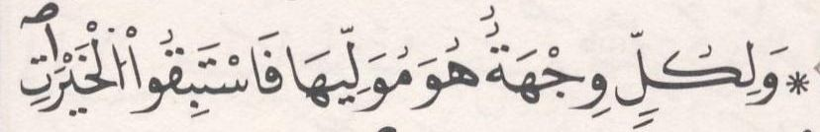 | ﺛﻣﻥ 2
ﺍﻟﺛﻣﻥ 18 ﻓﻲ ﺳﻭﺭﺓ ﺍﻟﺑﻘﺭﺓ | ﺻﻔﺣﺔ 24 | 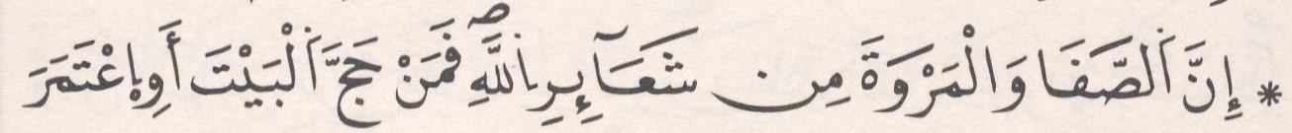 | ﺛﻣﻥ 3
ﺍﻟﺛﻣﻥ 19 ﻓﻲ ﺳﻭﺭﺓ ﺍﻟﺑﻘﺭﺓ | ﺻﻔﺣﺔ 25 | 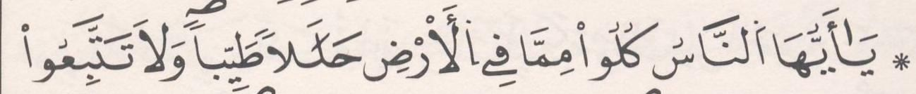 | ﺛﻣﻥ 4
ﺍﻟﺛﻣﻥ 20 ﻓﻲ ﺳﻭﺭﺓ ﺍﻟﺑﻘﺭﺓ | ﺻﻔﺣﺔ 27 |  | ﺛﻣﻥ 5

ﺍﻟﺛﻣﻥ 21 ﻓﻲ ﺳﻭﺭﺓ ﺍﻟﺑﻘﺭﺓ | ﺻﻔﺣﺔ 28 | 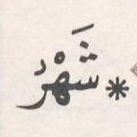 | ﺛﻣﻥ 6
ﺍﻟﺛﻣﻥ 22 ﻓﻲ ﺳﻭﺭﺓ ﺍﻟﺑﻘﺭﺓ | ﺻﻔﺣﺔ 29 | 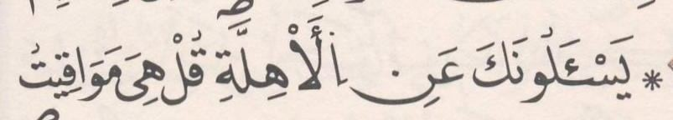 | ﺛﻣﻥ 7
ﺍﻟﺛﻣﻥ 23 ﻓﻲ ﺳﻭﺭﺓ ﺍﻟﺑﻘﺭﺓ | ﺻﻔﺣﺔ 31 |  | ﺛﻣﻥ 8
ﺍﻟﺛﻣﻥ 24 ﻓﻲ ﺳﻭﺭﺓ ﺍﻟﺑﻘﺭﺓ | ﺻﻔﺣﺔ 32 | 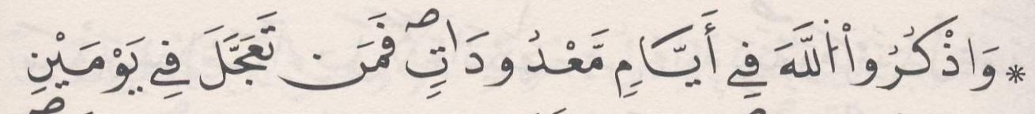 | ﺛﻣﻥ 1 | ﺣﺯﺏ 4 | ﻧﻘﺯﺓ 2
ﺍﻟﺛﻣﻥ 25 ﻓﻲ ﺳﻭﺭﺓ ﺍﻟﺑﻘﺭﺓ | ﺻﻔﺣﺔ 33 | 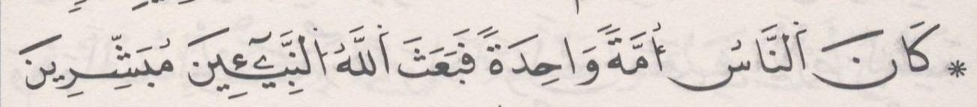 | ﺛﻣﻥ 2
ﺍﻟﺛﻣﻥ 26 ﻓﻲ ﺳﻭﺭﺓ ﺍﻟﺑﻘﺭﺓ | ﺻﻔﺣﺔ 34 | 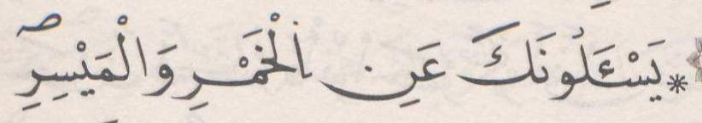 | ﺛﻣﻥ 3
ﺍﻟﺛﻣﻥ 27 ﻓﻲ ﺳﻭﺭﺓ ﺍﻟﺑﻘﺭﺓ | ﺻﻔﺣﺔ 36 | 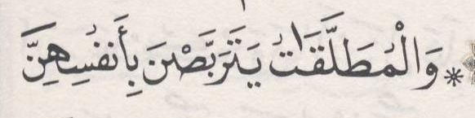 | ﺛﻣﻥ 4
ﺍﻟﺛﻣﻥ 28 ﻓﻲ ﺳﻭﺭﺓ ﺍﻟﺑﻘﺭﺓ | ﺻﻔﺣﺔ 37 | 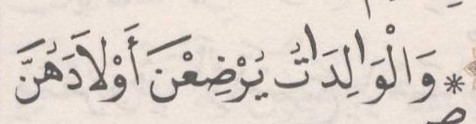 | ﺛﻣﻥ 5
ﺍﻟﺛﻣﻥ 29 ﻓﻲ ﺳﻭﺭﺓ ﺍﻟﺑﻘﺭﺓ | ﺻﻔﺣﺔ 38 | 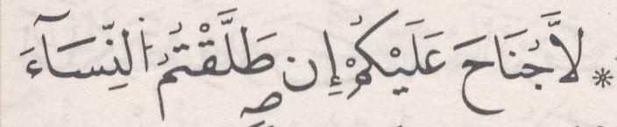 | ﺛﻣﻥ 6
ﺍﻟﺛﻣﻥ 30 ﻓﻲ ﺳﻭﺭﺓ ﺍﻟﺑﻘﺭﺓ | ﺻﻔﺣﺔ 39 | 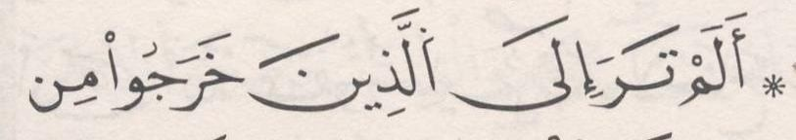 | ﺛﻣﻥ 7
ﺍﻟﺛﻣﻥ 31 ﻓﻲ ﺳﻭﺭﺓ ﺍﻟﺑﻘﺭﺓ | ﺻﻔﺣﺔ 40 | 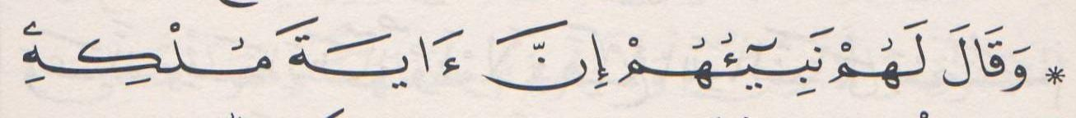 | ﺛﻣﻥ 8
ﺍﻟﺛﻣﻥ 32 ﻓﻲ ﺳﻭﺭﺓ ﺍﻟﺑﻘﺭﺓ | ﺻﻔﺣﺔ 42 | 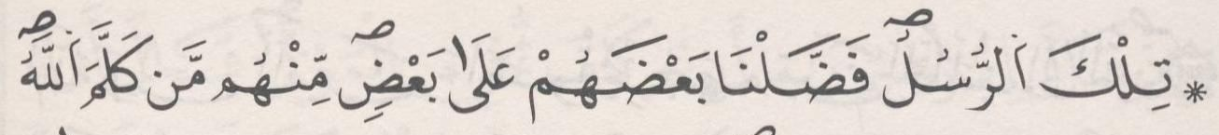 | ﺛﻣﻥ 1 | ﺣﺯﺏ 5
ﺍﻟﺛﻣﻥ 33 ﻓﻲ ﺳﻭﺭﺓ ﺍﻟﺑﻘﺭﺓ | ﺻﻔﺣﺔ 43 | 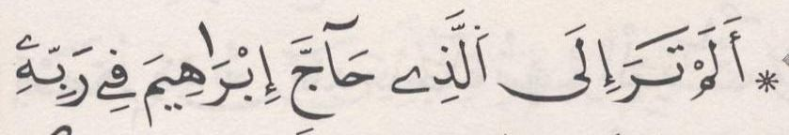 | ﺛﻣﻥ 2
ﺍﻟﺛﻣﻥ 34 ﻓﻲ ﺳﻭﺭﺓ ﺍﻟﺑﻘﺭﺓ | ﺻﻔﺣﺔ 44 | 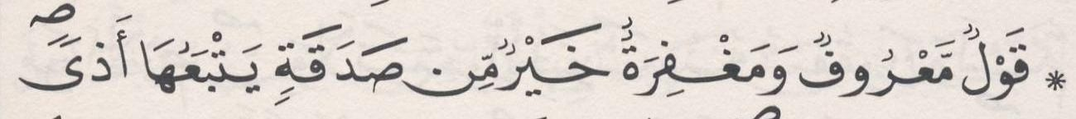 | ﺛﻣﻥ 3
ﺍﻟﺛﻣﻥ 35 ﻓﻲ ﺳﻭﺭﺓ ﺍﻟﺑﻘﺭﺓ | ﺻﻔﺣﺔ 45 | 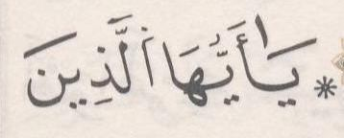 | ﺛﻣﻥ 4
ﺍﻟﺛﻣﻥ 36 ﻓﻲ ﺳﻭﺭﺓ ﺍﻟﺑﻘﺭﺓ | ﺻﻔﺣﺔ 46 | 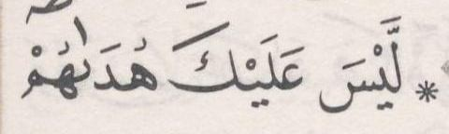 | ﺛﻣﻥ 5
ﺍﻟﺛﻣﻥ 37 ﻓﻲ ﺳﻭﺭﺓ ﺍﻟﺑﻘﺭﺓ | ﺻﻔﺣﺔ 48 | 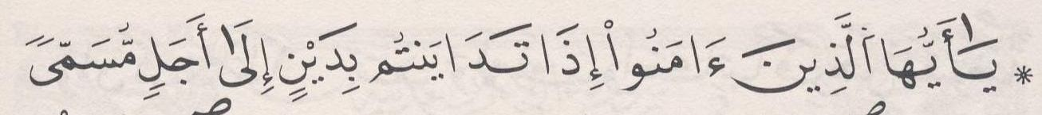 | ﺛﻣﻥ 6
ﺍﻟﺛﻣﻥ 38 ﻓﻲ ﺳﻭﺭﺓ ﺍﻟﺑﻘﺭﺓ | ﺻﻔﺣﺔ 49 | 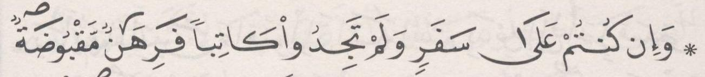 | ﺛﻣﻥ 7
[3] ﺳﻭﺭﺓ ﺁﻝ ﻋﻣﺭﺍﻥ

ﺍﻟﺛﻣﻥ 1 ﻓﻲ ﺳﻭﺭﺓ ﺁﻝ ﻋﻣﺭﺍﻥ | ﺻﻔﺣﺔ 50 | 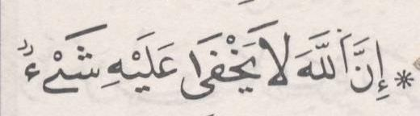 | ﺛﻣﻥ 8
ﺍﻟﺛﻣﻥ 2 ﻓﻲ ﺳﻭﺭﺓ ﺁﻝ ﻋﻣﺭﺍﻥ | ﺻﻔﺣﺔ 51 | 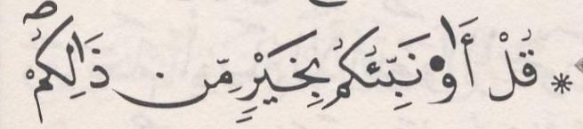 | ﺛﻣﻥ 1 | ﺣﺯﺏ 6
ﺍﻟﺛﻣﻥ 3 ﻓﻲ ﺳﻭﺭﺓ ﺁﻝ ﻋﻣﺭﺍﻥ | ﺻﻔﺣﺔ 53 | 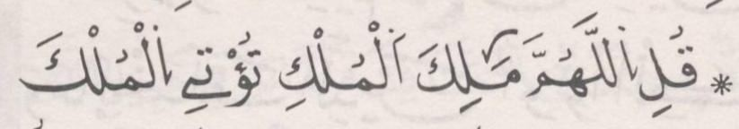 | ﺛﻣﻥ 2
ﺍﻟﺛﻣﻥ 4 ﻓﻲ ﺳﻭﺭﺓ ﺁﻝ ﻋﻣﺭﺍﻥ | ﺻﻔﺣﺔ 54 | 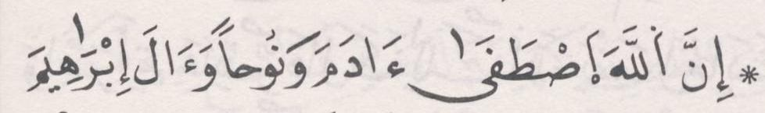 | ﺛﻣﻥ 3
ﺍﻟﺛﻣﻥ 5 ﻓﻲ ﺳﻭﺭﺓ ﺁﻝ ﻋﻣﺭﺍﻥ | ﺻﻔﺣﺔ 55 | 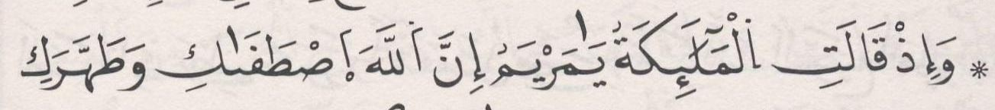 | ﺛﻣﻥ 4
ﺍﻟﺛﻣﻥ 6 ﻓﻲ ﺳﻭﺭﺓ ﺁﻝ ﻋﻣﺭﺍﻥ | ﺻﻔﺣﺔ 56 | 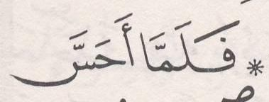 | ﺛﻣﻥ 5

ﺍﻟﺛﻣﻥ 7 ﻓﻲ ﺳﻭﺭﺓ ﺁﻝ ﻋﻣﺭﺍﻥ | ﺻﻔﺣﺔ 58 | 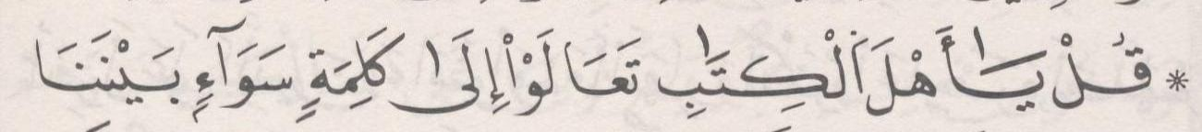 | ﺛﻣﻥ 6
ﺍﻟﺛﻣﻥ 8 ﻓﻲ ﺳﻭﺭﺓ ﺁﻝ ﻋﻣﺭﺍﻥ | ﺻﻔﺣﺔ 59 | 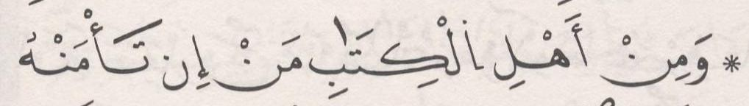 | ﺛﻣﻥ 7
ﺍﻟﺛﻣﻥ 9 ﻓﻲ ﺳﻭﺭﺓ ﺁﻝ ﻋﻣﺭﺍﻥ | ﺻﻔﺣﺔ 60 | 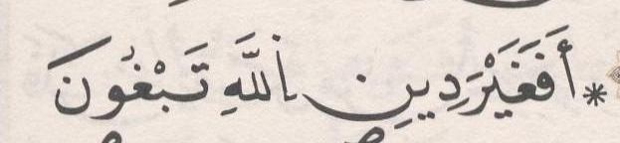 | ﺛﻣﻥ 8
ﺍﻟﺛﻣﻥ 10 ﻓﻲ ﺳﻭﺭﺓ ﺁﻝ ﻋﻣﺭﺍﻥ | ﺻﻔﺣﺔ 62 | 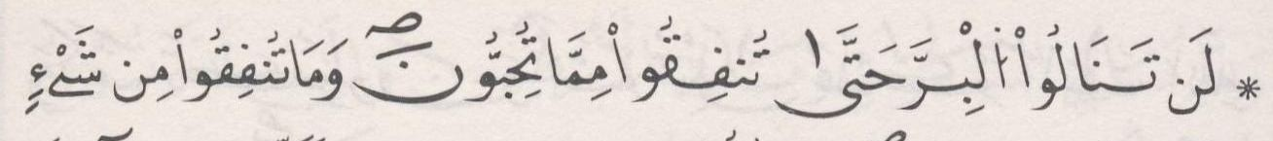 | ﺛﻣﻥ 1 | ﺣﺯﺏ 7 | ﻧﻘﺯﺓ 3
ﺍﻟﺛﻣﻥ 11 ﻓﻲ ﺳﻭﺭﺓ ﺁﻝ ﻋﻣﺭﺍﻥ | ﺻﻔﺣﺔ 63 |  | ﺛﻣﻥ 2
ﺍﻟﺛﻣﻥ 12 ﻓﻲ ﺳﻭﺭﺓ ﺁﻝ ﻋﻣﺭﺍﻥ | ﺻﻔﺣﺔ 64 | 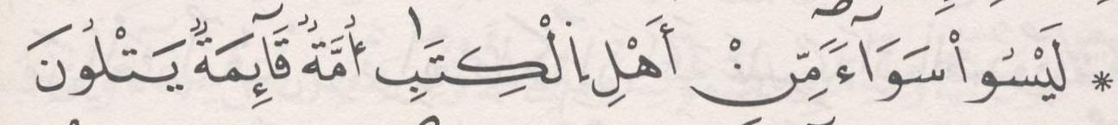 | ﺛﻣﻥ 3
ﺍﻟﺛﻣﻥ 13 ﻓﻲ ﺳﻭﺭﺓ ﺁﻝ ﻋﻣﺭﺍﻥ | ﺻﻔﺣﺔ 65 | 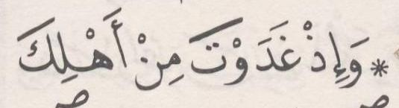 | ﺛﻣﻥ 4
ﺍﻟﺛﻣﻥ 14 ﻓﻲ ﺳﻭﺭﺓ ﺁﻝ ﻋﻣﺭﺍﻥ | ﺻﻔﺣﺔ 67 | 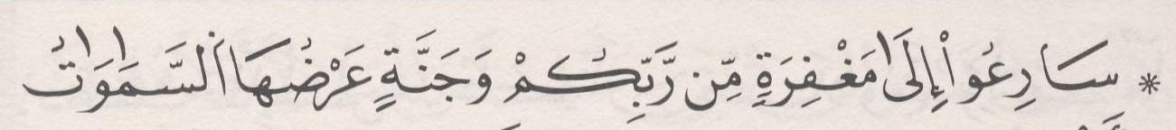 | ﺛﻣﻥ 5
ﺍﻟﺛﻣﻥ 15 ﻓﻲ ﺳﻭﺭﺓ ﺁﻝ ﻋﻣﺭﺍﻥ | ﺻﻔﺣﺔ 68 |  | ﺛﻣﻥ 6
ﺍﻟﺛﻣﻥ 16 ﻓﻲ ﺳﻭﺭﺓ ﺁﻝ ﻋﻣﺭﺍﻥ | ﺻﻔﺣﺔ 69 | 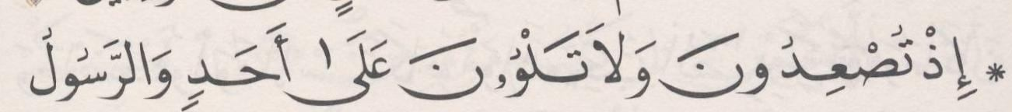 | ﺛﻣﻥ 7
ﺍﻟﺛﻣﻥ 17 ﻓﻲ ﺳﻭﺭﺓ ﺁﻝ ﻋﻣﺭﺍﻥ | ﺻﻔﺣﺔ 71 | 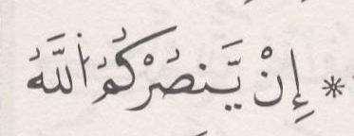 | ﺛﻣﻥ 8
ﺍﻟﺛﻣﻥ 18 ﻓﻲ ﺳﻭﺭﺓ ﺁﻝ ﻋﻣﺭﺍﻥ | ﺻﻔﺣﺔ 72 | 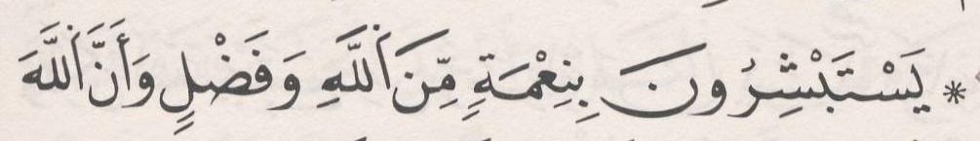 | ﺛﻣﻥ 1 | ﺣﺯﺏ 8
ﺍﻟﺛﻣﻥ 19 ﻓﻲ ﺳﻭﺭﺓ ﺁﻝ ﻋﻣﺭﺍﻥ | ﺻﻔﺣﺔ 73 | 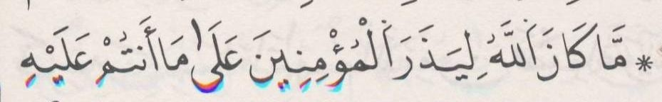 | ﺛﻣﻥ 2
ﺍﻟﺛﻣﻥ 20 ﻓﻲ ﺳﻭﺭﺓ ﺁﻝ ﻋﻣﺭﺍﻥ | ﺻﻔﺣﺔ 74 | 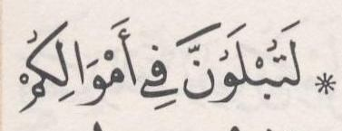 | ﺛﻣﻥ 3
ﺍﻟﺛﻣﻥ 21 ﻓﻲ ﺳﻭﺭﺓ ﺁﻝ ﻋﻣﺭﺍﻥ | ﺻﻔﺣﺔ 76 | 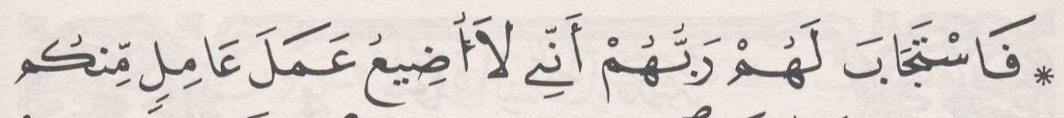 | ﺛﻣﻥ 4
[4] ﺳﻭﺭﺓ ﺍﻟﻧﺳﺎء

ﺍﻟﺛﻣﻥ 1 ﻓﻲ ﺳﻭﺭﺓ ﺍﻟﻧﺳﺎء | ﺻﻔﺣﺔ 77 | 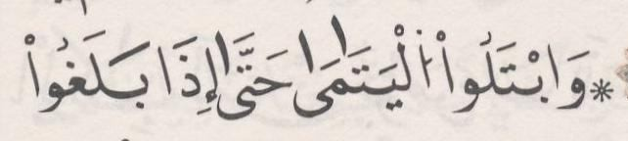 | ﺛﻣﻥ 5
ﺍﻟﺛﻣﻥ 2 ﻓﻲ ﺳﻭﺭﺓ ﺍﻟﻧﺳﺎء | ﺻﻔﺣﺔ 78 | 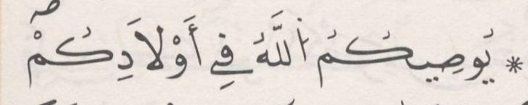 | ﺛﻣﻥ 6
ﺍﻟﺛﻣﻥ 3 ﻓﻲ ﺳﻭﺭﺓ ﺍﻟﻧﺳﺎء | ﺻﻔﺣﺔ 79 | 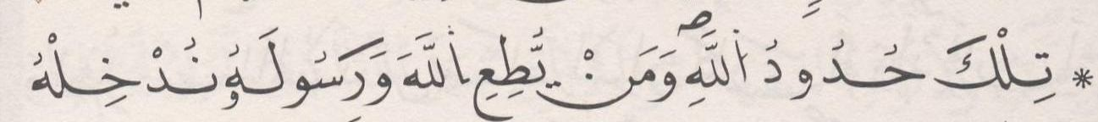 | ﺛﻣﻥ 7
ﺍﻟﺛﻣﻥ 4 ﻓﻲ ﺳﻭﺭﺓ ﺍﻟﻧﺳﺎء | ﺻﻔﺣﺔ 80 | 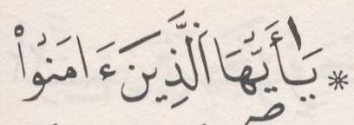 | ﺛﻣﻥ 8
ﺍﻟﺛﻣﻥ 5 ﻓﻲ ﺳﻭﺭﺓ ﺍﻟﻧﺳﺎء | ﺻﻔﺣﺔ 82 | 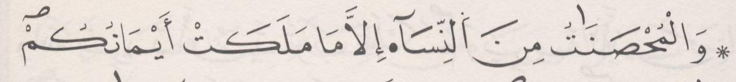 | ﺛﻣﻥ 1 | ﺣﺯﺏ 9
ﺍﻟﺛﻣﻥ 6 ﻓﻲ ﺳﻭﺭﺓ ﺍﻟﻧﺳﺎء | ﺻﻔﺣﺔ 83 | 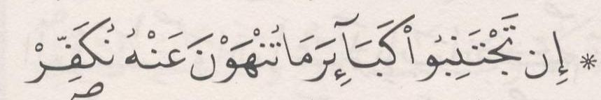 | ﺛﻣﻥ 2
ﺍﻟﺛﻣﻥ 7 ﻓﻲ ﺳﻭﺭﺓ ﺍﻟﻧﺳﺎء | ﺻﻔﺣﺔ 84 | 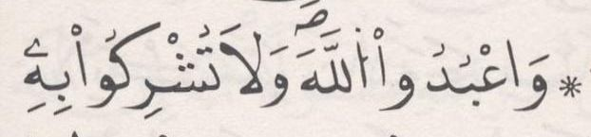 | ﺛﻣﻥ 3
ﺍﻟﺛﻣﻥ 8 ﻓﻲ ﺳﻭﺭﺓ ﺍﻟﻧﺳﺎء | ﺻﻔﺣﺔ 86 | 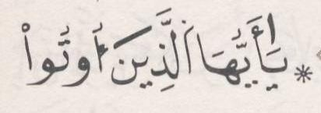 | ﺛﻣﻥ 4
ﺍﻟﺛﻣﻥ 9 ﻓﻲ ﺳﻭﺭﺓ ﺍﻟﻧﺳﺎء | ﺻﻔﺣﺔ 87 | 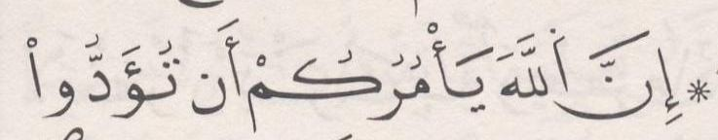 | ﺛﻣﻥ 5

ﺍﻟﺛﻣﻥ 10 ﻓﻲ ﺳﻭﺭﺓ ﺍﻟﻧﺳﺎء | ﺻﻔﺣﺔ 88 | 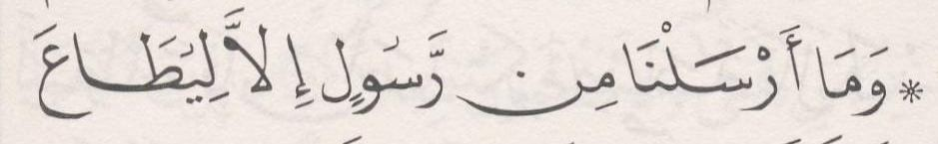 | ﺛﻣﻥ 6
ﺍﻟﺛﻣﻥ 11 ﻓﻲ ﺳﻭﺭﺓ ﺍﻟﻧﺳﺎء | ﺻﻔﺣﺔ 89 | 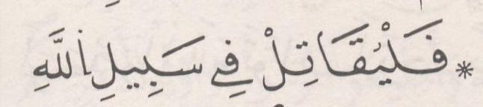 | ﺛﻣﻥ 7
ﺍﻟﺛﻣﻥ 12 ﻓﻲ ﺳﻭﺭﺓ ﺍﻟﻧﺳﺎء | ﺻﻔﺣﺔ 90 | 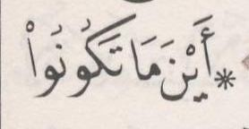 | ﺛﻣﻥ 8
ﺍﻟﺛﻣﻥ 13 ﻓﻲ ﺳﻭﺭﺓ ﺍﻟﻧﺳﺎء | ﺻﻔﺣﺔ 92 | 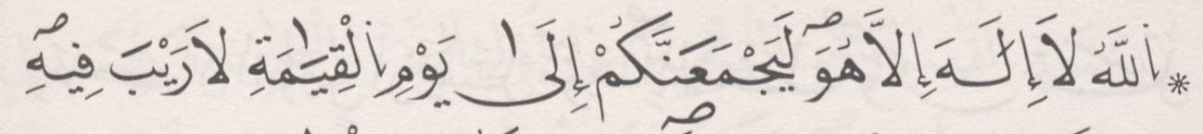 | ﺛﻣﻥ 1 | ﺣﺯﺏ 10 | ﻧﻘﺯﺓ 4
ﺍﻟﺛﻣﻥ 14 ﻓﻲ ﺳﻭﺭﺓ ﺍﻟﻧﺳﺎء | ﺻﻔﺣﺔ 93 | 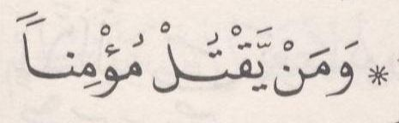 | ﺛﻣﻥ 2
ﺍﻟﺛﻣﻥ 15 ﻓﻲ ﺳﻭﺭﺓ ﺍﻟﻧﺳﺎء | ﺻﻔﺣﺔ 94 | 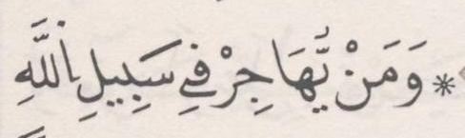 | ﺛﻣﻥ 3
ﺍﻟﺛﻣﻥ 16 ﻓﻲ ﺳﻭﺭﺓ ﺍﻟﻧﺳﺎء | ﺻﻔﺣﺔ 95 | 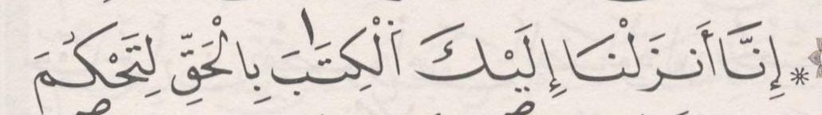 | ﺛﻣﻥ 4
ﺍﻟﺛﻣﻥ 17 ﻓﻲ ﺳﻭﺭﺓ ﺍﻟﻧﺳﺎء | ﺻﻔﺣﺔ 97 | 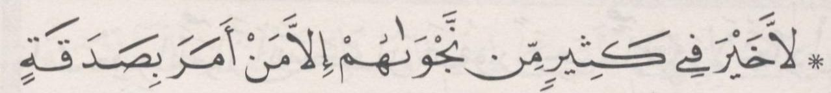 | ﺛﻣﻥ 5
ﺍﻟﺛﻣﻥ 18 ﻓﻲ ﺳﻭﺭﺓ ﺍﻟﻧﺳﺎء | ﺻﻔﺣﺔ 98 | 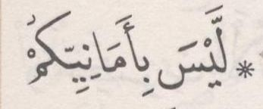 | ﺛﻣﻥ 6
ﺍﻟﺛﻣﻥ 19 ﻓﻲ ﺳﻭﺭﺓ ﺍﻟﻧﺳﺎء | ﺻﻔﺣﺔ 99 | 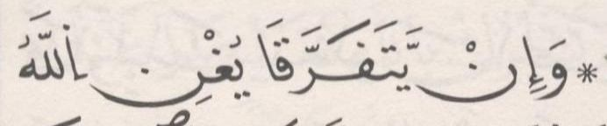 | ﺛﻣﻥ 7
ﺍﻟﺛﻣﻥ 20 ﻓﻲ ﺳﻭﺭﺓ ﺍﻟﻧﺳﺎء | ﺻﻔﺣﺔ 100 | 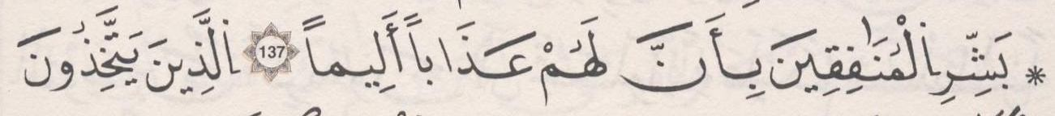 | ﺛﻣﻥ 8
ﺍﻟﺛﻣﻥ 21 ﻓﻲ ﺳﻭﺭﺓ ﺍﻟﻧﺳﺎء | ﺻﻔﺣﺔ 102 | 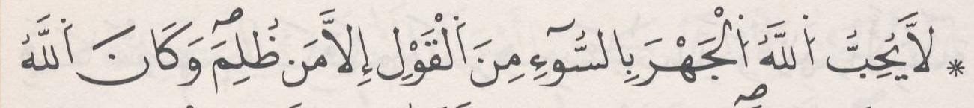 | ﺛﻣﻥ 1 | ﺣﺯﺏ 11
ﺍﻟﺛﻣﻥ 22 ﻓﻲ ﺳﻭﺭﺓ ﺍﻟﻧﺳﺎء | ﺻﻔﺣﺔ 103 | 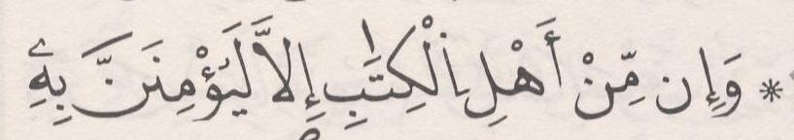 | ﺛﻣﻥ 2
ﺍﻟﺛﻣﻥ 23 ﻓﻲ ﺳﻭﺭﺓ ﺍﻟﻧﺳﺎء | ﺻﻔﺣﺔ 104 | 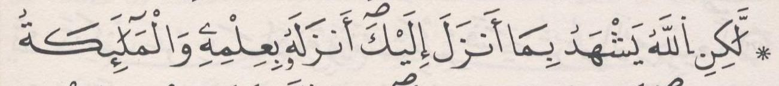 | ﺛﻣﻥ 3
ﺍﻟﺛﻣﻥ 24 ﻓﻲ ﺳﻭﺭﺓ ﺍﻟﻧﺳﺎء | ﺻﻔﺣﺔ 105 | 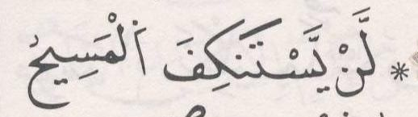 | ﺛﻣﻥ 4
[5] ﺳﻭﺭﺓ ﺍﻟﻣﺎﺋﺩﺓ

ﺍﻟﺛﻣﻥ 1 ﻓﻲ ﺳﻭﺭﺓ ﺍﻟﻣﺎﺋﺩﺓ | ﺻﻔﺣﺔ 107 | 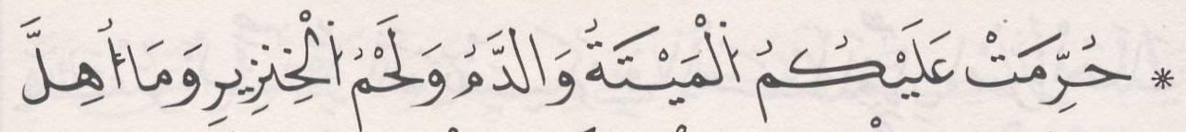 | ﺛﻣﻥ 5
ﺍﻟﺛﻣﻥ 2 ﻓﻲ ﺳﻭﺭﺓ ﺍﻟﻣﺎﺋﺩﺓ | ﺻﻔﺣﺔ 108 | 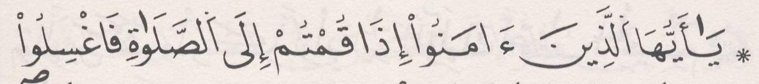 | ﺛﻣﻥ 6
ﺍﻟﺛﻣﻥ 3 ﻓﻲ ﺳﻭﺭﺓ ﺍﻟﻣﺎﺋﺩﺓ | ﺻﻔﺣﺔ 109 | 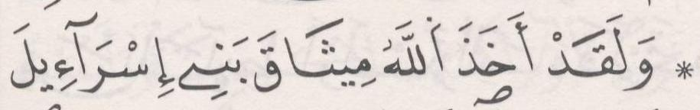 | ﺛﻣﻥ 7
ﺍﻟﺛﻣﻥ 4 ﻓﻲ ﺳﻭﺭﺓ ﺍﻟﻣﺎﺋﺩﺓ | ﺻﻔﺣﺔ 110 | 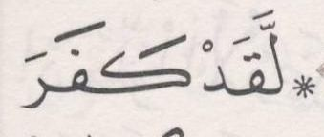 | ﺛﻣﻥ 8
ﺍﻟﺛﻣﻥ 5 ﻓﻲ ﺳﻭﺭﺓ ﺍﻟﻣﺎﺋﺩﺓ | ﺻﻔﺣﺔ 111 |  | ﺛﻣﻥ 1 | ﺣﺯﺏ 12
ﺍﻟﺛﻣﻥ 6 ﻓﻲ ﺳﻭﺭﺓ ﺍﻟﻣﺎﺋﺩﺓ | ﺻﻔﺣﺔ 113 | 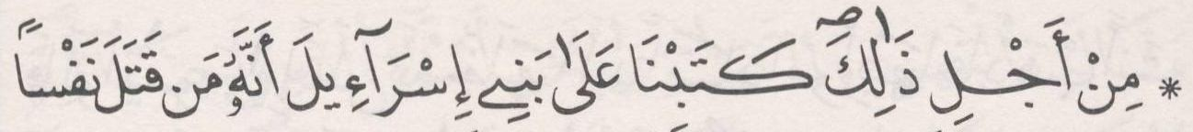 | ﺛﻣﻥ 2
ﺍﻟﺛﻣﻥ 7 ﻓﻲ ﺳﻭﺭﺓ ﺍﻟﻣﺎﺋﺩﺓ | ﺻﻔﺣﺔ 114 | 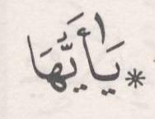 | ﺛﻣﻥ 3
ﺍﻟﺛﻣﻥ 8 ﻓﻲ ﺳﻭﺭﺓ ﺍﻟﻣﺎﺋﺩﺓ | ﺻﻔﺣﺔ 115 | 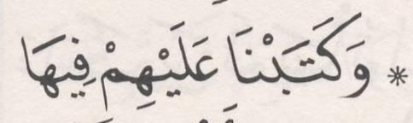 | ﺛﻣﻥ 4
ﺍﻟﺛﻣﻥ 9 ﻓﻲ ﺳﻭﺭﺓ ﺍﻟﻣﺎﺋﺩﺓ | ﺻﻔﺣﺔ 116 | 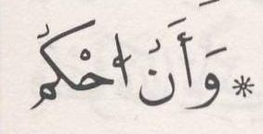 | ﺛﻣﻥ 5

ﺍﻟﺛﻣﻥ 10 ﻓﻲ ﺳﻭﺭﺓ ﺍﻟﻣﺎﺋﺩﺓ | ﺻﻔﺣﺔ 118 | 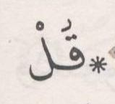 | ﺛﻣﻥ 6
ﺍﻟﺛﻣﻥ 11 ﻓﻲ ﺳﻭﺭﺓ ﺍﻟﻣﺎﺋﺩﺓ | ﺻﻔﺣﺔ 119 | 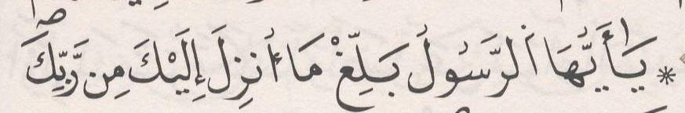 | ﺛﻣﻥ 7
ﺍﻟﺛﻣﻥ 12 ﻓﻲ ﺳﻭﺭﺓ ﺍﻟﻣﺎﺋﺩﺓ | ﺻﻔﺣﺔ 121 |  | ﺛﻣﻥ 8
ﺍﻟﺛﻣﻥ 13 ﻓﻲ ﺳﻭﺭﺓ ﺍﻟﻣﺎﺋﺩﺓ | ﺻﻔﺣﺔ 122 | 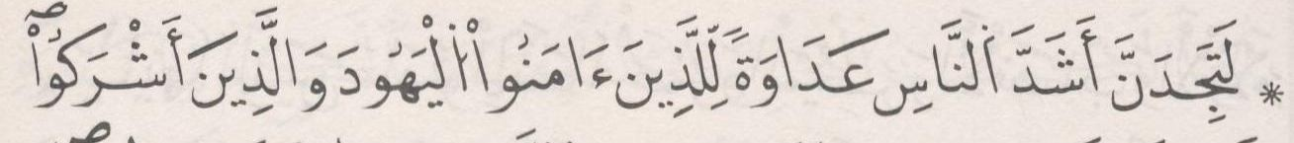 | ﺛﻣﻥ 1 | ﺣﺯﺏ 13 | ﻧﻘﺯﺓ 5
ﺍﻟﺛﻣﻥ 14 ﻓﻲ ﺳﻭﺭﺓ ﺍﻟﻣﺎﺋﺩﺓ | ﺻﻔﺣﺔ 123 |  | ﺛﻣﻥ 2
ﺍﻟﺛﻣﻥ 15 ﻓﻲ ﺳﻭﺭﺓ ﺍﻟﻣﺎﺋﺩﺓ | ﺻﻔﺣﺔ 124 | 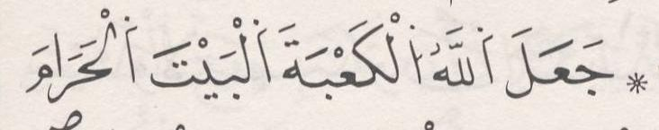 | ﺛﻣﻥ 3
ﺍﻟﺛﻣﻥ 16 ﻓﻲ ﺳﻭﺭﺓ ﺍﻟﻣﺎﺋﺩﺓ | ﺻﻔﺣﺔ 125 | 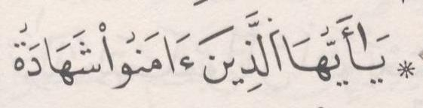 | ﺛﻣﻥ 4
ﺍﻟﺛﻣﻥ 17 ﻓﻲ ﺳﻭﺭﺓ ﺍﻟﻣﺎﺋﺩﺓ | ﺻﻔﺣﺔ 126 | 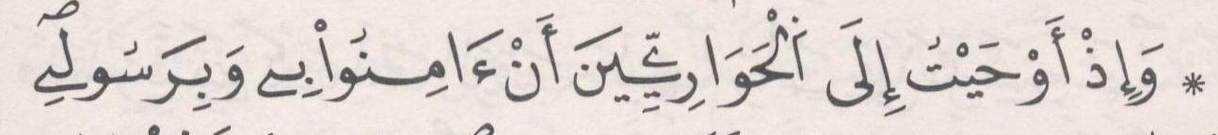 | ﺛﻣﻥ 5
[6] ﺳﻭﺭﺓ ﺍﻷﻧﻌﺎﻡ

ﺍﻟﺛﻣﻥ 1 ﻓﻲ ﺳﻭﺭﺓ ﺍﻷﻧﻌﺎﻡ | ﺻﻔﺣﺔ 128 | 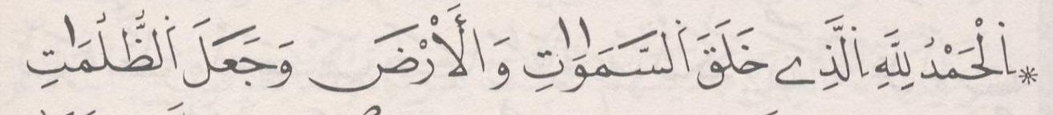 | ﺛﻣﻥ 6
ﺍﻟﺛﻣﻥ 2 ﻓﻲ ﺳﻭﺭﺓ ﺍﻷﻧﻌﺎﻡ | ﺻﻔﺣﺔ 129 | 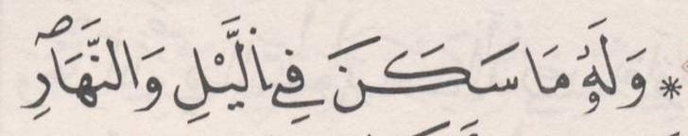 | ﺛﻣﻥ 7
ﺍﻟﺛﻣﻥ 3 ﻓﻲ ﺳﻭﺭﺓ ﺍﻷﻧﻌﺎﻡ | ﺻﻔﺣﺔ 130 | 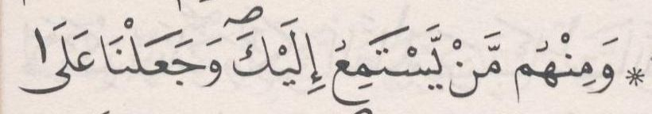 | ﺛﻣﻥ 8
ﺍﻟﺛﻣﻥ 4 ﻓﻲ ﺳﻭﺭﺓ ﺍﻷﻧﻌﺎﻡ | ﺻﻔﺣﺔ 132 | 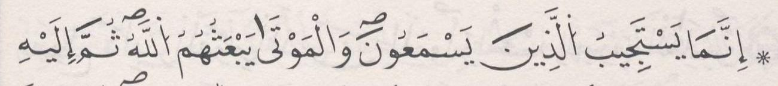 | ﺛﻣﻥ 1 | ﺣﺯﺏ 14
ﺍﻟﺛﻣﻥ 5 ﻓﻲ ﺳﻭﺭﺓ ﺍﻷﻧﻌﺎﻡ | ﺻﻔﺣﺔ 133 | 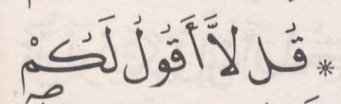 | ﺛﻣﻥ 2
ﺍﻟﺛﻣﻥ 6 ﻓﻲ ﺳﻭﺭﺓ ﺍﻷﻧﻌﺎﻡ | ﺻﻔﺣﺔ 134 | 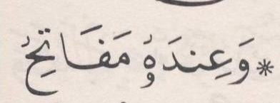 | ﺛﻣﻥ 3
ﺍﻟﺛﻣﻥ 7 ﻓﻲ ﺳﻭﺭﺓ ﺍﻷﻧﻌﺎﻡ | ﺻﻔﺣﺔ 136 | 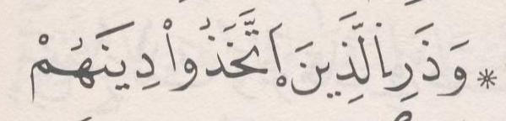 | ﺛﻣﻥ 4
ﺍﻟﺛﻣﻥ 8 ﻓﻲ ﺳﻭﺭﺓ ﺍﻷﻧﻌﺎﻡ | ﺻﻔﺣﺔ 137 | 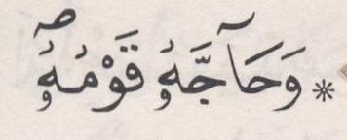 | ﺛﻣﻥ 5
ﺍﻟﺛﻣﻥ 9 ﻓﻲ ﺳﻭﺭﺓ ﺍﻷﻧﻌﺎﻡ | ﺻﻔﺣﺔ 139 | 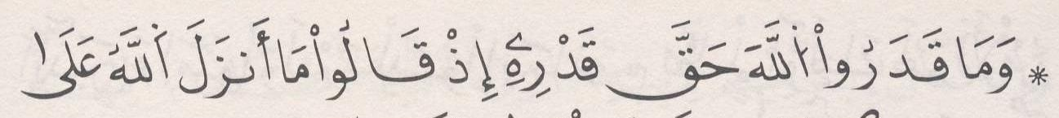 | ﺛﻣﻥ 6
ﺍﻟﺛﻣﻥ 10 ﻓﻲ ﺳﻭﺭﺓ ﺍﻷﻧﻌﺎﻡ | ﺻﻔﺣﺔ 140 | 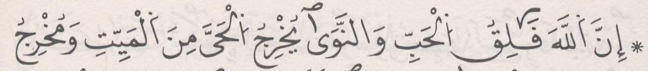 | ﺛﻣﻥ 7
ﺍﻟﺛﻣﻥ 11 ﻓﻲ ﺳﻭﺭﺓ ﺍﻷﻧﻌﺎﻡ | ﺻﻔﺣﺔ 140 | 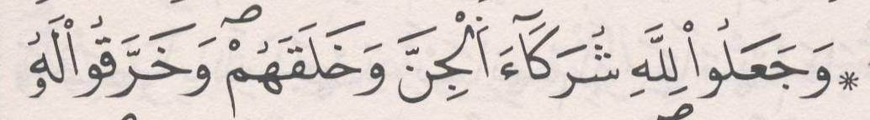 | ﺛﻣﻥ 8
ﺍﻟﺛﻣﻥ 12 ﻓﻲ ﺳﻭﺭﺓ ﺍﻷﻧﻌﺎﻡ | ﺻﻔﺣﺔ 142 | 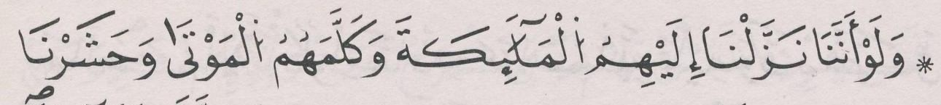 | ﺛﻣﻥ 1 | ﺣﺯﺏ 15
ﺍﻟﺛﻣﻥ 13 ﻓﻲ ﺳﻭﺭﺓ ﺍﻷﻧﻌﺎﻡ | ﺻﻔﺣﺔ 143 | 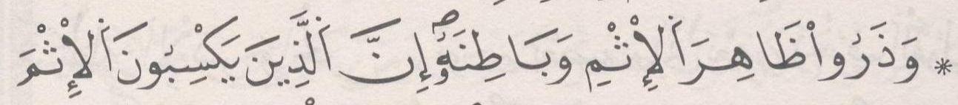 | ﺛﻣﻥ 2
ﺍﻟﺛﻣﻥ 14 ﻓﻲ ﺳﻭﺭﺓ ﺍﻷﻧﻌﺎﻡ | ﺻﻔﺣﺔ 144 | 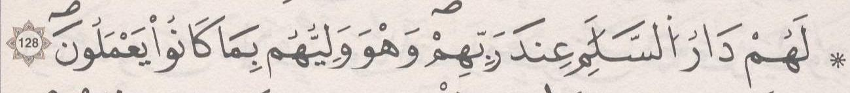 | ﺛﻣﻥ 3
ﺍﻟﺛﻣﻥ 15 ﻓﻲ ﺳﻭﺭﺓ ﺍﻷﻧﻌﺎﻡ | ﺻﻔﺣﺔ 145 |  | ﺛﻣﻥ 4
ﺍﻟﺛﻣﻥ 16 ﻓﻲ ﺳﻭﺭﺓ ﺍﻷﻧﻌﺎﻡ | ﺻﻔﺣﺔ 146 | 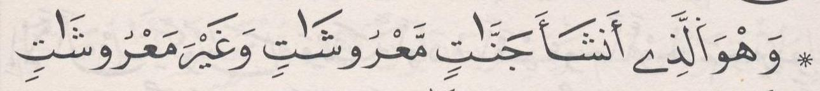 | ﺛﻣﻥ 5

ﺍﻟﺛﻣﻥ 17 ﻓﻲ ﺳﻭﺭﺓ ﺍﻷﻧﻌﺎﻡ | ﺻﻔﺣﺔ 147 | 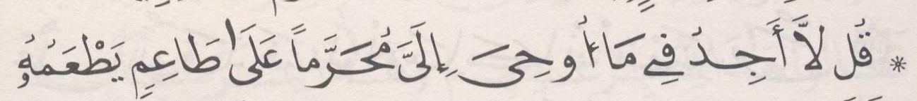 | ﺛﻣﻥ 6
ﺍﻟﺛﻣﻥ 18 ﻓﻲ ﺳﻭﺭﺓ ﺍﻷﻧﻌﺎﻡ | ﺻﻔﺣﺔ 148 | 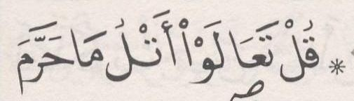 | ﺛﻣﻥ 7
ﺍﻟﺛﻣﻥ 19 ﻓﻲ ﺳﻭﺭﺓ ﺍﻷﻧﻌﺎﻡ | ﺻﻔﺣﺔ 150 |  | ﺛﻣﻥ 8
[7] ﺳﻭﺭﺓ ﺍﻷﻋﺭﺍﻑ

ﺍﻟﺛﻣﻥ 1 ﻓﻲ ﺳﻭﺭﺓ ﺍﻷﻋﺭﺍﻑ | ﺻﻔﺣﺔ 151 | 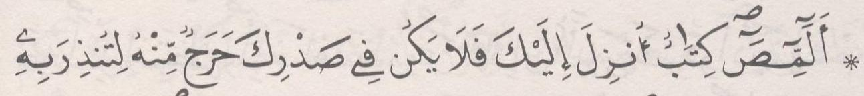 | ﺛﻣﻥ 1 | ﺣﺯﺏ 16 | ﻧﻘﺯﺓ 6
ﺍﻟﺛﻣﻥ 2 ﻓﻲ ﺳﻭﺭﺓ ﺍﻷﻋﺭﺍﻑ | ﺻﻔﺣﺔ 152 | 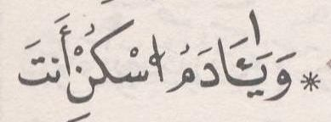 | ﺛﻣﻥ 2
ﺍﻟﺛﻣﻥ 3 ﻓﻲ ﺳﻭﺭﺓ ﺍﻷﻋﺭﺍﻑ | ﺻﻔﺣﺔ 153 | 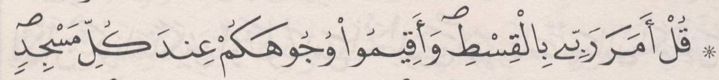 | ﺛﻣﻥ 3
ﺍﻟﺛﻣﻥ 4 ﻓﻲ ﺳﻭﺭﺓ ﺍﻷﻋﺭﺍﻑ | ﺻﻔﺣﺔ 155 |  | ﺛﻣﻥ 4
ﺍﻟﺛﻣﻥ 5 ﻓﻲ ﺳﻭﺭﺓ ﺍﻷﻋﺭﺍﻑ | ﺻﻔﺣﺔ 156 | 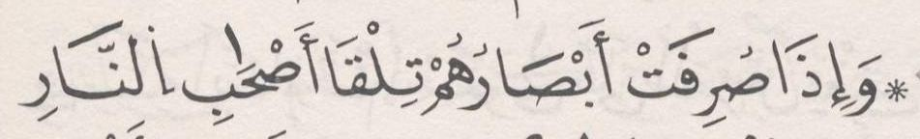 | ﺛﻣﻥ 5
ﺍﻟﺛﻣﻥ 6 ﻓﻲ ﺳﻭﺭﺓ ﺍﻷﻋﺭﺍﻑ | ﺻﻔﺣﺔ 157 | 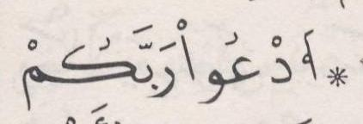 | ﺛﻣﻥ 6
ﺍﻟﺛﻣﻥ 7 ﻓﻲ ﺳﻭﺭﺓ ﺍﻷﻋﺭﺍﻑ | ﺻﻔﺣﺔ 158 | 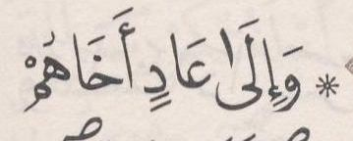 | ﺛﻣﻥ 7
ﺍﻟﺛﻣﻥ 8 ﻓﻲ ﺳﻭﺭﺓ ﺍﻷﻋﺭﺍﻑ | ﺻﻔﺣﺔ 160 | 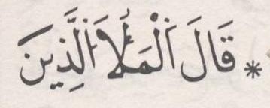 | ﺛﻣﻥ 8
ﺍﻟﺛﻣﻥ 9 ﻓﻲ ﺳﻭﺭﺓ ﺍﻷﻋﺭﺍﻑ | ﺻﻔﺣﺔ 162 |  | ﺛﻣﻥ 1 | ﺣﺯﺏ 17
ﺍﻟﺛﻣﻥ 10 ﻓﻲ ﺳﻭﺭﺓ ﺍﻷﻋﺭﺍﻑ | ﺻﻔﺣﺔ 163 | 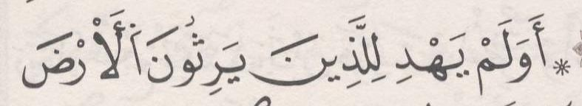 | ﺛﻣﻥ 2
ﺍﻟﺛﻣﻥ 11 ﻓﻲ ﺳﻭﺭﺓ ﺍﻷﻋﺭﺍﻑ | ﺻﻔﺣﺔ 164 | 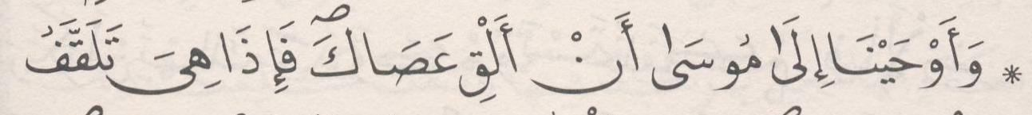 | ﺛﻣﻥ 3
ﺍﻟﺛﻣﻥ 12 ﻓﻲ ﺳﻭﺭﺓ ﺍﻷﻋﺭﺍﻑ | ﺻﻔﺣﺔ 166 | 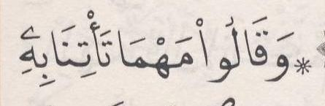 | ﺛﻣﻥ 4
ﺍﻟﺛﻣﻥ 13 ﻓﻲ ﺳﻭﺭﺓ ﺍﻷﻋﺭﺍﻑ | ﺻﻔﺣﺔ 167 | 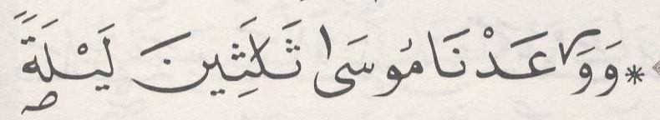 | ﺛﻣﻥ 5
ﺍﻟﺛﻣﻥ 14 ﻓﻲ ﺳﻭﺭﺓ ﺍﻷﻋﺭﺍﻑ | ﺻﻔﺣﺔ 168 | 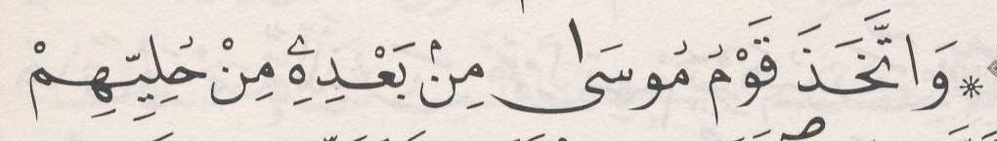 | ﺛﻣﻥ 6
ﺍﻟﺛﻣﻥ 15 ﻓﻲ ﺳﻭﺭﺓ ﺍﻷﻋﺭﺍﻑ | ﺻﻔﺣﺔ 170 | 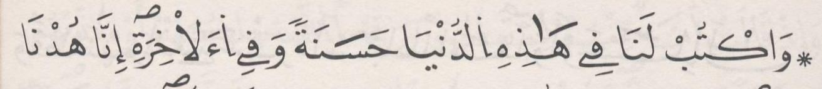 | ﺛﻣﻥ 7
ﺍﻟﺛﻣﻥ 16 ﻓﻲ ﺳﻭﺭﺓ ﺍﻷﻋﺭﺍﻑ | ﺻﻔﺣﺔ 171 | 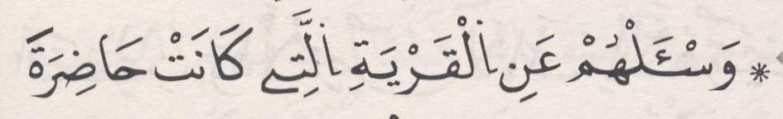 | ﺛﻣﻥ 8
ﺍﻟﺛﻣﻥ 17 ﻓﻲ ﺳﻭﺭﺓ ﺍﻷﻋﺭﺍﻑ | ﺻﻔﺣﺔ 173 | 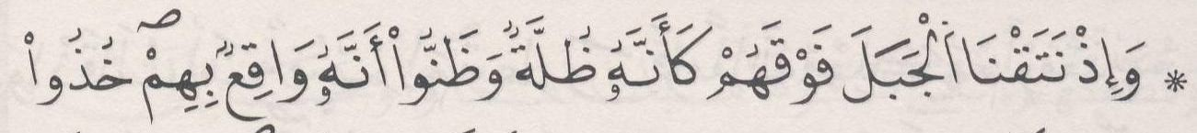 | ﺛﻣﻥ 1 | ﺣﺯﺏ 18
ﺍﻟﺛﻣﻥ 18 ﻓﻲ ﺳﻭﺭﺓ ﺍﻷﻋﺭﺍﻑ | ﺻﻔﺣﺔ 174 | 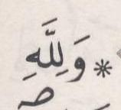 | ﺛﻣﻥ 2
ﺍﻟﺛﻣﻥ 19 ﻓﻲ ﺳﻭﺭﺓ ﺍﻷﻋﺭﺍﻑ | ﺻﻔﺣﺔ 175 | 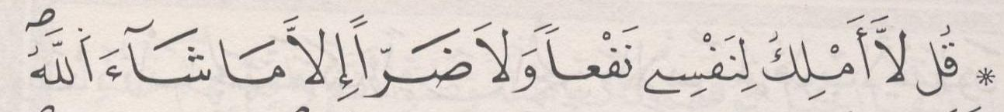 | ﺛﻣﻥ 3
ﺍﻟﺛﻣﻥ 20 ﻓﻲ ﺳﻭﺭﺓ ﺍﻷﻋﺭﺍﻑ | ﺻﻔﺣﺔ 176 | 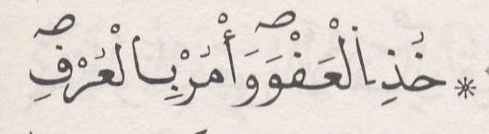 | ﺛﻣﻥ 4
[8] ﺳﻭﺭﺓ ﺍﻷﻧﻔﺎﻝ

ﺍﻟﺛﻣﻥ 1 ﻓﻲ ﺳﻭﺭﺓ ﺍﻷﻧﻔﺎﻝ | ﺻﻔﺣﺔ 177 | 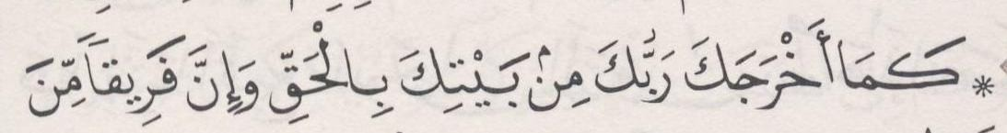 | ﺛﻣﻥ 5
ﺍﻟﺛﻣﻥ 2 ﻓﻲ ﺳﻭﺭﺓ ﺍﻷﻧﻔﺎﻝ | ﺻﻔﺣﺔ 178 | 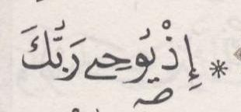 | ﺛﻣﻥ 6
ﺍﻟﺛﻣﻥ 3 ﻓﻲ ﺳﻭﺭﺓ ﺍﻷﻧﻔﺎﻝ | ﺻﻔﺣﺔ 179 | 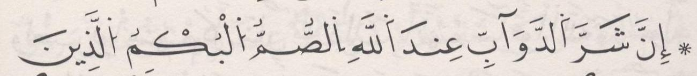 | ﺛﻣﻥ 7
ﺍﻟﺛﻣﻥ 4 ﻓﻲ ﺳﻭﺭﺓ ﺍﻷﻧﻔﺎﻝ | ﺻﻔﺣﺔ 180 | 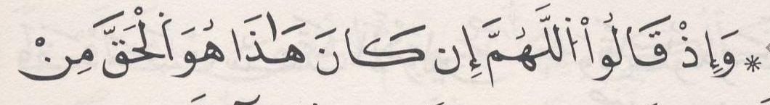 | ﺛﻣﻥ 8
ﺍﻟﺛﻣﻥ 5 ﻓﻲ ﺳﻭﺭﺓ ﺍﻷﻧﻔﺎﻝ | ﺻﻔﺣﺔ 182 | 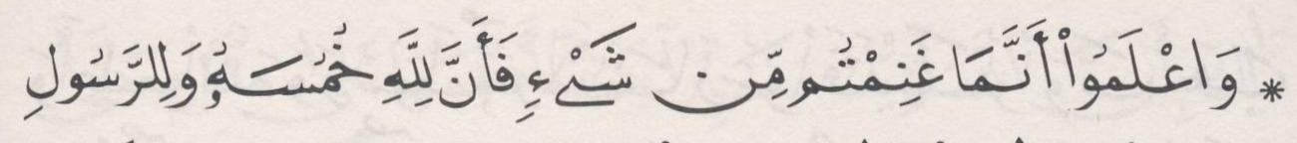 | ﺛﻣﻥ 1 | ﺣﺯﺏ 19 | ﻧﻘﺯﺓ 7
ﺍﻟﺛﻣﻥ 6 ﻓﻲ ﺳﻭﺭﺓ ﺍﻷﻧﻔﺎﻝ | ﺻﻔﺣﺔ 183 | 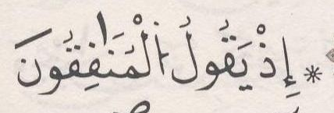 | ﺛﻣﻥ 2
ﺍﻟﺛﻣﻥ 7 ﻓﻲ ﺳﻭﺭﺓ ﺍﻷﻧﻔﺎﻝ | ﺻﻔﺣﺔ 184 | 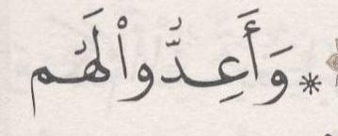 | ﺛﻣﻥ 3
ﺍﻟﺛﻣﻥ 8 ﻓﻲ ﺳﻭﺭﺓ ﺍﻷﻧﻔﺎﻝ | ﺻﻔﺣﺔ 186 | 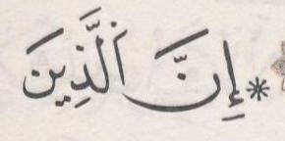 | ﺛﻣﻥ 4
[9] ﺳﻭﺭﺓ ﺍﻟﺗﻭﺑﺔ

ﺍﻟﺛﻣﻥ 1 ﻓﻲ ﺳﻭﺭﺓ ﺍﻟﺗﻭﺑﺔ | ﺻﻔﺣﺔ 187 | 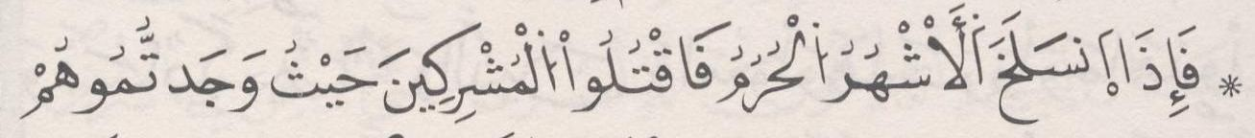 | ﺛﻣﻥ 5
ﺍﻟﺛﻣﻥ 2 ﻓﻲ ﺳﻭﺭﺓ ﺍﻟﺗﻭﺑﺔ | ﺻﻔﺣﺔ 188 | 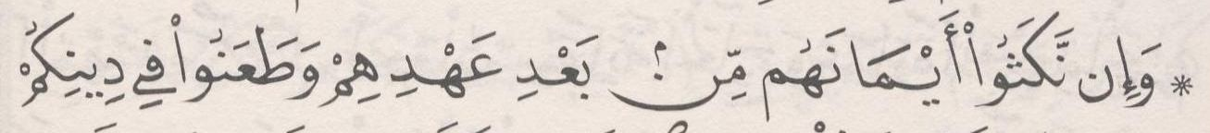 | ﺛﻣﻥ 6
ﺍﻟﺛﻣﻥ 3 ﻓﻲ ﺳﻭﺭﺓ ﺍﻟﺗﻭﺑﺔ | ﺻﻔﺣﺔ 189 | 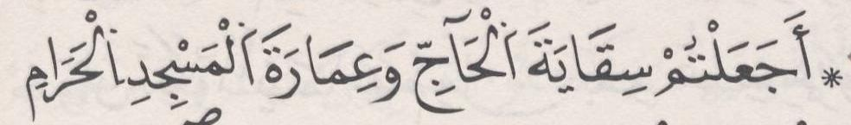 | ﺛﻣﻥ 7
ﺍﻟﺛﻣﻥ 4 ﻓﻲ ﺳﻭﺭﺓ ﺍﻟﺗﻭﺑﺔ | ﺻﻔﺣﺔ 190 | 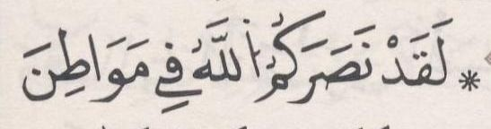 | ﺛﻣﻥ 8
ﺍﻟﺛﻣﻥ 5 ﻓﻲ ﺳﻭﺭﺓ ﺍﻟﺗﻭﺑﺔ | ﺻﻔﺣﺔ 192 | 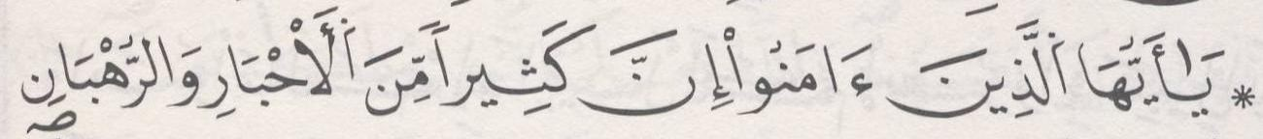 | ﺛﻣﻥ 1 | ﺣﺯﺏ 20
ﺍﻟﺛﻣﻥ 6 ﻓﻲ ﺳﻭﺭﺓ ﺍﻟﺗﻭﺑﺔ | ﺻﻔﺣﺔ 193 | 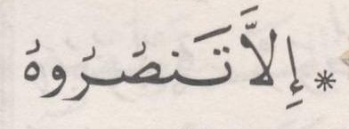 | ﺛﻣﻥ 2
ﺍﻟﺛﻣﻥ 7 ﻓﻲ ﺳﻭﺭﺓ ﺍﻟﺗﻭﺑﺔ | ﺻﻔﺣﺔ 194 | 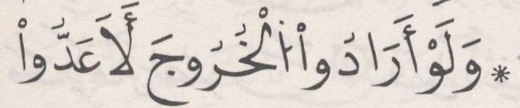 | ﺛﻣﻥ 3
ﺍﻟﺛﻣﻥ 8 ﻓﻲ ﺳﻭﺭﺓ ﺍﻟﺗﻭﺑﺔ | ﺻﻔﺣﺔ 195 | 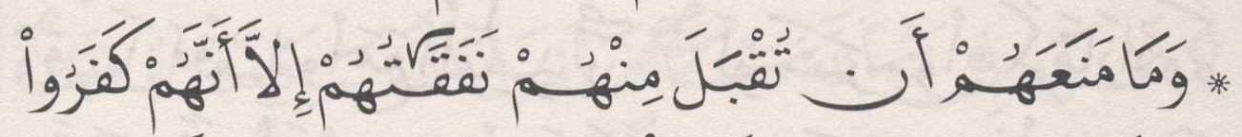 | ﺛﻣﻥ 4
ﺍﻟﺛﻣﻥ 9 ﻓﻲ ﺳﻭﺭﺓ ﺍﻟﺗﻭﺑﺔ | ﺻﻔﺣﺔ 196 | 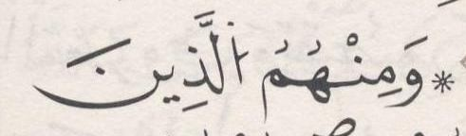 | ﺛﻣﻥ 5
ﺍﻟﺛﻣﻥ 10 ﻓﻲ ﺳﻭﺭﺓ ﺍﻟﺗﻭﺑﺔ | ﺻﻔﺣﺔ 198 | 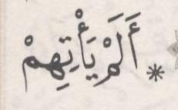 | ﺛﻣﻥ 6
ﺍﻟﺛﻣﻥ 11 ﻓﻲ ﺳﻭﺭﺓ ﺍﻟﺗﻭﺑﺔ | ﺻﻔﺣﺔ 199 | 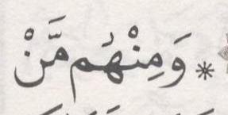 | ﺛﻣﻥ 7
ﺍﻟﺛﻣﻥ 12 ﻓﻲ ﺳﻭﺭﺓ ﺍﻟﺗﻭﺑﺔ | ﺻﻔﺣﺔ 200 | 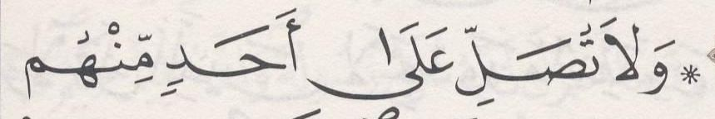 | ﺛﻣﻥ 8
ﺍﻟﺛﻣﻥ 13 ﻓﻲ ﺳﻭﺭﺓ ﺍﻟﺗﻭﺑﺔ | ﺻﻔﺣﺔ 202 | 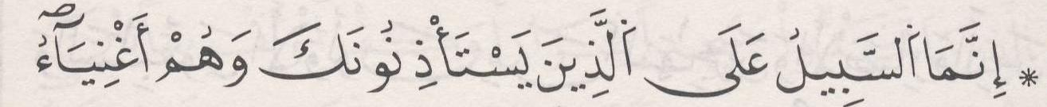 | ﺛﻣﻥ 1 | ﺣﺯﺏ 21
ﺍﻟﺛﻣﻥ 14 ﻓﻲ ﺳﻭﺭﺓ ﺍﻟﺗﻭﺑﺔ | ﺻﻔﺣﺔ 203 | 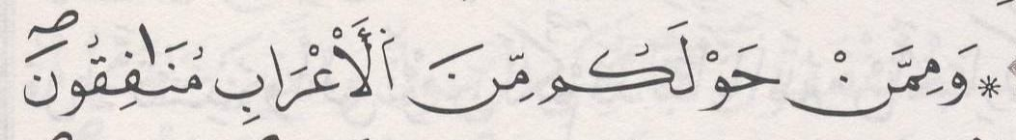 | ﺛﻣﻥ 2
ﺍﻟﺛﻣﻥ 15 ﻓﻲ ﺳﻭﺭﺓ ﺍﻟﺗﻭﺑﺔ | ﺻﻔﺣﺔ 204 | 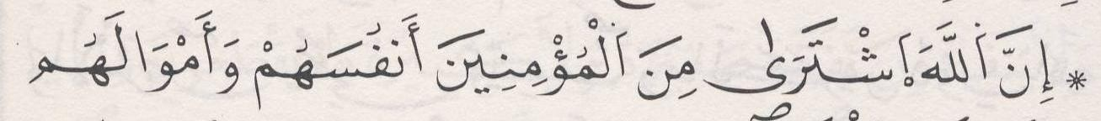 | ﺛﻣﻥ 3
ﺍﻟﺛﻣﻥ 16 ﻓﻲ ﺳﻭﺭﺓ ﺍﻟﺗﻭﺑﺔ | ﺻﻔﺣﺔ 205 | 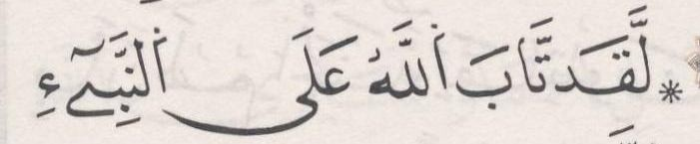 | ﺛﻣﻥ 4

ﺍﻟﺛﻣﻥ 17 ﻓﻲ ﺳﻭﺭﺓ ﺍﻟﺗﻭﺑﺔ | ﺻﻔﺣﺔ 207 | 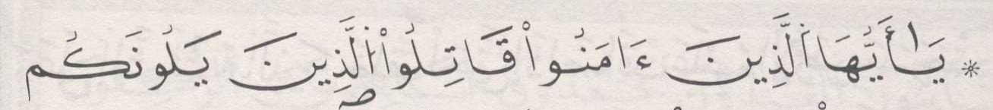 | ﺛﻣﻥ 5
[10] ﺳﻭﺭﺓ ﻳﻭﻧﺱ

ﺍﻟﺛﻣﻥ 1 ﻓﻲ ﺳﻭﺭﺓ ﻳﻭﻧﺱ | ﺻﻔﺣﺔ 208 | 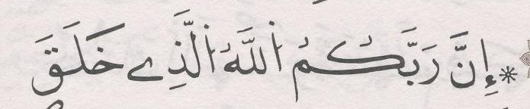 | ﺛﻣﻥ 6
ﺍﻟﺛﻣﻥ 2 ﻓﻲ ﺳﻭﺭﺓ ﻳﻭﻧﺱ | ﺻﻔﺣﺔ 209 | 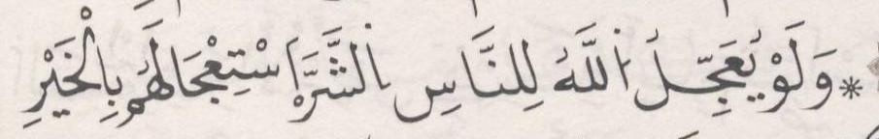 | ﺛﻣﻥ 7
ﺍﻟﺛﻣﻥ 3 ﻓﻲ ﺳﻭﺭﺓ ﻳﻭﻧﺱ | ﺻﻔﺣﺔ 210 | 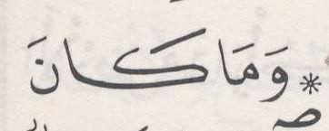 | ﺛﻣﻥ 8
ﺍﻟﺛﻣﻥ 4 ﻓﻲ ﺳﻭﺭﺓ ﻳﻭﻧﺱ | ﺻﻔﺣﺔ 212 | 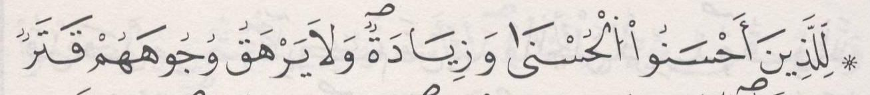 | ﺛﻣﻥ 1 | ﺣﺯﺏ 22 | ﻧﻘﺯﺓ 8
ﺍﻟﺛﻣﻥ 5 ﻓﻲ ﺳﻭﺭﺓ ﻳﻭﻧﺱ | ﺻﻔﺣﺔ 213 | 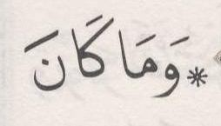 | ﺛﻣﻥ 2
ﺍﻟﺛﻣﻥ 6 ﻓﻲ ﺳﻭﺭﺓ ﻳﻭﻧﺱ | ﺻﻔﺣﺔ 214 | 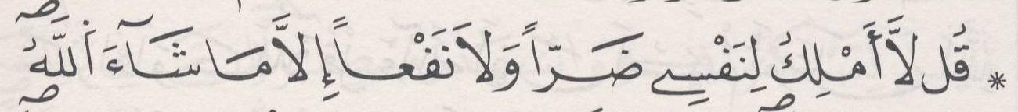 | ﺛﻣﻥ 3
ﺍﻟﺛﻣﻥ 7 ﻓﻲ ﺳﻭﺭﺓ ﻳﻭﻧﺱ | ﺻﻔﺣﺔ 215 |  | ﺛﻣﻥ 4
ﺍﻟﺛﻣﻥ 8 ﻓﻲ ﺳﻭﺭﺓ ﻳﻭﻧﺱ | ﺻﻔﺣﺔ 217 | 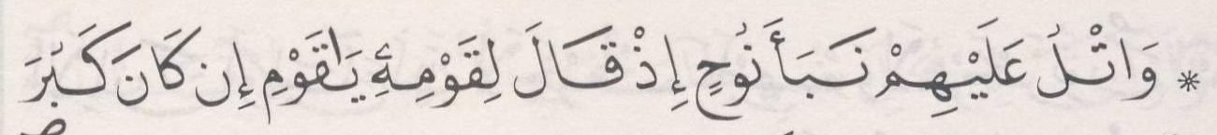 | ﺛﻣﻥ 5
ﺍﻟﺛﻣﻥ 9 ﻓﻲ ﺳﻭﺭﺓ ﻳﻭﻧﺱ | ﺻﻔﺣﺔ 218 | 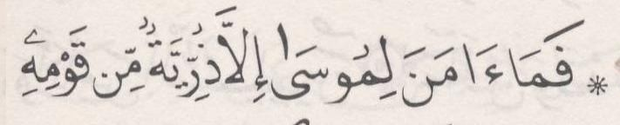 | ﺛﻣﻥ 6
ﺍﻟﺛﻣﻥ 10 ﻓﻲ ﺳﻭﺭﺓ ﻳﻭﻧﺱ | ﺻﻔﺣﺔ 219 |  | ﺛﻣﻥ 7
ﺍﻟﺛﻣﻥ 11 ﻓﻲ ﺳﻭﺭﺓ ﻳﻭﻧﺱ | ﺻﻔﺣﺔ 220 | 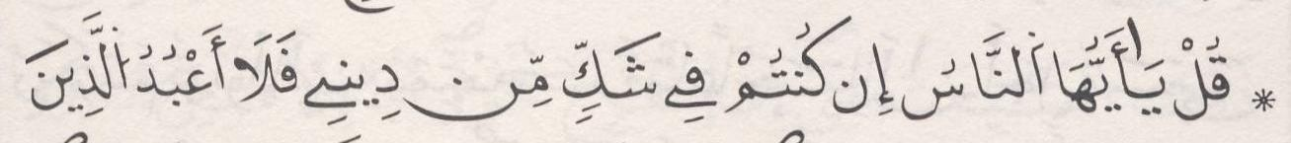 | ﺛﻣﻥ 8
[11] ﺳﻭﺭﺓ ﻫﻭﺩ

ﺍﻟﺛﻣﻥ 1 ﻓﻲ ﺳﻭﺭﺓ ﻫﻭﺩ | ﺻﻔﺣﺔ 222 | 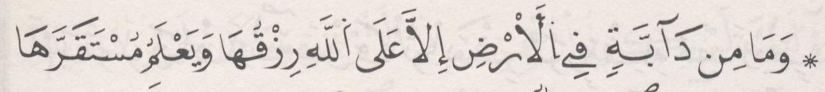 | ﺛﻣﻥ 1 | ﺣﺯﺏ 23
ﺍﻟﺛﻣﻥ 2 ﻓﻲ ﺳﻭﺭﺓ ﻫﻭﺩ | ﺻﻔﺣﺔ 223 | 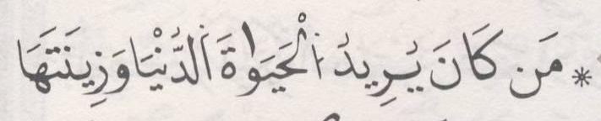 | ﺛﻣﻥ 2
ﺍﻟﺛﻣﻥ 3 ﻓﻲ ﺳﻭﺭﺓ ﻫﻭﺩ | ﺻﻔﺣﺔ 224 | 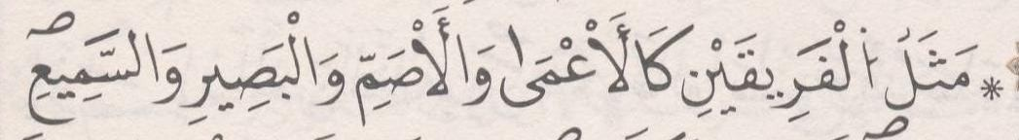 | ﺛﻣﻥ 3
ﺍﻟﺛﻣﻥ 4 ﻓﻲ ﺳﻭﺭﺓ ﻫﻭﺩ | ﺻﻔﺣﺔ 225 | 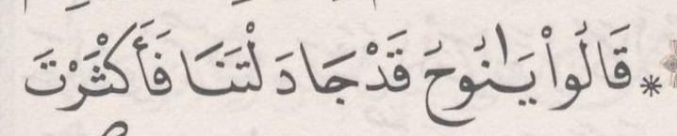 | ﺛﻣﻥ 4
ﺍﻟﺛﻣﻥ 5 ﻓﻲ ﺳﻭﺭﺓ ﻫﻭﺩ | ﺻﻔﺣﺔ 226 | 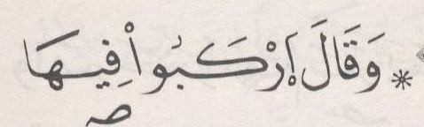 | ﺛﻣﻥ 5
ﺍﻟﺛﻣﻥ 6 ﻓﻲ ﺳﻭﺭﺓ ﻫﻭﺩ | ﺻﻔﺣﺔ 227 | 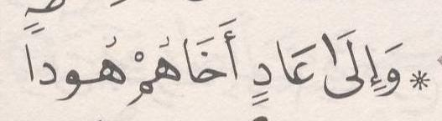 | ﺛﻣﻥ 6
ﺍﻟﺛﻣﻥ 7 ﻓﻲ ﺳﻭﺭﺓ ﻫﻭﺩ | ﺻﻔﺣﺔ 228 |  | ﺛﻣﻥ 7
ﺍﻟﺛﻣﻥ 8 ﻓﻲ ﺳﻭﺭﺓ ﻫﻭﺩ | ﺻﻔﺣﺔ 230 | 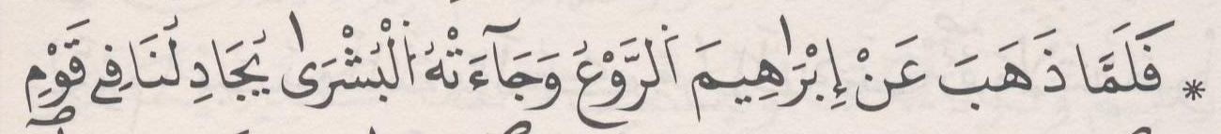 | ﺛﻣﻥ 8
ﺍﻟﺛﻣﻥ 9 ﻓﻲ ﺳﻭﺭﺓ ﻫﻭﺩ | ﺻﻔﺣﺔ 231 | 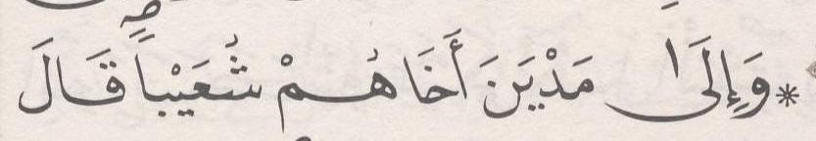 | ﺛﻣﻥ 1 | ﺣﺯﺏ 24
ﺍﻟﺛﻣﻥ 10 ﻓﻲ ﺳﻭﺭﺓ ﻫﻭﺩ | ﺻﻔﺣﺔ 232 | 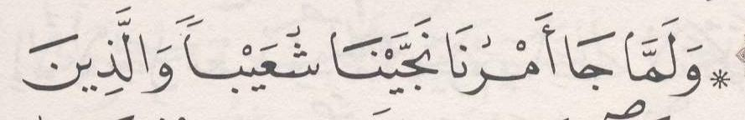 | ﺛﻣﻥ 2

ﺍﻟﺛﻣﻥ 11 ﻓﻲ ﺳﻭﺭﺓ ﻫﻭﺩ | ﺻﻔﺣﺔ 233 | 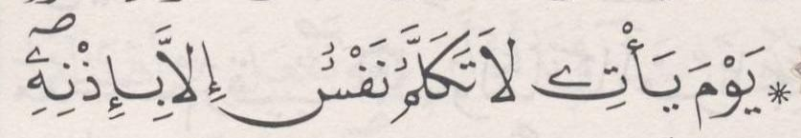 | ﺛﻣﻥ 3
ﺍﻟﺛﻣﻥ 12 ﻓﻲ ﺳﻭﺭﺓ ﻫﻭﺩ | ﺻﻔﺣﺔ 235 |  | ﺛﻣﻥ 4
[12] ﺳﻭﺭﺓ ﻳﻭﺳﻑ

ﺍﻟﺛﻣﻥ 1 ﻓﻲ ﺳﻭﺭﺓ ﻳﻭﺳﻑ | ﺻﻔﺣﺔ 236 | 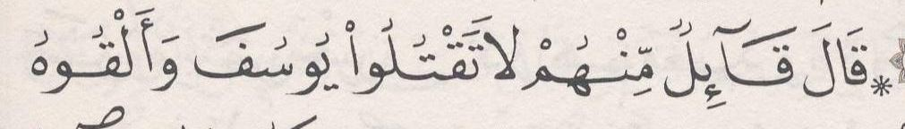 | ﺛﻣﻥ 5
ﺍﻟﺛﻣﻥ 2 ﻓﻲ ﺳﻭﺭﺓ ﻳﻭﺳﻑ | ﺻﻔﺣﺔ 237 | 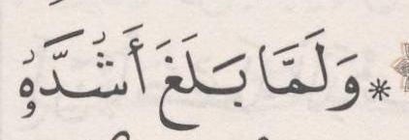 | ﺛﻣﻥ 6
ﺍﻟﺛﻣﻥ 3 ﻓﻲ ﺳﻭﺭﺓ ﻳﻭﺳﻑ | ﺻﻔﺣﺔ 239 | 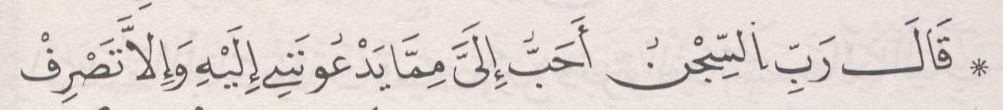 | ﺛﻣﻥ 7
ﺍﻟﺛﻣﻥ 4 ﻓﻲ ﺳﻭﺭﺓ ﻳﻭﺳﻑ | ﺻﻔﺣﺔ 240 |  | ﺛﻣﻥ 8
ﺍﻟﺛﻣﻥ 5 ﻓﻲ ﺳﻭﺭﺓ ﻳﻭﺳﻑ | ﺻﻔﺣﺔ 242 | 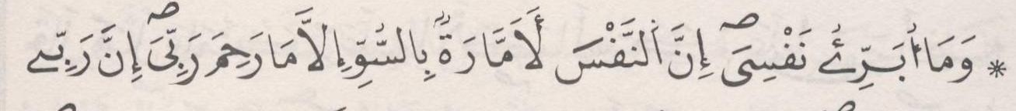 | ﺛﻣﻥ 1 | ﺣﺯﺏ 25 | ﻧﻘﺯﺓ 9
ﺍﻟﺛﻣﻥ 6 ﻓﻲ ﺳﻭﺭﺓ ﻳﻭﺳﻑ | ﺻﻔﺣﺔ 243 | 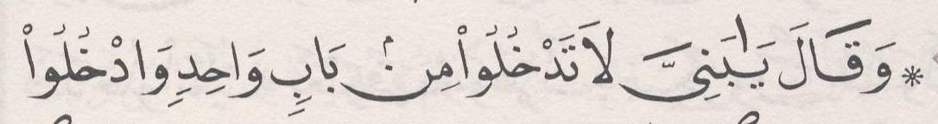 | ﺛﻣﻥ 2
ﺍﻟﺛﻣﻥ 7 ﻓﻲ ﺳﻭﺭﺓ ﻳﻭﺳﻑ | ﺻﻔﺣﺔ 244 |  | ﺛﻣﻥ 3
ﺍﻟﺛﻣﻥ 8 ﻓﻲ ﺳﻭﺭﺓ ﻳﻭﺳﻑ | ﺻﻔﺣﺔ 246 | 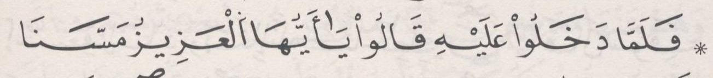 | ﺛﻣﻥ 4
ﺍﻟﺛﻣﻥ 9 ﻓﻲ ﺳﻭﺭﺓ ﻳﻭﺳﻑ | ﺻﻔﺣﺔ 247 | 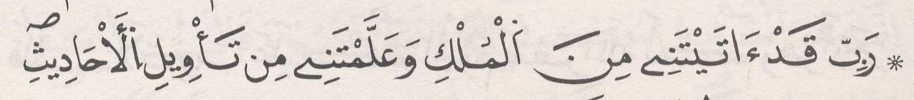 | ﺛﻣﻥ 5
ﺍﻟﺛﻣﻥ 10 ﻓﻲ ﺳﻭﺭﺓ ﻳﻭﺳﻑ | ﺻﻔﺣﺔ 248 |  | ﺛﻣﻥ 6
[13] ﺳﻭﺭﺓ ﺍﻟﺭﻋﺩ

ﺍﻟﺛﻣﻥ 1 ﻓﻲ ﺳﻭﺭﺓ ﺍﻟﺭﻋﺩ | ﺻﻔﺣﺔ 249 | 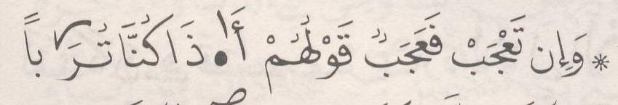 | ﺛﻣﻥ 7
ﺍﻟﺛﻣﻥ 2 ﻓﻲ ﺳﻭﺭﺓ ﺍﻟﺭﻋﺩ | ﺻﻔﺣﺔ 251 | 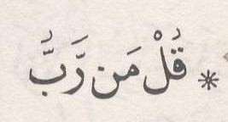 | ﺛﻣﻥ 8
ﺍﻟﺛﻣﻥ 3 ﻓﻲ ﺳﻭﺭﺓ ﺍﻟﺭﻋﺩ | ﺻﻔﺣﺔ 252 |  | ﺛﻣﻥ 1 | ﺣﺯﺏ 26
ﺍﻟﺛﻣﻥ 4 ﻓﻲ ﺳﻭﺭﺓ ﺍﻟﺭﻋﺩ | ﺻﻔﺣﺔ 253 | 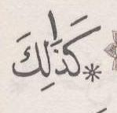 | ﺛﻣﻥ 2
ﺍﻟﺛﻣﻥ 5 ﻓﻲ ﺳﻭﺭﺓ ﺍﻟﺭﻋﺩ | ﺻﻔﺣﺔ 254 | 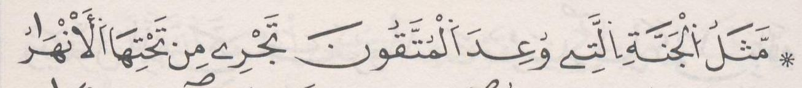 | ﺛﻣﻥ 3
[14] ﺳﻭﺭﺓ ﺇﺑﺭﺍﻫﻳﻡ

ﺍﻟﺛﻣﻥ 1 ﻓﻲ ﺳﻭﺭﺓ ﺇﺑﺭﺍﻫﻳﻡ | ﺻﻔﺣﺔ 255 | 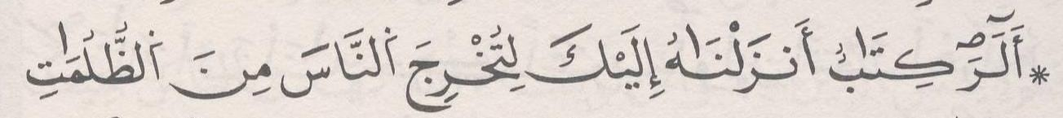 | ﺛﻣﻥ 4
ﺍﻟﺛﻣﻥ 2 ﻓﻲ ﺳﻭﺭﺓ ﺇﺑﺭﺍﻫﻳﻡ | ﺻﻔﺣﺔ 256 | 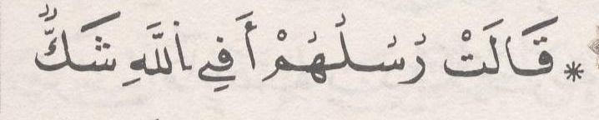 | ﺛﻣﻥ 5
ﺍﻟﺛﻣﻥ 3 ﻓﻲ ﺳﻭﺭﺓ ﺇﺑﺭﺍﻫﻳﻡ | ﺻﻔﺣﺔ 258 | 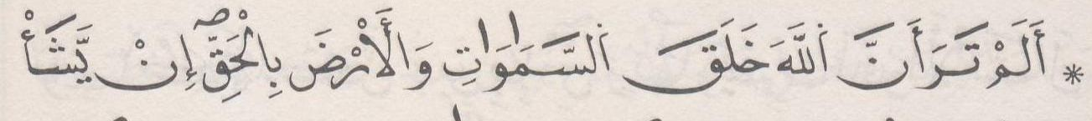 | ﺛﻣﻥ 6
ﺍﻟﺛﻣﻥ 4 ﻓﻲ ﺳﻭﺭﺓ ﺇﺑﺭﺍﻫﻳﻡ | ﺻﻔﺣﺔ 259 | 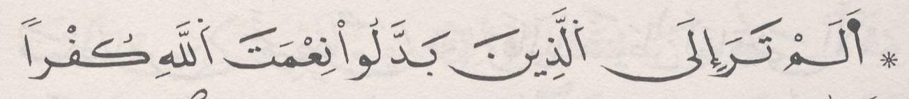 | ﺛﻣﻥ 7

ﺍﻟﺛﻣﻥ 5 ﻓﻲ ﺳﻭﺭﺓ ﺇﺑﺭﺍﻫﻳﻡ | ﺻﻔﺣﺔ 260 |  | ﺛﻣﻥ 8
[15] ﺳﻭﺭﺓ ﺍﻟﺣﺟﺭ

ﺍﻟﺛﻣﻥ 1 ﻓﻲ ﺳﻭﺭﺓ ﺍﻟﺣﺟﺭ | ﺻﻔﺣﺔ 262 | 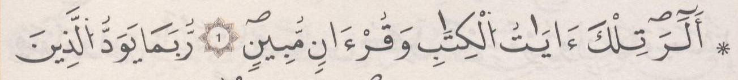 | ﺛﻣﻥ 1 | ﺣﺯﺏ 27
ﺍﻟﺛﻣﻥ 2 ﻓﻲ ﺳﻭﺭﺓ ﺍﻟﺣﺟﺭ | ﺻﻔﺣﺔ 263 | 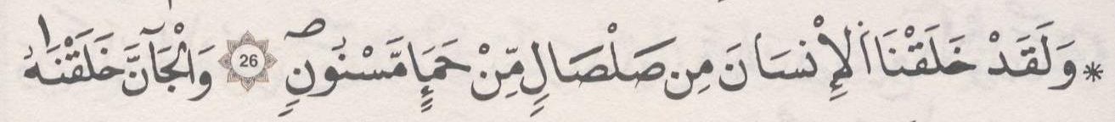 | ﺛﻣﻥ 2
ﺍﻟﺛﻣﻥ 3 ﻓﻲ ﺳﻭﺭﺓ ﺍﻟﺣﺟﺭ | ﺻﻔﺣﺔ 264 | 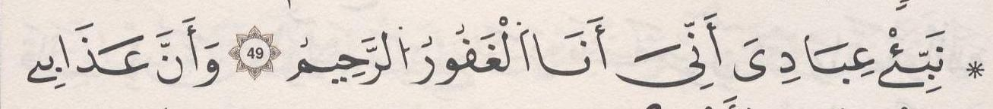 | ﺛﻣﻥ 3
ﺍﻟﺛﻣﻥ 4 ﻓﻲ ﺳﻭﺭﺓ ﺍﻟﺣﺟﺭ | ﺻﻔﺣﺔ 266 | 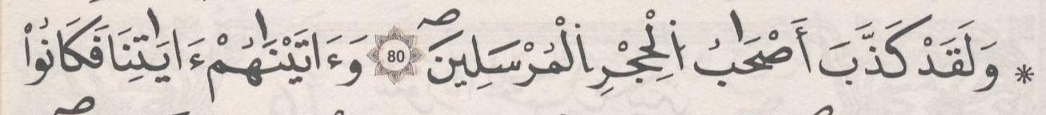 | ﺛﻣﻥ 4
[16] ﺳﻭﺭﺓ ﺍﻟﻧﺣﻝ

ﺍﻟﺛﻣﻥ 1 ﻓﻲ ﺳﻭﺭﺓ ﺍﻟﻧﺣﻝ | ﺻﻔﺣﺔ 267 | 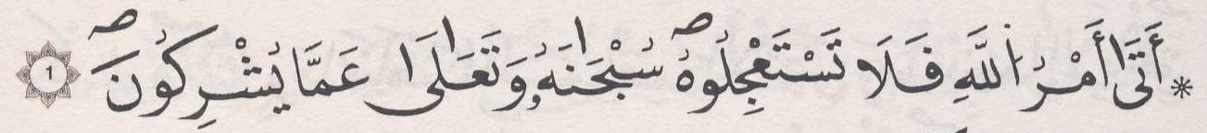 | ﺛﻣﻥ 5
ﺍﻟﺛﻣﻥ 2 ﻓﻲ ﺳﻭﺭﺓ ﺍﻟﻧﺣﻝ | ﺻﻔﺣﺔ 269 | 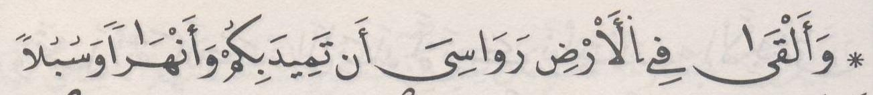 | ﺛﻣﻥ 6
ﺍﻟﺛﻣﻥ 3 ﻓﻲ ﺳﻭﺭﺓ ﺍﻟﻧﺣﻝ | ﺻﻔﺣﺔ 270 | 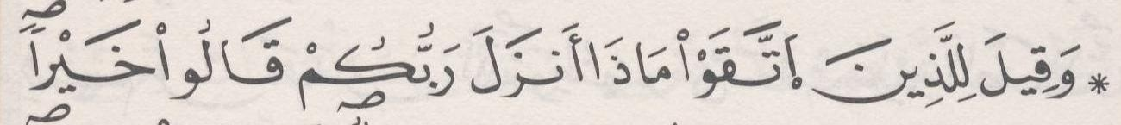 | ﺛﻣﻥ 7
ﺍﻟﺛﻣﻥ 4 ﻓﻲ ﺳﻭﺭﺓ ﺍﻟﻧﺣﻝ | ﺻﻔﺣﺔ 271 | 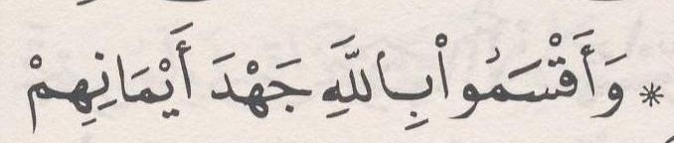 | ﺛﻣﻥ 8
ﺍﻟﺛﻣﻥ 5 ﻓﻲ ﺳﻭﺭﺓ ﺍﻟﻧﺣﻝ | ﺻﻔﺣﺔ 273 | 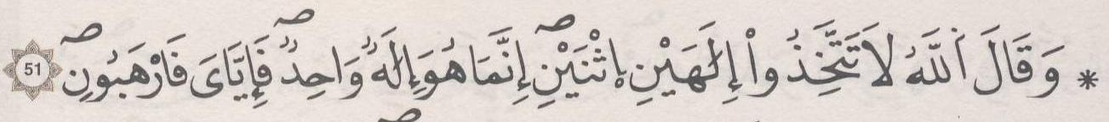 | ﺛﻣﻥ 1 | ﺣﺯﺏ 28 | ﻧﻘﺯﺓ 10
ﺍﻟﺛﻣﻥ 6 ﻓﻲ ﺳﻭﺭﺓ ﺍﻟﻧﺣﻝ | ﺻﻔﺣﺔ 273 | 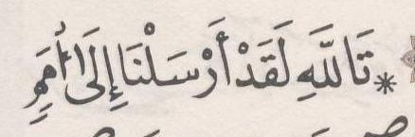 | ﺛﻣﻥ 2
ﺍﻟﺛﻣﻥ 7 ﻓﻲ ﺳﻭﺭﺓ ﺍﻟﻧﺣﻝ | ﺻﻔﺣﺔ 274 | 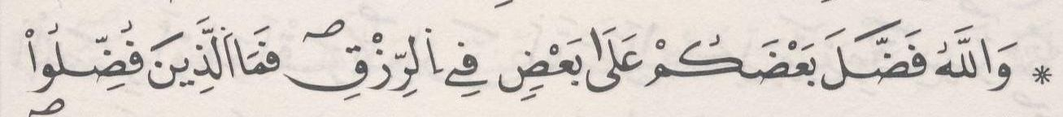 | ﺛﻣﻥ 3
ﺍﻟﺛﻣﻥ 8 ﻓﻲ ﺳﻭﺭﺓ ﺍﻟﻧﺣﻝ | ﺻﻔﺣﺔ 275 | 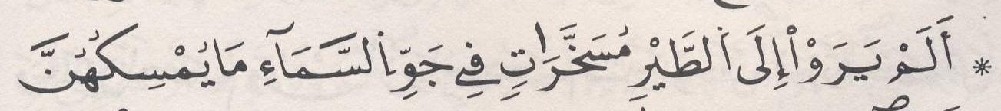 | ﺛﻣﻥ 4
ﺍﻟﺛﻣﻥ 9 ﻓﻲ ﺳﻭﺭﺓ ﺍﻟﻧﺣﻝ | ﺻﻔﺣﺔ 277 | 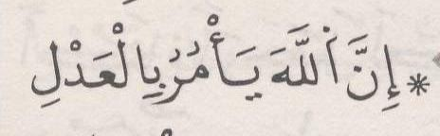 | ﺛﻣﻥ 5
ﺍﻟﺛﻣﻥ 10 ﻓﻲ ﺳﻭﺭﺓ ﺍﻟﻧﺣﻝ | ﺻﻔﺣﺔ 278 | 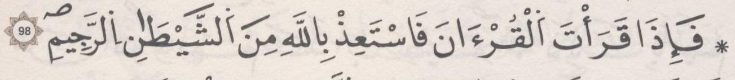 | ﺛﻣﻥ 6
ﺍﻟﺛﻣﻥ 11 ﻓﻲ ﺳﻭﺭﺓ ﺍﻟﻧﺣﻝ | ﺻﻔﺣﺔ 280 |  | ﺛﻣﻥ 7
ﺍﻟﺛﻣﻥ 12 ﻓﻲ ﺳﻭﺭﺓ ﺍﻟﻧﺣﻝ | ﺻﻔﺣﺔ 281 | 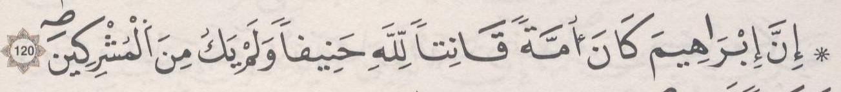 | ﺛﻣﻥ 8
[17] ﺳﻭﺭﺓ ﺍﻹﺳﺭﺍء

ﺍﻟﺛﻣﻥ 1 ﻓﻲ ﺳﻭﺭﺓ ﺍﻹﺳﺭﺍء | ﺻﻔﺣﺔ 282 | 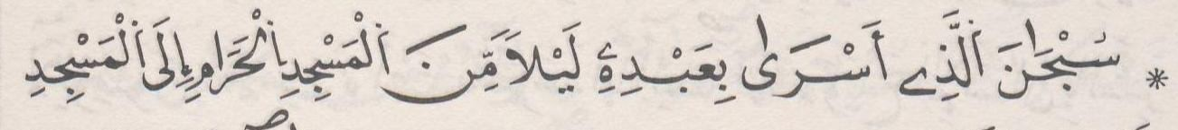 | ﺛﻣﻥ 1 | ﺣﺯﺏ 29
ﺍﻟﺛﻣﻥ 2 ﻓﻲ ﺳﻭﺭﺓ ﺍﻹﺳﺭﺍء | ﺻﻔﺣﺔ 283 |  | ﺛﻣﻥ 2
ﺍﻟﺛﻣﻥ 3 ﻓﻲ ﺳﻭﺭﺓ ﺍﻹﺳﺭﺍء | ﺻﻔﺣﺔ 284 | 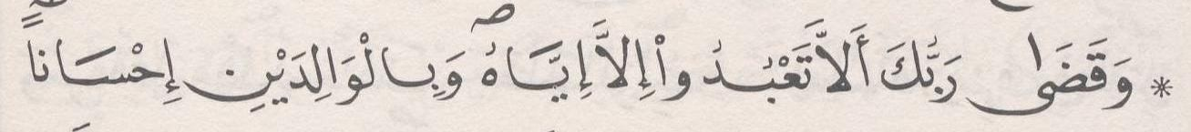 | ﺛﻣﻥ 3
ﺍﻟﺛﻣﻥ 4 ﻓﻲ ﺳﻭﺭﺓ ﺍﻹﺳﺭﺍء | ﺻﻔﺣﺔ 285 | 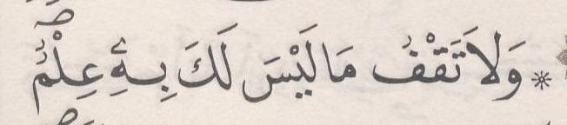 | ﺛﻣﻥ 4

ﺍﻟﺛﻣﻥ 5 ﻓﻲ ﺳﻭﺭﺓ ﺍﻹﺳﺭﺍء | ﺻﻔﺣﺔ 287 | 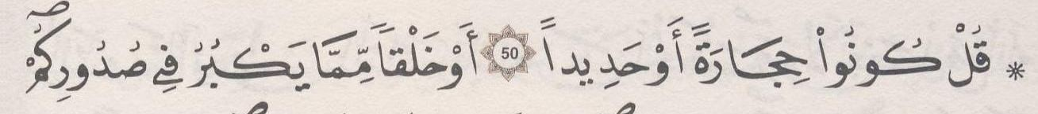 | ﺛﻣﻥ 5
ﺍﻟﺛﻣﻥ 6 ﻓﻲ ﺳﻭﺭﺓ ﺍﻹﺳﺭﺍء | ﺻﻔﺣﺔ 288 | 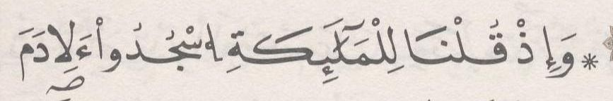 | ﺛﻣﻥ 6
ﺍﻟﺛﻣﻥ 7 ﻓﻲ ﺳﻭﺭﺓ ﺍﻹﺳﺭﺍء | ﺻﻔﺣﺔ 289 | 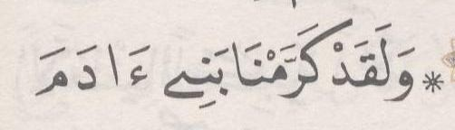 | ﺛﻣﻥ 7
ﺍﻟﺛﻣﻥ 8 ﻓﻲ ﺳﻭﺭﺓ ﺍﻹﺳﺭﺍء | ﺻﻔﺣﺔ 290 | 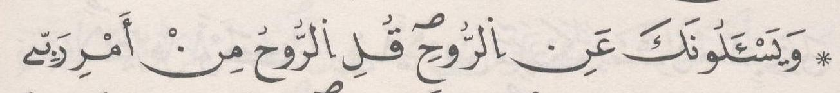 | ﺛﻣﻥ 8
ﺍﻟﺛﻣﻥ 9 ﻓﻲ ﺳﻭﺭﺓ ﺍﻹﺳﺭﺍء | ﺻﻔﺣﺔ 292 | 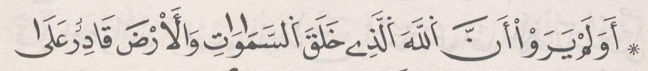 | ﺛﻣﻥ 1 | ﺣﺯﺏ 30
[18] ﺳﻭﺭﺓ ﺍﻟﻛﻬﻑ

ﺍﻟﺛﻣﻥ 1 ﻓﻲ ﺳﻭﺭﺓ ﺍﻟﻛﻬﻑ | ﺻﻔﺣﺔ 293 | 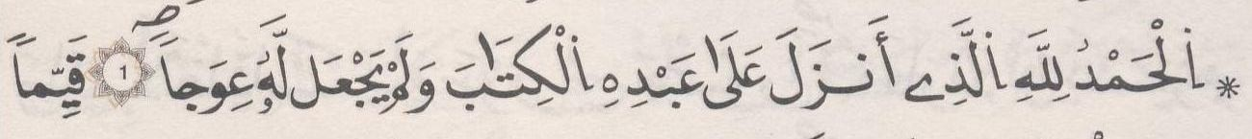 | ﺛﻣﻥ 2
ﺍﻟﺛﻣﻥ 2 ﻓﻲ ﺳﻭﺭﺓ ﺍﻟﻛﻬﻑ | ﺻﻔﺣﺔ 295 | 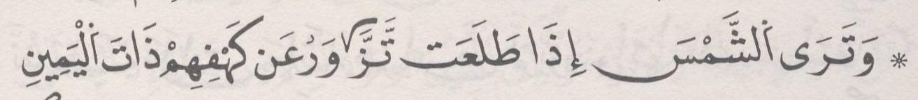 | ﺛﻣﻥ 3
ﺍﻟﺛﻣﻥ 3 ﻓﻲ ﺳﻭﺭﺓ ﺍﻟﻛﻬﻑ | ﺻﻔﺣﺔ 296 | 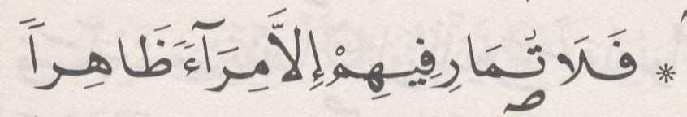 | ﺛﻣﻥ 4
ﺍﻟﺛﻣﻥ 4 ﻓﻲ ﺳﻭﺭﺓ ﺍﻟﻛﻬﻑ | ﺻﻔﺣﺔ 297 | 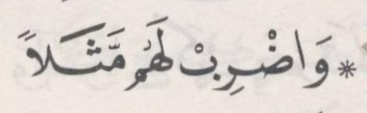 | ﺛﻣﻥ 5
ﺍﻟﺛﻣﻥ 5 ﻓﻲ ﺳﻭﺭﺓ ﺍﻟﻛﻬﻑ | ﺻﻔﺣﺔ 298 |  | ﺛﻣﻥ 6
ﺍﻟﺛﻣﻥ 6 ﻓﻲ ﺳﻭﺭﺓ ﺍﻟﻛﻬﻑ | ﺻﻔﺣﺔ 300 | 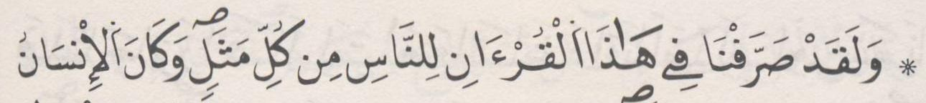 | ﺛﻣﻥ 7
ﺍﻟﺛﻣﻥ 7 ﻓﻲ ﺳﻭﺭﺓ ﺍﻟﻛﻬﻑ | ﺻﻔﺣﺔ 301 | 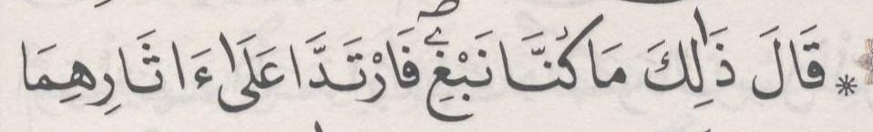 | ﺛﻣﻥ 8
ﺍﻟﺛﻣﻥ 8 ﻓﻲ ﺳﻭﺭﺓ ﺍﻟﻛﻬﻑ | ﺻﻔﺣﺔ 302 | 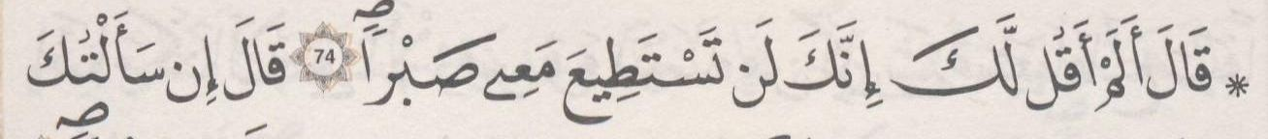 | ﺛﻣﻥ 1 | ﺣﺯﺏ 31 | ﻧﻘﺯﺓ 11
ﺍﻟﺛﻣﻥ 9 ﻓﻲ ﺳﻭﺭﺓ ﺍﻟﻛﻬﻑ | ﺻﻔﺣﺔ 302 | 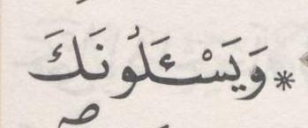 | ﺛﻣﻥ 2
ﺍﻟﺛﻣﻥ 10 ﻓﻲ ﺳﻭﺭﺓ ﺍﻟﻛﻬﻑ | ﺻﻔﺣﺔ 304 | 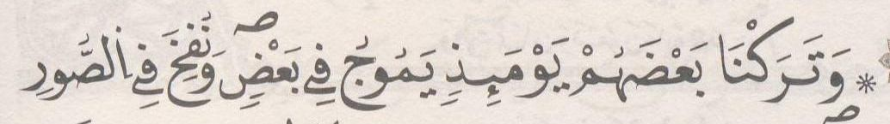 | ﺛﻣﻥ 3
[19] ﺳﻭﺭﺓ ﻣﺭﻳﻡ

ﺍﻟﺛﻣﻥ 1 ﻓﻲ ﺳﻭﺭﺓ ﻣﺭﻳﻡ | ﺻﻔﺣﺔ 305 | 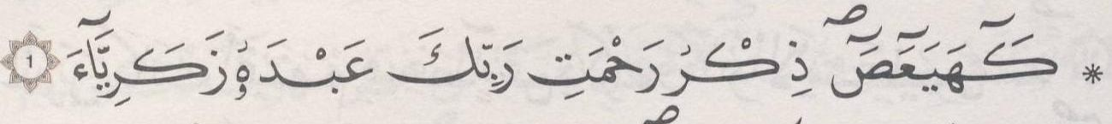 | ﺛﻣﻥ 4
ﺍﻟﺛﻣﻥ 2 ﻓﻲ ﺳﻭﺭﺓ ﻣﺭﻳﻡ | ﺻﻔﺣﺔ 306 | 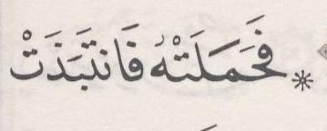 | ﺛﻣﻥ 5
ﺍﻟﺛﻣﻥ 3 ﻓﻲ ﺳﻭﺭﺓ ﻣﺭﻳﻡ | ﺻﻔﺣﺔ 308 | 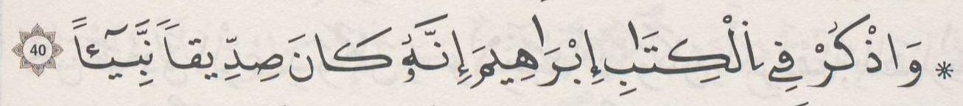 | ﺛﻣﻥ 6
ﺍﻟﺛﻣﻥ 4 ﻓﻲ ﺳﻭﺭﺓ ﻣﺭﻳﻡ | ﺻﻔﺣﺔ 309 |  | ﺛﻣﻥ 7
ﺍﻟﺛﻣﻥ 5 ﻓﻲ ﺳﻭﺭﺓ ﻣﺭﻳﻡ | ﺻﻔﺣﺔ 311 | 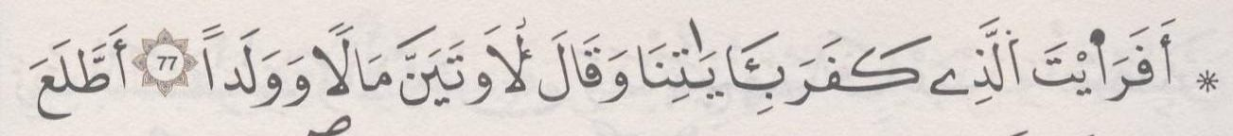 | ﺛﻣﻥ 8
[20] ﺳﻭﺭﺓ ﻁﻪ

ﺍﻟﺛﻣﻥ 1 ﻓﻲ ﺳﻭﺭﺓ ﻁﻪ | ﺻﻔﺣﺔ 312 | 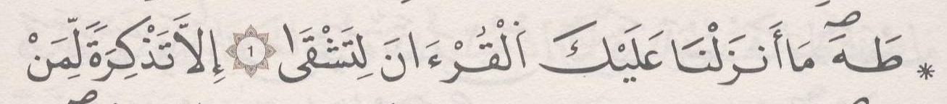 | ﺛﻣﻥ 1 | ﺣﺯﺏ 32

ﺍﻟﺛﻣﻥ 2 ﻓﻲ ﺳﻭﺭﺓ ﻁﻪ | ﺻﻔﺣﺔ 313 | 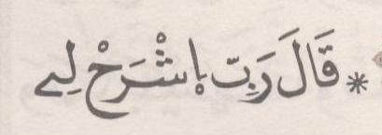 | ﺛﻣﻥ 2
ﺍﻟﺛﻣﻥ 3 ﻓﻲ ﺳﻭﺭﺓ ﻁﻪ | ﺻﻔﺣﺔ 315 | 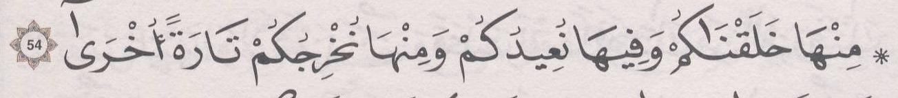 | ﺛﻣﻥ 3
ﺍﻟﺛﻣﻥ 4 ﻓﻲ ﺳﻭﺭﺓ ﻁﻪ | ﺻﻔﺣﺔ 316 | 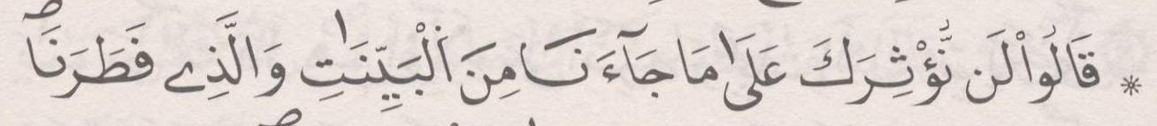 | ﺛﻣﻥ 4
ﺍﻟﺛﻣﻥ 5 ﻓﻲ ﺳﻭﺭﺓ ﻁﻪ | ﺻﻔﺣﺔ 317 | 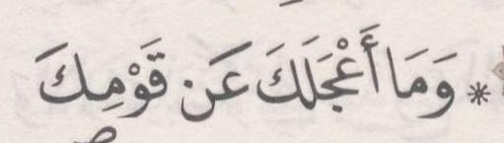 | ﺛﻣﻥ 5
ﺍﻟﺛﻣﻥ 6 ﻓﻲ ﺳﻭﺭﺓ ﻁﻪ | ﺻﻔﺣﺔ 318 | 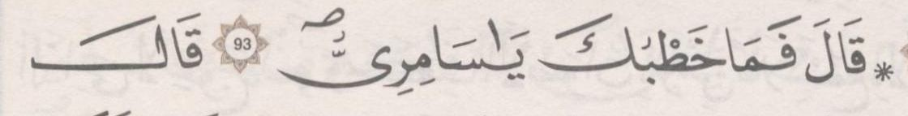 | ﺛﻣﻥ 6
ﺍﻟﺛﻣﻥ 7 ﻓﻲ ﺳﻭﺭﺓ ﻁﻪ | ﺻﻔﺣﺔ 319 | 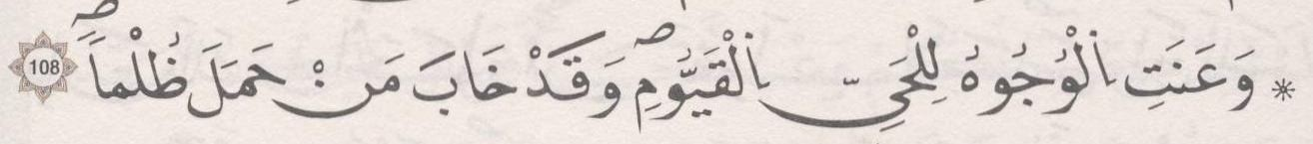 | ﺛﻣﻥ 7
ﺍﻟﺛﻣﻥ 8 ﻓﻲ ﺳﻭﺭﺓ ﻁﻪ | ﺻﻔﺣﺔ 321 | 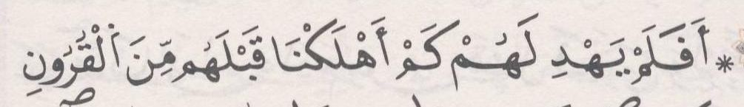 | ﺛﻣﻥ 8
[21] ﺳﻭﺭﺓ ﺍﻷﻧﺑﻳﺎء

ﺍﻟﺛﻣﻥ 1 ﻓﻲ ﺳﻭﺭﺓ ﺍﻷﻧﺑﻳﺎء | ﺻﻔﺣﺔ 322 | 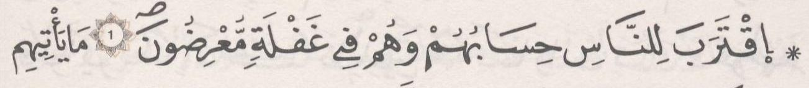 | ﺛﻣﻥ 1 | ﺣﺯﺏ 33
ﺍﻟﺛﻣﻥ 2 ﻓﻲ ﺳﻭﺭﺓ ﺍﻷﻧﺑﻳﺎء | ﺻﻔﺣﺔ 323 | 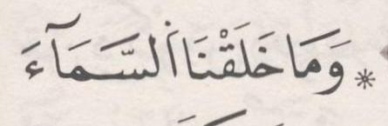 | ﺛﻣﻥ 2
ﺍﻟﺛﻣﻥ 3 ﻓﻲ ﺳﻭﺭﺓ ﺍﻷﻧﺑﻳﺎء | ﺻﻔﺣﺔ 324 | 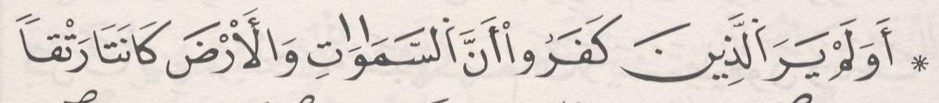 | ﺛﻣﻥ 3
ﺍﻟﺛﻣﻥ 4 ﻓﻲ ﺳﻭﺭﺓ ﺍﻷﻧﺑﻳﺎء | ﺻﻔﺣﺔ 325 |  | ﺛﻣﻥ 4
ﺍﻟﺛﻣﻥ 5 ﻓﻲ ﺳﻭﺭﺓ ﺍﻷﻧﺑﻳﺎء | ﺻﻔﺣﺔ 326 | 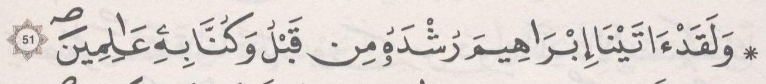 | ﺛﻣﻥ 5
ﺍﻟﺛﻣﻥ 6 ﻓﻲ ﺳﻭﺭﺓ ﺍﻷﻧﺑﻳﺎء | ﺻﻔﺣﺔ 328 | 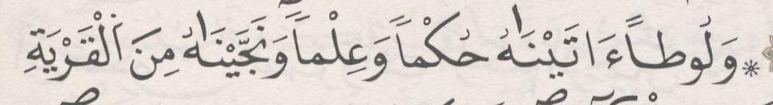 | ﺛﻣﻥ 6
ﺍﻟﺛﻣﻥ 7 ﻓﻲ ﺳﻭﺭﺓ ﺍﻷﻧﺑﻳﺎء | ﺻﻔﺣﺔ 329 | 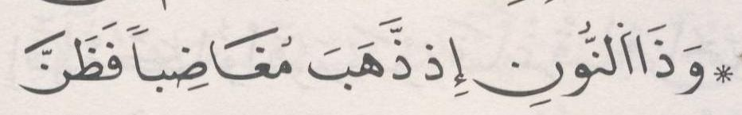 | ﺛﻣﻥ 7
ﺍﻟﺛﻣﻥ 8 ﻓﻲ ﺳﻭﺭﺓ ﺍﻷﻧﺑﻳﺎء | ﺻﻔﺣﺔ 331 |  | ﺛﻣﻥ 8
[22] ﺳﻭﺭﺓ ﺍﻟﺣﺞ

ﺍﻟﺛﻣﻥ 1 ﻓﻲ ﺳﻭﺭﺓ ﺍﻟﺣﺞ | ﺻﻔﺣﺔ 332 | 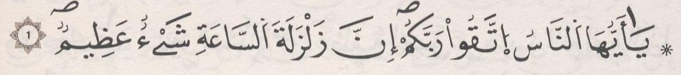 | ﺛﻣﻥ 1 | ﺣﺯﺏ 34 | ﻧﻘﺯﺓ 12
ﺍﻟﺛﻣﻥ 2 ﻓﻲ ﺳﻭﺭﺓ ﺍﻟﺣﺞ | ﺻﻔﺣﺔ 333 | 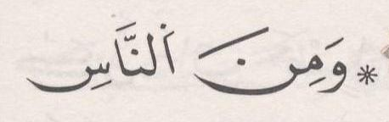 | ﺛﻣﻥ 2
ﺍﻟﺛﻣﻥ 3 ﻓﻲ ﺳﻭﺭﺓ ﺍﻟﺣﺞ | ﺻﻔﺣﺔ 334 | 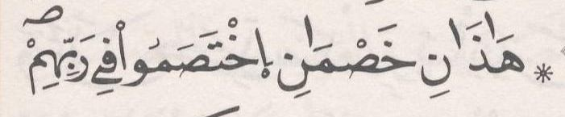 | ﺛﻣﻥ 3
ﺍﻟﺛﻣﻥ 4 ﻓﻲ ﺳﻭﺭﺓ ﺍﻟﺣﺞ | ﺻﻔﺣﺔ 335 | 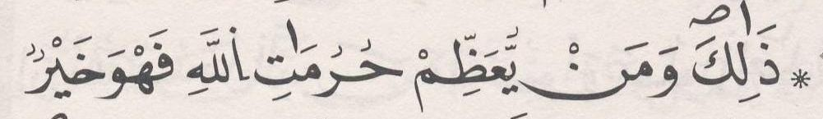 | ﺛﻣﻥ 4
ﺍﻟﺛﻣﻥ 5 ﻓﻲ ﺳﻭﺭﺓ ﺍﻟﺣﺞ | ﺻﻔﺣﺔ 336 | 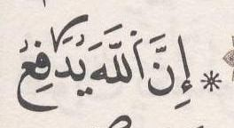 | ﺛﻣﻥ 5
ﺍﻟﺛﻣﻥ 6 ﻓﻲ ﺳﻭﺭﺓ ﺍﻟﺣﺞ | ﺻﻔﺣﺔ 338 | 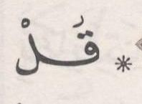 | ﺛﻣﻥ 6
ﺍﻟﺛﻣﻥ 7 ﻓﻲ ﺳﻭﺭﺓ ﺍﻟﺣﺞ | ﺻﻔﺣﺔ 339 | 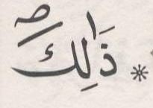 | ﺛﻣﻥ 7

ﺍﻟﺛﻣﻥ 8 ﻓﻲ ﺳﻭﺭﺓ ﺍﻟﺣﺞ | ﺻﻔﺣﺔ 340 |  | ﺛﻣﻥ 8
[23] ﺳﻭﺭﺓ ﺍﻟﻣﺅﻣﻧﻭﻥ

ﺍﻟﺛﻣﻥ 1 ﻓﻲ ﺳﻭﺭﺓ ﺍﻟﻣﺅﻣﻧﻭﻥ | ﺻﻔﺣﺔ 342 |  | ﺛﻣﻥ 1 | ﺣﺯﺏ 35
ﺍﻟﺛﻣﻥ 2 ﻓﻲ ﺳﻭﺭﺓ ﺍﻟﻣﺅﻣﻧﻭﻥ | ﺻﻔﺣﺔ 343 |  | ﺛﻣﻥ 2
ﺍﻟﺛﻣﻥ 3 ﻓﻲ ﺳﻭﺭﺓ ﺍﻟﻣﺅﻣﻧﻭﻥ | ﺻﻔﺣﺔ 344 | 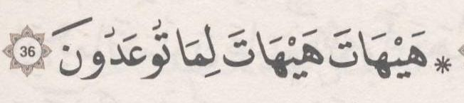 | ﺛﻣﻥ 3
ﺍﻟﺛﻣﻥ 4 ﻓﻲ ﺳﻭﺭﺓ ﺍﻟﻣﺅﻣﻧﻭﻥ | ﺻﻔﺣﺔ 345 | 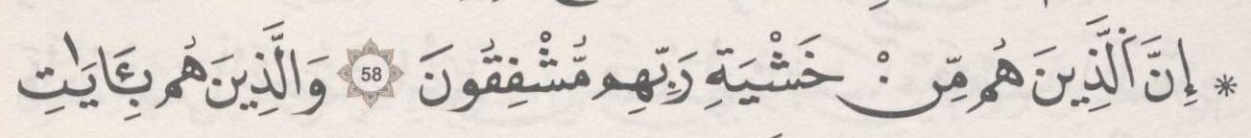 | ﺛﻣﻥ 4
ﺍﻟﺛﻣﻥ 5 ﻓﻲ ﺳﻭﺭﺓ ﺍﻟﻣﺅﻣﻧﻭﻥ | ﺻﻔﺣﺔ 347 | 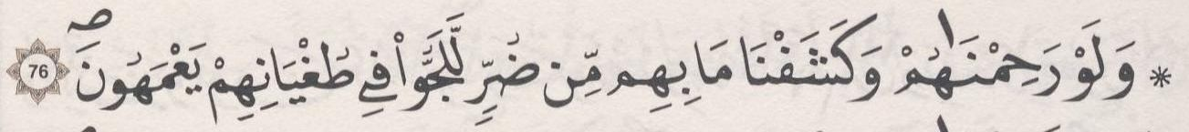 | ﺛﻣﻥ 5
ﺍﻟﺛﻣﻥ 6 ﻓﻲ ﺳﻭﺭﺓ ﺍﻟﻣﺅﻣﻧﻭﻥ | ﺻﻔﺣﺔ 348 | 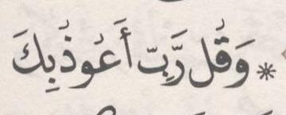 | ﺛﻣﻥ 6
ﺍﻟﺛﻣﻥ 7 ﻓﻲ ﺳﻭﺭﺓ ﺍﻟﻣﺅﻣﻧﻭﻥ | ﺻﻔﺣﺔ 349 | 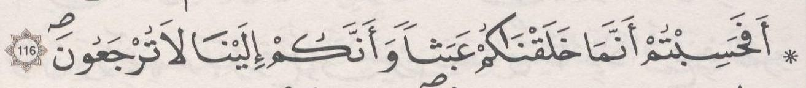 | ﺛﻣﻥ 7
[24] ﺳﻭﺭﺓ ﺍﻟﻧﻭﺭ

ﺍﻟﺛﻣﻥ 1 ﻓﻲ ﺳﻭﺭﺓ ﺍﻟﻧﻭﺭ | ﺻﻔﺣﺔ 351 |  | ﺛﻣﻥ 8
ﺍﻟﺛﻣﻥ 2 ﻓﻲ ﺳﻭﺭﺓ ﺍﻟﻧﻭﺭ | ﺻﻔﺣﺔ 352 |  | ﺛﻣﻥ 1 | ﺣﺯﺏ 36
ﺍﻟﺛﻣﻥ 3 ﻓﻲ ﺳﻭﺭﺓ ﺍﻟﻧﻭﺭ | ﺻﻔﺣﺔ 353 | 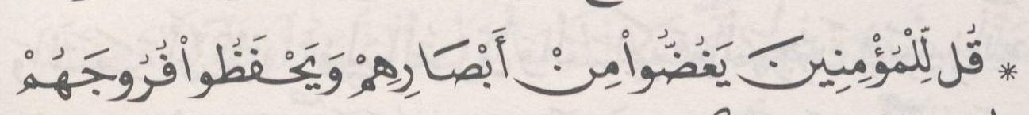 | ﺛﻣﻥ 2
ﺍﻟﺛﻣﻥ 4 ﻓﻲ ﺳﻭﺭﺓ ﺍﻟﻧﻭﺭ | ﺻﻔﺣﺔ 354 | 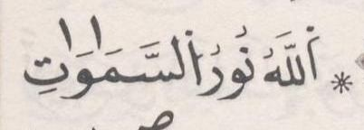 | ﺛﻣﻥ 3
ﺍﻟﺛﻣﻥ 5 ﻓﻲ ﺳﻭﺭﺓ ﺍﻟﻧﻭﺭ | ﺻﻔﺣﺔ 355 | 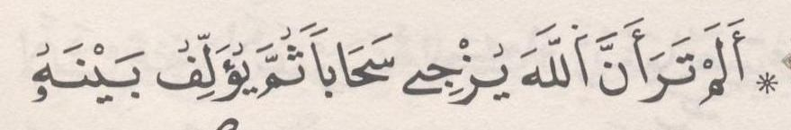 | ﺛﻣﻥ 4
ﺍﻟﺛﻣﻥ 6 ﻓﻲ ﺳﻭﺭﺓ ﺍﻟﻧﻭﺭ | ﺻﻔﺣﺔ 356 | 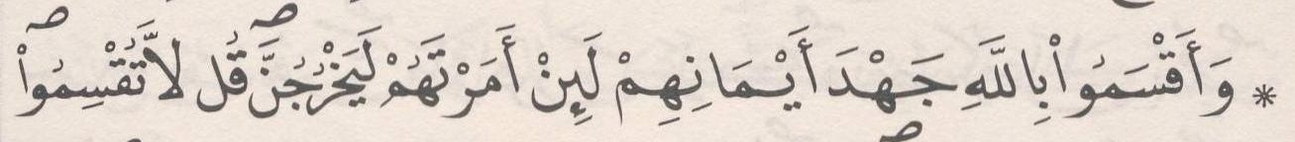 | ﺛﻣﻥ 5
ﺍﻟﺛﻣﻥ 7 ﻓﻲ ﺳﻭﺭﺓ ﺍﻟﻧﻭﺭ | ﺻﻔﺣﺔ 358 | 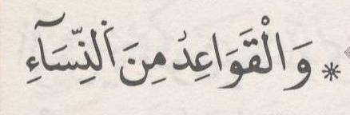 | ﺛﻣﻥ 6
ﺍﻟﺛﻣﻥ 8 ﻓﻲ ﺳﻭﺭﺓ ﺍﻟﻧﻭﺭ | ﺻﻔﺣﺔ 359 | 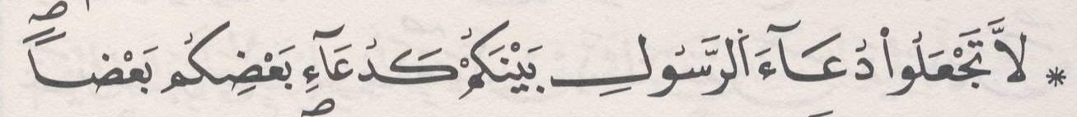 | ﺛﻣﻥ 7
[25] ﺳﻭﺭﺓ ﺍﻟﻔﺭﻗﺎﻥ

ﺍﻟﺛﻣﻥ 1 ﻓﻲ ﺳﻭﺭﺓ ﺍﻟﻔﺭﻗﺎﻥ | ﺻﻔﺣﺔ 360 | 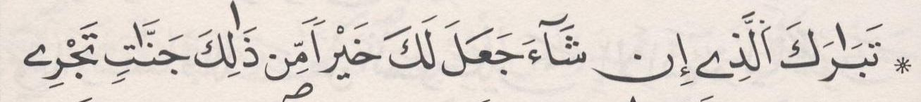 | ﺛﻣﻥ 8
ﺍﻟﺛﻣﻥ 2 ﻓﻲ ﺳﻭﺭﺓ ﺍﻟﻔﺭﻗﺎﻥ | ﺻﻔﺣﺔ 362 | 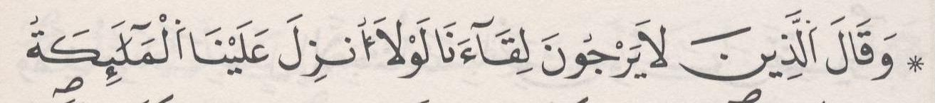 | ﺛﻣﻥ 1 | ﺣﺯﺏ 37 | ﻧﻘﺯﺓ 13
ﺍﻟﺛﻣﻥ 3 ﻓﻲ ﺳﻭﺭﺓ ﺍﻟﻔﺭﻗﺎﻥ | ﺻﻔﺣﺔ 362 | 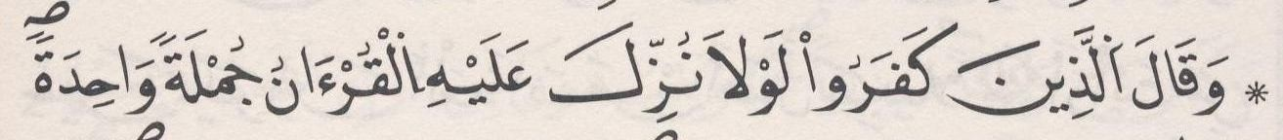 | ﺛﻣﻥ 2
ﺍﻟﺛﻣﻥ 4 ﻓﻲ ﺳﻭﺭﺓ ﺍﻟﻔﺭﻗﺎﻥ | ﺻﻔﺣﺔ 364 |  | ﺛﻣﻥ 3
ﺍﻟﺛﻣﻥ 5 ﻓﻲ ﺳﻭﺭﺓ ﺍﻟﻔﺭﻗﺎﻥ | ﺻﻔﺣﺔ 365 | 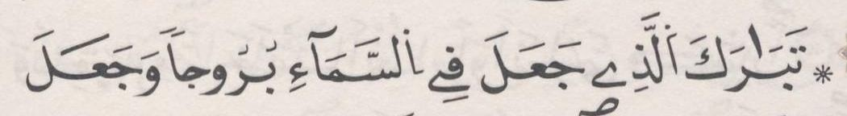 | ﺛﻣﻥ 4

[26] ﺳﻭﺭﺓ ﺍﻟﺷﻌﺭﺍء

ﺍﻟﺛﻣﻥ 1 ﻓﻲ ﺳﻭﺭﺓ ﺍﻟﺷﻌﺭﺍء | ﺻﻔﺣﺔ 367 | 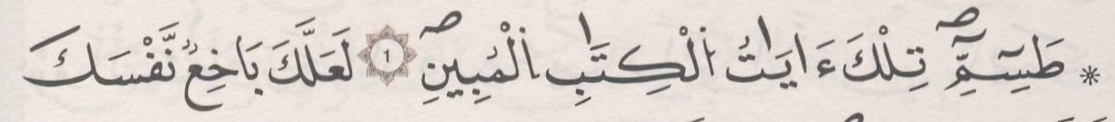 | ﺛﻣﻥ 5
ﺍﻟﺛﻣﻥ 2 ﻓﻲ ﺳﻭﺭﺓ ﺍﻟﺷﻌﺭﺍء | ﺻﻔﺣﺔ 368 | 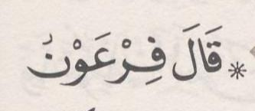 | ﺛﻣﻥ 6
ﺍﻟﺛﻣﻥ 3 ﻓﻲ ﺳﻭﺭﺓ ﺍﻟﺷﻌﺭﺍء | ﺻﻔﺣﺔ 369 | 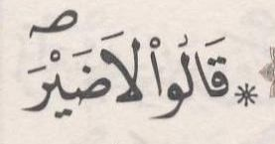 | ﺛﻣﻥ 7
ﺍﻟﺛﻣﻥ 4 ﻓﻲ ﺳﻭﺭﺓ ﺍﻟﺷﻌﺭﺍء | ﺻﻔﺣﺔ 370 |  | ﺛﻣﻥ 8
ﺍﻟﺛﻣﻥ 5 ﻓﻲ ﺳﻭﺭﺓ ﺍﻟﺷﻌﺭﺍء | ﺻﻔﺣﺔ 371 | 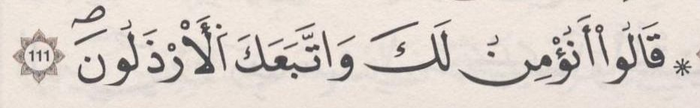 | ﺛﻣﻥ 1 | ﺣﺯﺏ 38
ﺍﻟﺛﻣﻥ 6 ﻓﻲ ﺳﻭﺭﺓ ﺍﻟﺷﻌﺭﺍء | ﺻﻔﺣﺔ 373 | 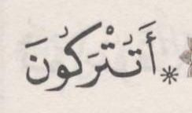 | ﺛﻣﻥ 2
ﺍﻟﺛﻣﻥ 7 ﻓﻲ ﺳﻭﺭﺓ ﺍﻟﺷﻌﺭﺍء | ﺻﻔﺣﺔ 374 | 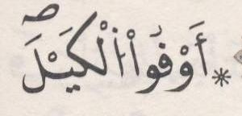 | ﺛﻣﻥ 3
ﺍﻟﺛﻣﻥ 8 ﻓﻲ ﺳﻭﺭﺓ ﺍﻟﺷﻌﺭﺍء | ﺻﻔﺣﺔ 376 | 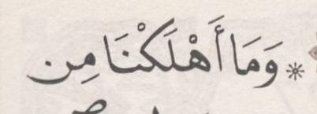 | ﺛﻣﻥ 4
[27] ﺳﻭﺭﺓ ﺍﻟﻧﻣﻝ

ﺍﻟﺛﻣﻥ 1 ﻓﻲ ﺳﻭﺭﺓ ﺍﻟﻧﻣﻝ | ﺻﻔﺣﺔ 377 | 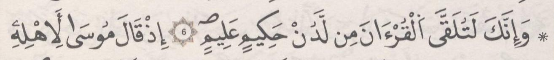 | ﺛﻣﻥ 5
ﺍﻟﺛﻣﻥ 2 ﻓﻲ ﺳﻭﺭﺓ ﺍﻟﻧﻣﻝ | ﺻﻔﺣﺔ 378 | 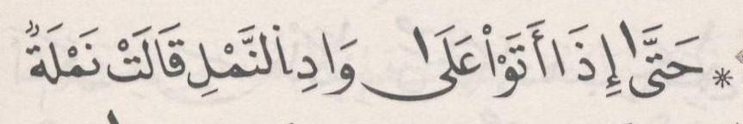 | ﺛﻣﻥ 6
ﺍﻟﺛﻣﻥ 3 ﻓﻲ ﺳﻭﺭﺓ ﺍﻟﻧﻣﻝ | ﺻﻔﺣﺔ 379 | 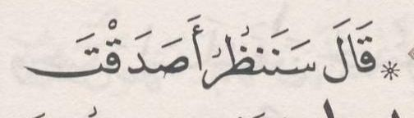 | ﺛﻣﻥ 7
ﺍﻟﺛﻣﻥ 4 ﻓﻲ ﺳﻭﺭﺓ ﺍﻟﻧﻣﻝ | ﺻﻔﺣﺔ 380 | 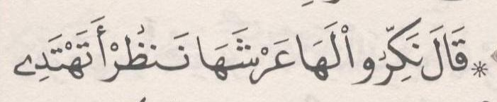 | ﺛﻣﻥ 8
ﺍﻟﺛﻣﻥ 5 ﻓﻲ ﺳﻭﺭﺓ ﺍﻟﻧﻣﻝ | ﺻﻔﺣﺔ 382 | 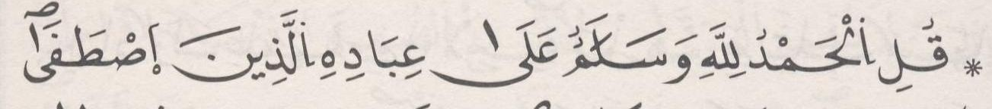 | ﺛﻣﻥ 1 | ﺣﺯﺏ 39
ﺍﻟﺛﻣﻥ 6 ﻓﻲ ﺳﻭﺭﺓ ﺍﻟﻧﻣﻝ | ﺻﻔﺣﺔ 383 | 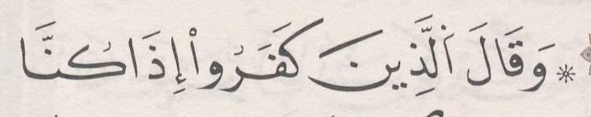 | ﺛﻣﻥ 2
ﺍﻟﺛﻣﻥ 7 ﻓﻲ ﺳﻭﺭﺓ ﺍﻟﻧﻣﻝ | ﺻﻔﺣﺔ 384 | 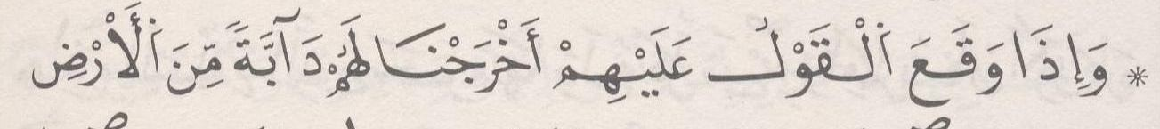 | ﺛﻣﻥ 3
[28] ﺳﻭﺭﺓ ﺍﻟﻘﺻﺹ

ﺍﻟﺛﻣﻥ 1 ﻓﻲ ﺳﻭﺭﺓ ﺍﻟﻘﺻﺹ | ﺻﻔﺣﺔ 385 | 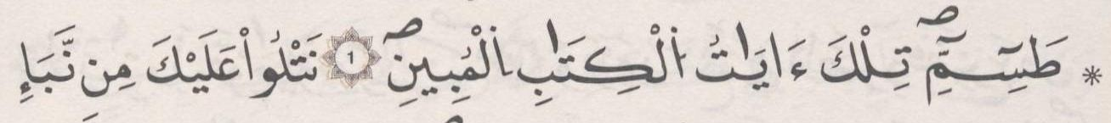 | ﺛﻣﻥ 4
ﺍﻟﺛﻣﻥ 2 ﻓﻲ ﺳﻭﺭﺓ ﺍﻟﻘﺻﺹ | ﺻﻔﺣﺔ 386 | 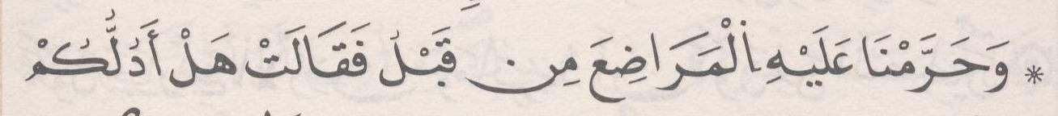 | ﺛﻣﻥ 5
ﺍﻟﺛﻣﻥ 3 ﻓﻲ ﺳﻭﺭﺓ ﺍﻟﻘﺻﺹ | ﺻﻔﺣﺔ 387 | 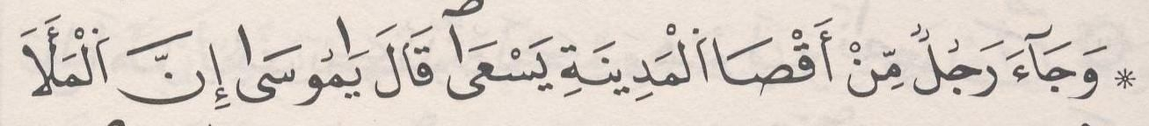 | ﺛﻣﻥ 6
ﺍﻟﺛﻣﻥ 4 ﻓﻲ ﺳﻭﺭﺓ ﺍﻟﻘﺻﺹ | ﺻﻔﺣﺔ 389 | 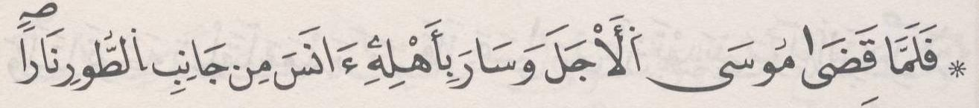 | ﺛﻣﻥ 7
ﺍﻟﺛﻣﻥ 5 ﻓﻲ ﺳﻭﺭﺓ ﺍﻟﻘﺻﺹ | ﺻﻔﺣﺔ 390 | 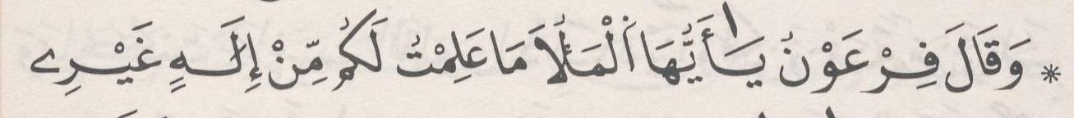 | ﺛﻣﻥ 8
ﺍﻟﺛﻣﻥ 6 ﻓﻲ ﺳﻭﺭﺓ ﺍﻟﻘﺻﺹ | ﺻﻔﺣﺔ 392 | 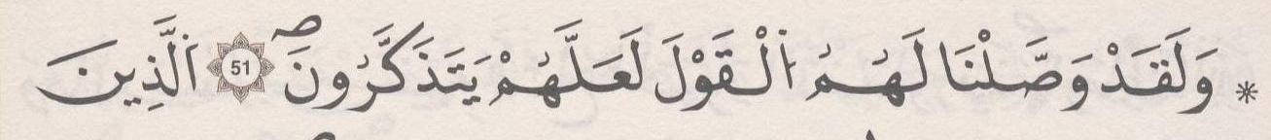 | ﺛﻣﻥ 1 | ﺣﺯﺏ 40 | ﻧﻘﺯﺓ 14

ﺍﻟﺛﻣﻥ 7 ﻓﻲ ﺳﻭﺭﺓ ﺍﻟﻘﺻﺹ | ﺻﻔﺣﺔ 393 | 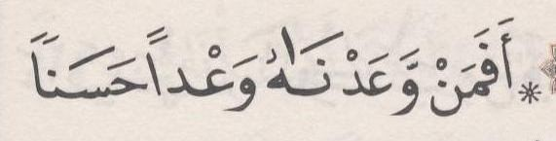 | ﺛﻣﻥ 2
ﺍﻟﺛﻣﻥ 8 ﻓﻲ ﺳﻭﺭﺓ ﺍﻟﻘﺻﺹ | ﺻﻔﺣﺔ 394 | 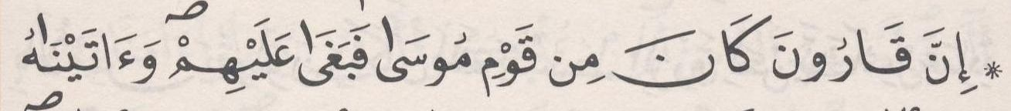 | ﺛﻣﻥ 3
ﺍﻟﺛﻣﻥ 9 ﻓﻲ ﺳﻭﺭﺓ ﺍﻟﻘﺻﺹ | ﺻﻔﺣﺔ 395 | 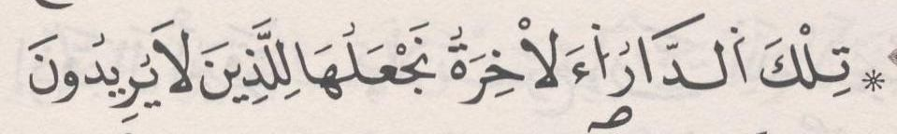 | ﺛﻣﻥ 4
[29] ﺳﻭﺭﺓ ﺍﻟﻌﻧﻛﺑﻭﺕ

ﺍﻟﺛﻣﻥ 1 ﻓﻲ ﺳﻭﺭﺓ ﺍﻟﻌﻧﻛﺑﻭﺕ | ﺻﻔﺣﺔ 397 | 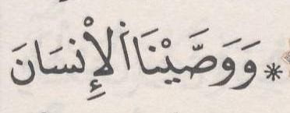 | ﺛﻣﻥ 5
ﺍﻟﺛﻣﻥ 2 ﻓﻲ ﺳﻭﺭﺓ ﺍﻟﻌﻧﻛﺑﻭﺕ | ﺻﻔﺣﺔ 398 | 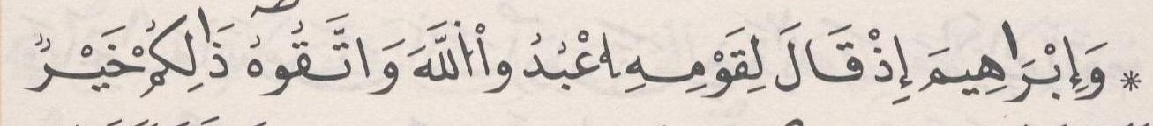 | ﺛﻣﻥ 6
ﺍﻟﺛﻣﻥ 3 ﻓﻲ ﺳﻭﺭﺓ ﺍﻟﻌﻧﻛﺑﻭﺕ | ﺻﻔﺣﺔ 399 | 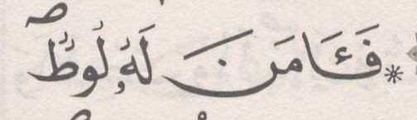 | ﺛﻣﻥ 7
ﺍﻟﺛﻣﻥ 4 ﻓﻲ ﺳﻭﺭﺓ ﺍﻟﻌﻧﻛﺑﻭﺕ | ﺻﻔﺣﺔ 400 | 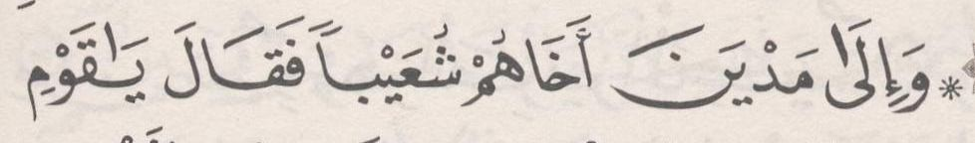 | ﺛﻣﻥ 8
ﺍﻟﺛﻣﻥ 5 ﻓﻲ ﺳﻭﺭﺓ ﺍﻟﻌﻧﻛﺑﻭﺕ | ﺻﻔﺣﺔ 402 |  | ﺛﻣﻥ 1 | ﺣﺯﺏ 41
ﺍﻟﺛﻣﻥ 6 ﻓﻲ ﺳﻭﺭﺓ ﺍﻟﻌﻧﻛﺑﻭﺕ | ﺻﻔﺣﺔ 403 | 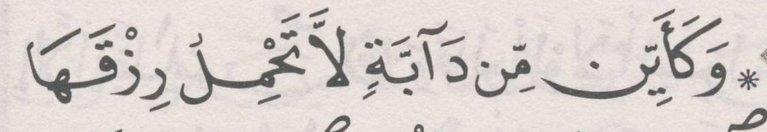 | ﺛﻣﻥ 2
[30] ﺳﻭﺭﺓ ﺍﻟﺭﻭﻡ

ﺍﻟﺛﻣﻥ 1 ﻓﻲ ﺳﻭﺭﺓ ﺍﻟﺭﻭﻡ | ﺻﻔﺣﺔ 405 | 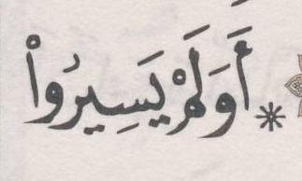 | ﺛﻣﻥ 3
ﺍﻟﺛﻣﻥ 2 ﻓﻲ ﺳﻭﺭﺓ ﺍﻟﺭﻭﻡ | ﺻﻔﺣﺔ 406 | 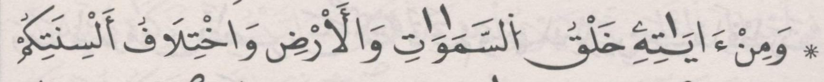 | ﺛﻣﻥ 4
ﺍﻟﺛﻣﻥ 3 ﻓﻲ ﺳﻭﺭﺓ ﺍﻟﺭﻭﻡ | ﺻﻔﺣﺔ 407 | 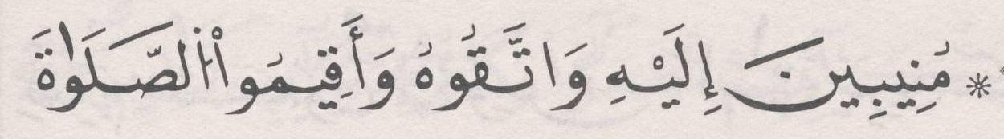 | ﺛﻣﻥ 5
ﺍﻟﺛﻣﻥ 4 ﻓﻲ ﺳﻭﺭﺓ ﺍﻟﺭﻭﻡ | ﺻﻔﺣﺔ 408 | 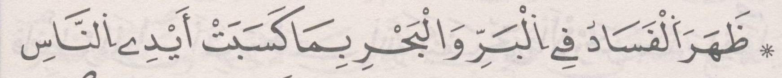 | ﺛﻣﻥ 6
ﺍﻟﺛﻣﻥ 5 ﻓﻲ ﺳﻭﺭﺓ ﺍﻟﺭﻭﻡ | ﺻﻔﺣﺔ 410 | 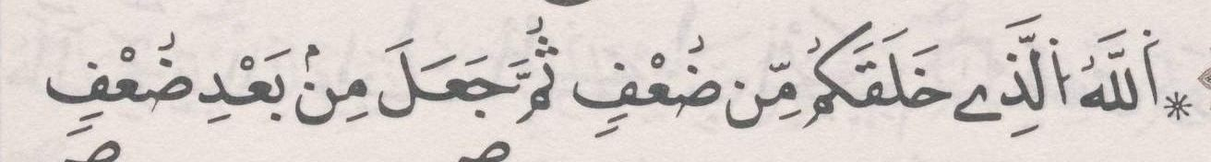 | ﺛﻣﻥ 7
[31] ﺳﻭﺭﺓ ﻟﻘﻣﺎﻥ

ﺍﻟﺛﻣﻥ 1 ﻓﻲ ﺳﻭﺭﺓ ﻟﻘﻣﺎﻥ | ﺻﻔﺣﺔ 412 | 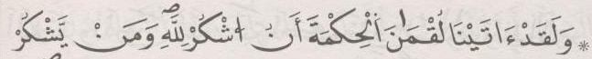 | ﺛﻣﻥ 8
ﺍﻟﺛﻣﻥ 2 ﻓﻲ ﺳﻭﺭﺓ ﻟﻘﻣﺎﻥ | ﺻﻔﺣﺔ 413 | 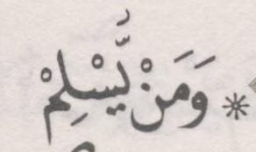 | ﺛﻣﻥ 1 | ﺣﺯﺏ 42
ﺍﻟﺛﻣﻥ 3 ﻓﻲ ﺳﻭﺭﺓ ﻟﻘﻣﺎﻥ | ﺻﻔﺣﺔ 414 | 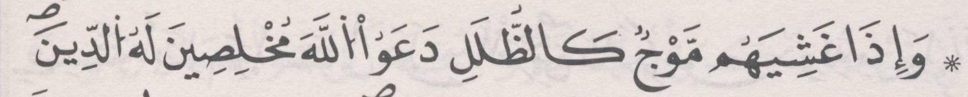 | ﺛﻣﻥ 2
[32] ﺳﻭﺭﺓ ﺍﻟﺳﺟﺩﺓ

ﺍﻟﺛﻣﻥ 1 ﻓﻲ ﺳﻭﺭﺓ ﺍﻟﺳﺟﺩﺓ | ﺻﻔﺣﺔ 415 | 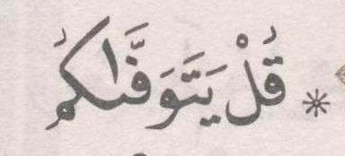 | ﺛﻣﻥ 3
ﺍﻟﺛﻣﻥ 2 ﻓﻲ ﺳﻭﺭﺓ ﺍﻟﺳﺟﺩﺓ | ﺻﻔﺣﺔ 417 | 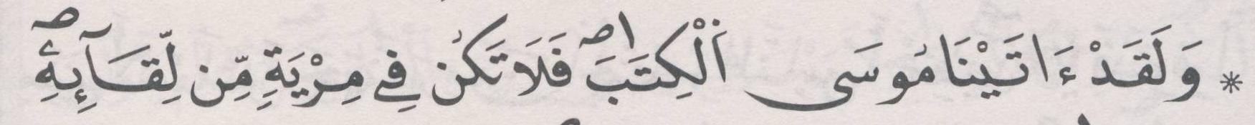 | ﺛﻣﻥ 4
[33] ﺳﻭﺭﺓ ﺍﻷﺣﺯﺍﺏ

ﺍﻟﺛﻣﻥ 1 ﻓﻲ ﺳﻭﺭﺓ ﺍﻷﺣﺯﺍﺏ | ﺻﻔﺣﺔ 418 | 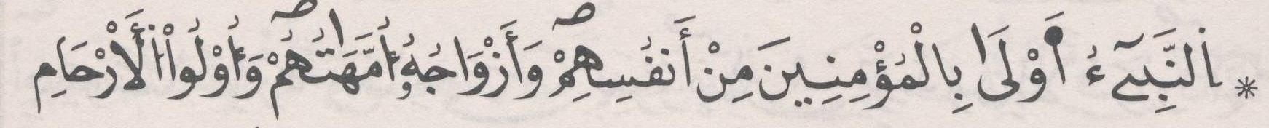 | ﺛﻣﻥ 5
ﺍﻟﺛﻣﻥ 2 ﻓﻲ ﺳﻭﺭﺓ ﺍﻷﺣﺯﺍﺏ | ﺻﻔﺣﺔ 419 | 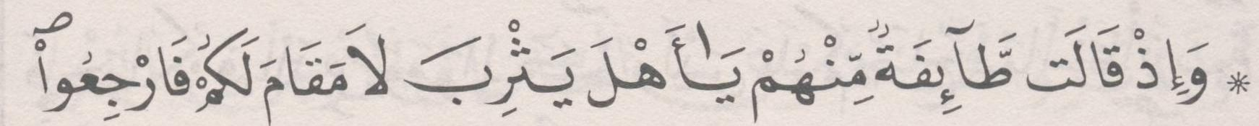 | ﺛﻣﻥ 6
ﺍﻟﺛﻣﻥ 3 ﻓﻲ ﺳﻭﺭﺓ ﺍﻷﺣﺯﺍﺏ | ﺻﻔﺣﺔ 420 | 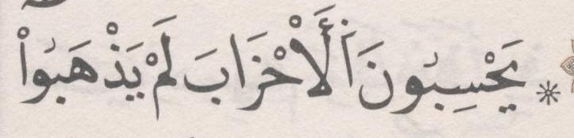 | ﺛﻣﻥ 7
ﺍﻟﺛﻣﻥ 4 ﻓﻲ ﺳﻭﺭﺓ ﺍﻷﺣﺯﺍﺏ | ﺻﻔﺣﺔ 422 | 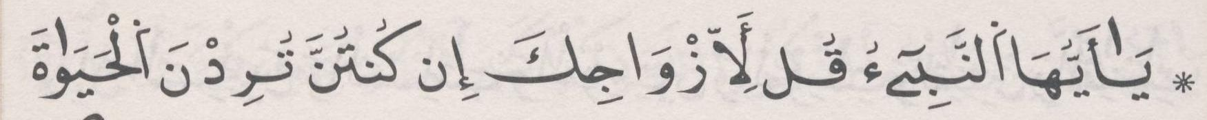 | ﺛﻣﻥ 8
ﺍﻟﺛﻣﻥ 5 ﻓﻲ ﺳﻭﺭﺓ ﺍﻷﺣﺯﺍﺏ | ﺻﻔﺣﺔ 423 |  | ﺛﻣﻥ 1 | ﺣﺯﺏ 43 | ﻧﻘﺯﺓ 15
ﺍﻟﺛﻣﻥ 6 ﻓﻲ ﺳﻭﺭﺓ ﺍﻷﺣﺯﺍﺏ | ﺻﻔﺣﺔ 423 | 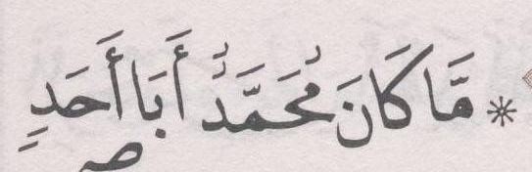 | ﺛﻣﻥ 2
ﺍﻟﺛﻣﻥ 7 ﻓﻲ ﺳﻭﺭﺓ ﺍﻷﺣﺯﺍﺏ | ﺻﻔﺣﺔ 425 |  | ﺛﻣﻥ 3
ﺍﻟﺛﻣﻥ 8 ﻓﻲ ﺳﻭﺭﺓ ﺍﻷﺣﺯﺍﺏ | ﺻﻔﺣﺔ 426 |  | ﺛﻣﻥ 4
ﺍﻟﺛﻣﻥ 9 ﻓﻲ ﺳﻭﺭﺓ ﺍﻷﺣﺯﺍﺏ | ﺻﻔﺣﺔ 426 | 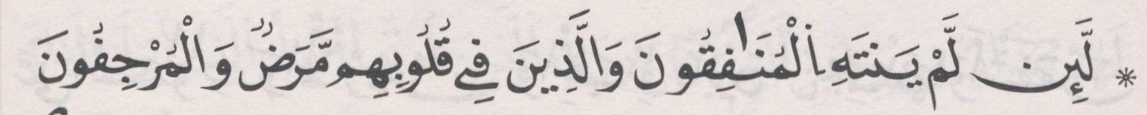 | ﺛﻣﻥ 5
ﺍﻟﺛﻣﻥ 10 ﻓﻲ ﺳﻭﺭﺓ ﺍﻷﺣﺯﺍﺏ | ﺻﻔﺣﺔ 427 | 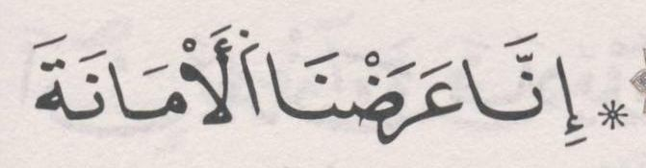 | ﺛﻣﻥ 6
[34] ﺳﻭﺭﺓ ﺳﺑﺄ

ﺍﻟﺛﻣﻥ 1 ﻓﻲ ﺳﻭﺭﺓ ﺳﺑﺄ | ﺻﻔﺣﺔ 428 |  | ﺛﻣﻥ 7
ﺍﻟﺛﻣﻥ 2 ﻓﻲ ﺳﻭﺭﺓ ﺳﺑﺄ | ﺻﻔﺣﺔ 430 |  | ﺛﻣﻥ 8
ﺍﻟﺛﻣﻥ 3 ﻓﻲ ﺳﻭﺭﺓ ﺳﺑﺄ | ﺻﻔﺣﺔ 431 | 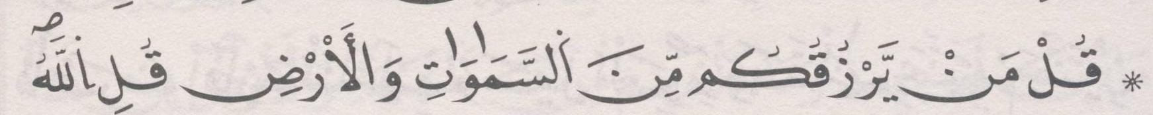 | ﺛﻣﻥ 1 | ﺣﺯﺏ 44
ﺍﻟﺛﻣﻥ 4 ﻓﻲ ﺳﻭﺭﺓ ﺳﺑﺄ | ﺻﻔﺣﺔ 432 | 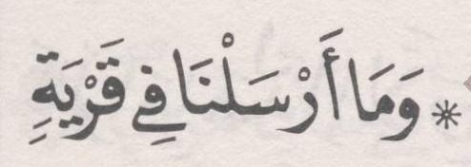 | ﺛﻣﻥ 2
ﺍﻟﺛﻣﻥ 5 ﻓﻲ ﺳﻭﺭﺓ ﺳﺑﺄ | ﺻﻔﺣﺔ 433 |  | ﺛﻣﻥ 3
[35] ﺳﻭﺭﺓ ﻓﺎﻁﺭ

ﺍﻟﺛﻣﻥ 1 ﻓﻲ ﺳﻭﺭﺓ ﻓﺎﻁﺭ | ﺻﻔﺣﺔ 435 | 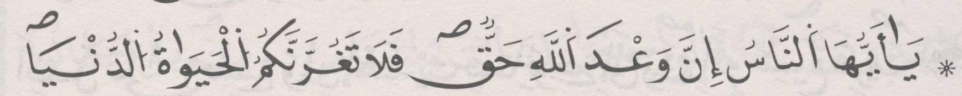 | ﺛﻣﻥ 4
ﺍﻟﺛﻣﻥ 2 ﻓﻲ ﺳﻭﺭﺓ ﻓﺎﻁﺭ | ﺻﻔﺣﺔ 436 | 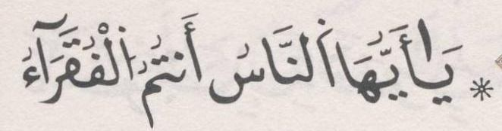 | ﺛﻣﻥ 5
ﺍﻟﺛﻣﻥ 3 ﻓﻲ ﺳﻭﺭﺓ ﻓﺎﻁﺭ | ﺻﻔﺣﺔ 438 | 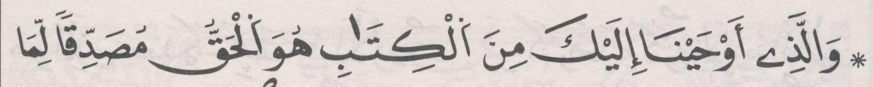 | ﺛﻣﻥ 6
ﺍﻟﺛﻣﻥ 4 ﻓﻲ ﺳﻭﺭﺓ ﻓﺎﻁﺭ | ﺻﻔﺣﺔ 439 |  | ﺛﻣﻥ 7
[36] ﺳﻭﺭﺓ ﻳﺱ

ﺍﻟﺛﻣﻥ 1 ﻓﻲ ﺳﻭﺭﺓ ﻳﺱ | ﺻﻔﺣﺔ 440 | 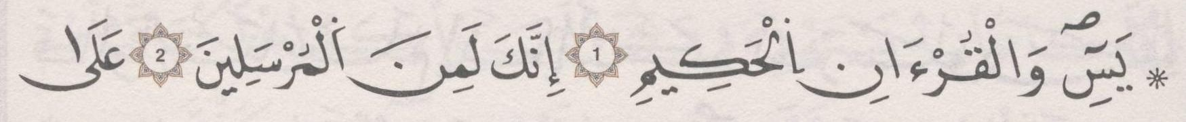 | ﺛﻣﻥ 8
ﺍﻟﺛﻣﻥ 2 ﻓﻲ ﺳﻭﺭﺓ ﻳﺱ | ﺻﻔﺣﺔ 442 |  | ﺛﻣﻥ 1 | ﺣﺯﺏ 45

ﺍﻟﺛﻣﻥ 3 ﻓﻲ ﺳﻭﺭﺓ ﻳﺱ | ﺻﻔﺣﺔ 443 | 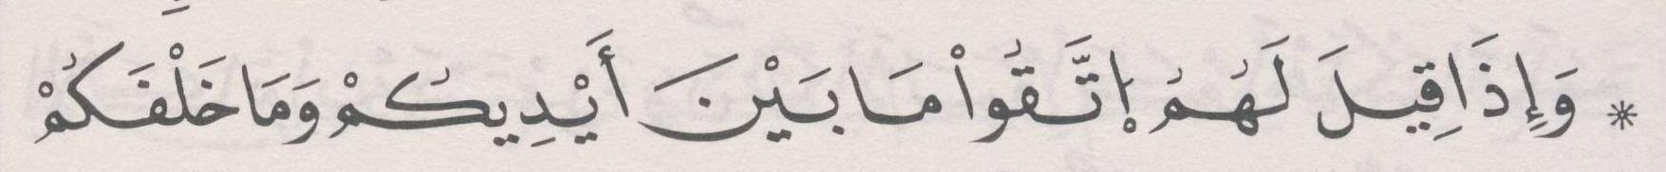 | ﺛﻣﻥ 2
ﺍﻟﺛﻣﻥ 4 ﻓﻲ ﺳﻭﺭﺓ ﻳﺱ | ﺻﻔﺣﺔ 444 | 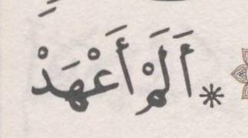 | ﺛﻣﻥ 3
ﺍﻟﺛﻣﻥ 5 ﻓﻲ ﺳﻭﺭﺓ ﻳﺱ | ﺻﻔﺣﺔ 445 | 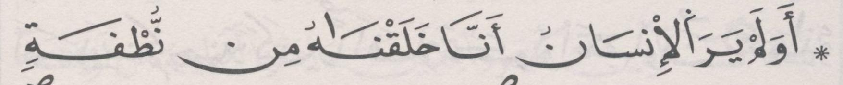 | ﺛﻣﻥ 4
[37] ﺳﻭﺭﺓ ﺍﻟﺻﺎﻓﺎﺕ

ﺍﻟﺛﻣﻥ 1 ﻓﻲ ﺳﻭﺭﺓ ﺍﻟﺻﺎﻓﺎﺕ | ﺻﻔﺣﺔ 446 | 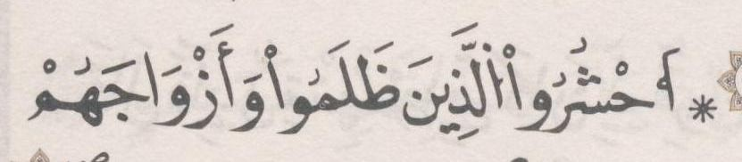 | ﺛﻣﻥ 5
ﺍﻟﺛﻣﻥ 2 ﻓﻲ ﺳﻭﺭﺓ ﺍﻟﺻﺎﻓﺎﺕ | ﺻﻔﺣﺔ 447 |  | ﺛﻣﻥ 6
ﺍﻟﺛﻣﻥ 3 ﻓﻲ ﺳﻭﺭﺓ ﺍﻟﺻﺎﻓﺎﺕ | ﺻﻔﺣﺔ 448 | 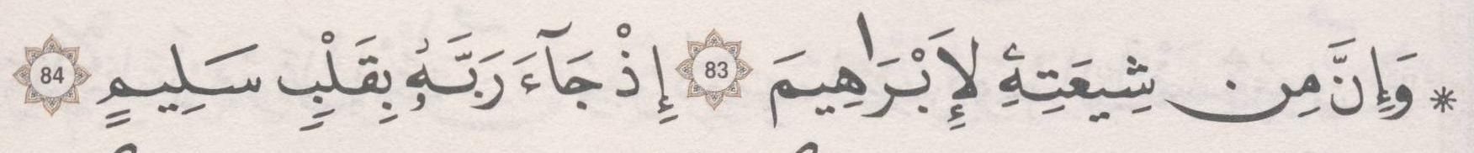 | ﺛﻣﻥ 7
ﺍﻟﺛﻣﻥ 4 ﻓﻲ ﺳﻭﺭﺓ ﺍﻟﺻﺎﻓﺎﺕ | ﺻﻔﺣﺔ 449 | 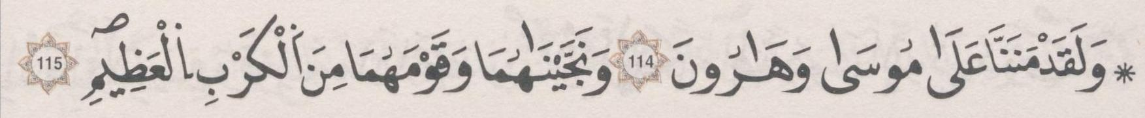 | ﺛﻣﻥ 8
ﺍﻟﺛﻣﻥ 5 ﻓﻲ ﺳﻭﺭﺓ ﺍﻟﺻﺎﻓﺎﺕ | ﺻﻔﺣﺔ 451 |  | ﺛﻣﻥ 1 | ﺣﺯﺏ 46 | ﻧﻘﺯﺓ 16
[38] ﺳﻭﺭﺓ ﺹ

ﺍﻟﺛﻣﻥ 1 ﻓﻲ ﺳﻭﺭﺓ ﺹ | ﺻﻔﺣﺔ 452 |  | ﺛﻣﻥ 2
ﺍﻟﺛﻣﻥ 2 ﻓﻲ ﺳﻭﺭﺓ ﺹ | ﺻﻔﺣﺔ 453 | 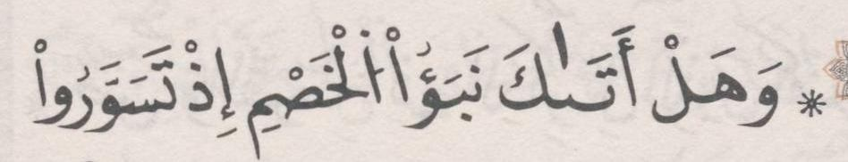 | ﺛﻣﻥ 3
ﺍﻟﺛﻣﻥ 3 ﻓﻲ ﺳﻭﺭﺓ ﺹ | ﺻﻔﺣﺔ 454 | 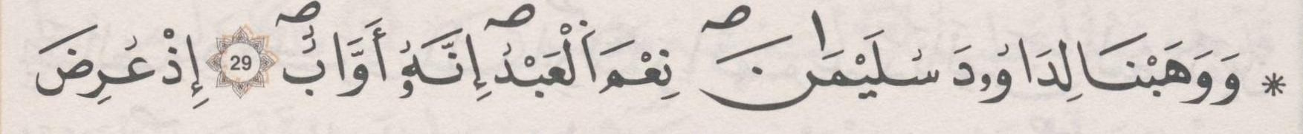 | ﺛﻣﻥ 4
ﺍﻟﺛﻣﻥ 4 ﻓﻲ ﺳﻭﺭﺓ ﺹ | ﺻﻔﺣﺔ 455 | 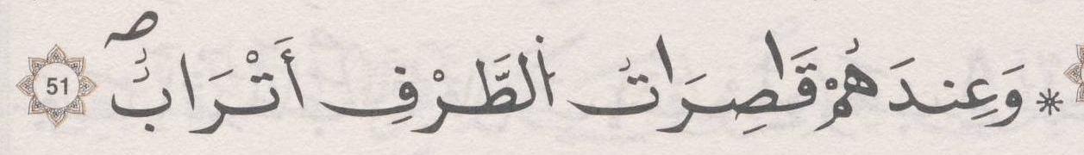 | ﺛﻣﻥ 5
ﺍﻟﺛﻣﻥ 5 ﻓﻲ ﺳﻭﺭﺓ ﺹ | ﺻﻔﺣﺔ 457 | 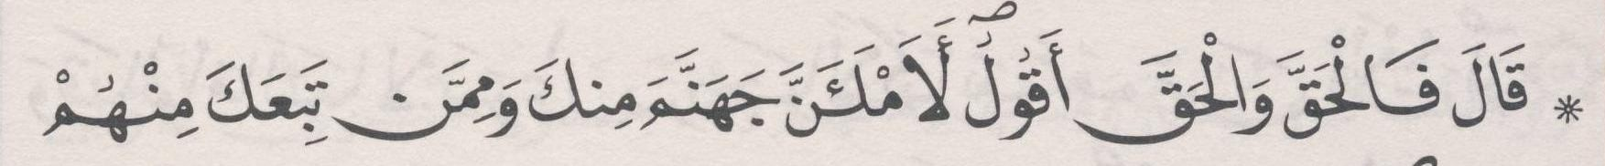 | ﺛﻣﻥ 6
[39] ﺳﻭﺭﺓ ﺍﻟﺯﻣﺭ

ﺍﻟﺛﻣﻥ 1 ﻓﻲ ﺳﻭﺭﺓ ﺍﻟﺯﻣﺭ | ﺻﻔﺣﺔ 458 | 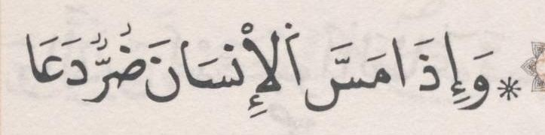 | ﺛﻣﻥ 7
ﺍﻟﺛﻣﻥ 2 ﻓﻲ ﺳﻭﺭﺓ ﺍﻟﺯﻣﺭ | ﺻﻔﺣﺔ 459 |  | ﺛﻣﻥ 8
ﺍﻟﺛﻣﻥ 3 ﻓﻲ ﺳﻭﺭﺓ ﺍﻟﺯﻣﺭ | ﺻﻔﺣﺔ 461 | 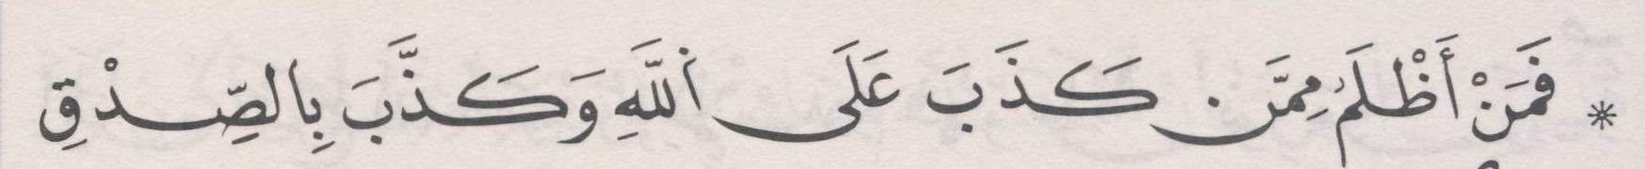 | ﺛﻣﻥ 1 | ﺣﺯﺏ 47
ﺍﻟﺛﻣﻥ 4 ﻓﻲ ﺳﻭﺭﺓ ﺍﻟﺯﻣﺭ | ﺻﻔﺣﺔ 462 | 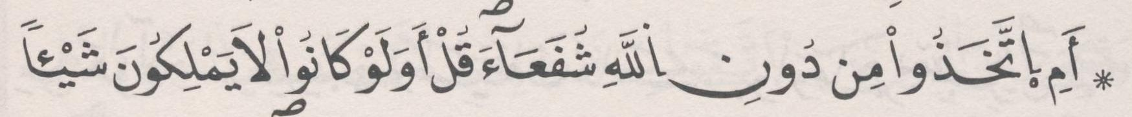 | ﺛﻣﻥ 2
ﺍﻟﺛﻣﻥ 5 ﻓﻲ ﺳﻭﺭﺓ ﺍﻟﺯﻣﺭ | ﺻﻔﺣﺔ 463 | 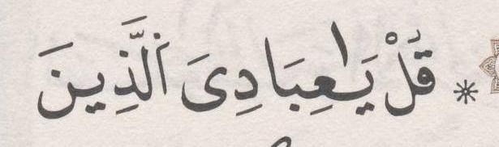 | ﺛﻣﻥ 3
ﺍﻟﺛﻣﻥ 6 ﻓﻲ ﺳﻭﺭﺓ ﺍﻟﺯﻣﺭ | ﺻﻔﺣﺔ 464 |  | ﺛﻣﻥ 4
[40] ﺳﻭﺭﺓ ﻏﺎﻓﺭ

ﺍﻟﺛﻣﻥ 1 ﻓﻲ ﺳﻭﺭﺓ ﻏﺎﻓﺭ | ﺻﻔﺣﺔ 466 | 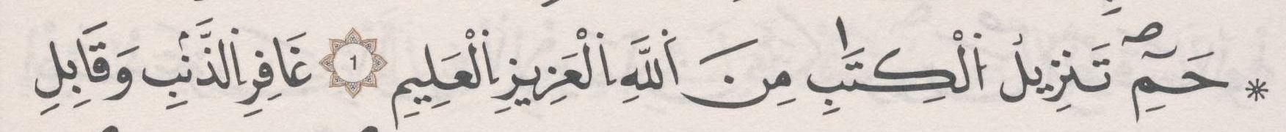 | ﺛﻣﻥ 5

ﺍﻟﺛﻣﻥ 2 ﻓﻲ ﺳﻭﺭﺓ ﻏﺎﻓﺭ | ﺻﻔﺣﺔ 467 |  | ﺛﻣﻥ 6
ﺍﻟﺛﻣﻥ 3 ﻓﻲ ﺳﻭﺭﺓ ﻏﺎﻓﺭ | ﺻﻔﺣﺔ 468 |  | ﺛﻣﻥ 7
ﺍﻟﺛﻣﻥ 4 ﻓﻲ ﺳﻭﺭﺓ ﻏﺎﻓﺭ | ﺻﻔﺣﺔ 469 | 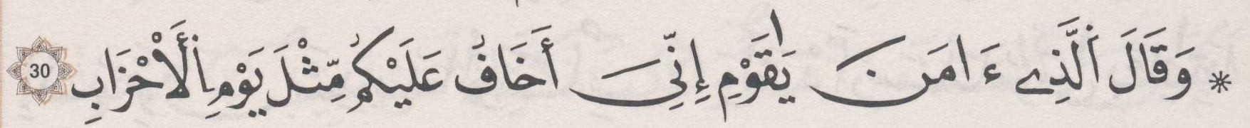 | ﺛﻣﻥ 8
ﺍﻟﺛﻣﻥ 5 ﻓﻲ ﺳﻭﺭﺓ ﻏﺎﻓﺭ | ﺻﻔﺣﺔ 471 | 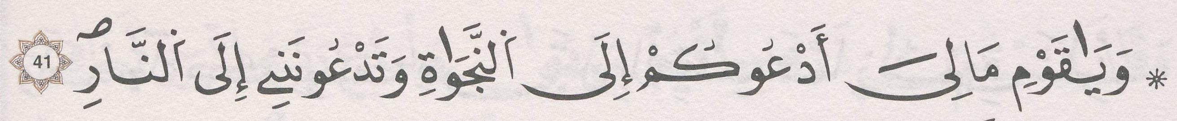 | ﺛﻣﻥ 1 | ﺣﺯﺏ 48
ﺍﻟﺛﻣﻥ 6 ﻓﻲ ﺳﻭﺭﺓ ﻏﺎﻓﺭ | ﺻﻔﺣﺔ 472 | 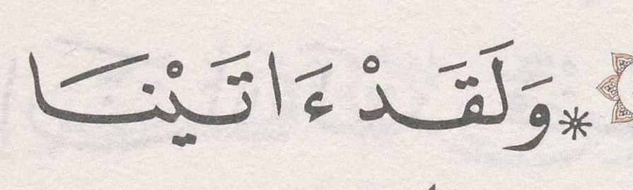 | ﺛﻣﻥ 2
ﺍﻟﺛﻣﻥ 7 ﻓﻲ ﺳﻭﺭﺓ ﻏﺎﻓﺭ | ﺻﻔﺣﺔ 473 | 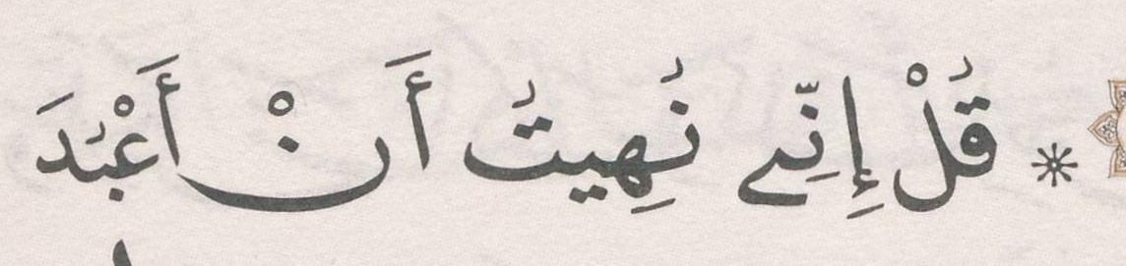 | ﺛﻣﻥ 3
ﺍﻟﺛﻣﻥ 8 ﻓﻲ ﺳﻭﺭﺓ ﻏﺎﻓﺭ | ﺻﻔﺣﺔ 475 | 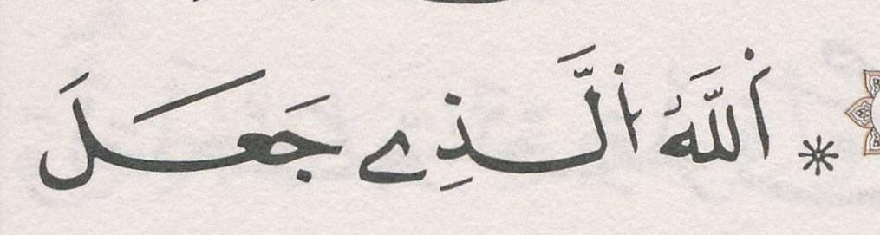 | ﺛﻣﻥ 4
[41] ﺳﻭﺭﺓ ﻓﺻﻠﺕ

ﺍﻟﺛﻣﻥ 1 ﻓﻲ ﺳﻭﺭﺓ ﻓﺻﻠﺕ | ﺻﻔﺣﺔ 476 | 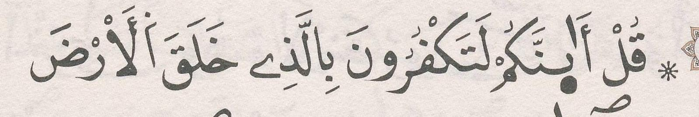 | ﺛﻣﻥ 5
ﺍﻟﺛﻣﻥ 2 ﻓﻲ ﺳﻭﺭﺓ ﻓﺻﻠﺕ | ﺻﻔﺣﺔ 477 | 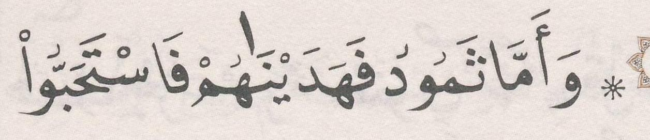 | ﺛﻣﻥ 6
ﺍﻟﺛﻣﻥ 3 ﻓﻲ ﺳﻭﺭﺓ ﻓﺻﻠﺕ | ﺻﻔﺣﺔ 478 |  | ﺛﻣﻥ 7
ﺍﻟﺛﻣﻥ 4 ﻓﻲ ﺳﻭﺭﺓ ﻓﺻﻠﺕ | ﺻﻔﺣﺔ 479 | 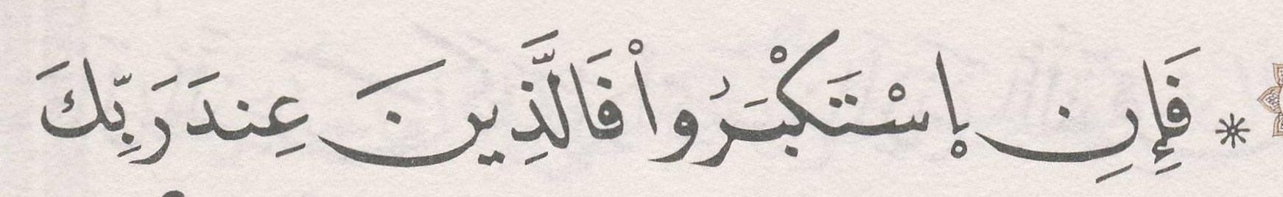 | ﺛﻣﻥ 8
ﺍﻟﺛﻣﻥ 5 ﻓﻲ ﺳﻭﺭﺓ ﻓﺻﻠﺕ | ﺻﻔﺣﺔ 481 |  | ﺛﻣﻥ 1 | ﺣﺯﺏ 49 | ﻧﻘﺯﺓ 17
[42] ﺳﻭﺭﺓ ﺍﻟﺷﻭﺭﻯ

ﺍﻟﺛﻣﻥ 1 ﻓﻲ ﺳﻭﺭﺓ ﺍﻟﺷﻭﺭﻯ | ﺻﻔﺣﺔ 482 | 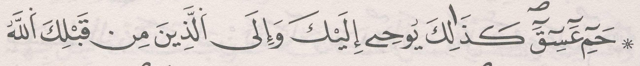 | ﺛﻣﻥ 2
ﺍﻟﺛﻣﻥ 2 ﻓﻲ ﺳﻭﺭﺓ ﺍﻟﺷﻭﺭﻯ | ﺻﻔﺣﺔ 483 | 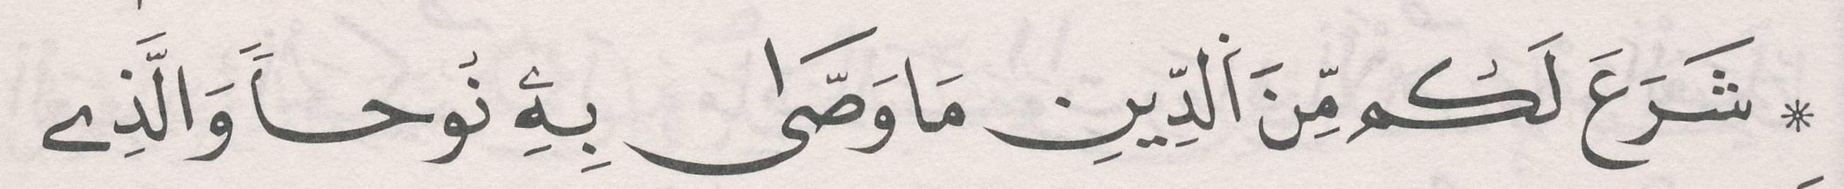 | ﺛﻣﻥ 3
ﺍﻟﺛﻣﻥ 3 ﻓﻲ ﺳﻭﺭﺓ ﺍﻟﺷﻭﺭﻯ | ﺻﻔﺣﺔ 484 | 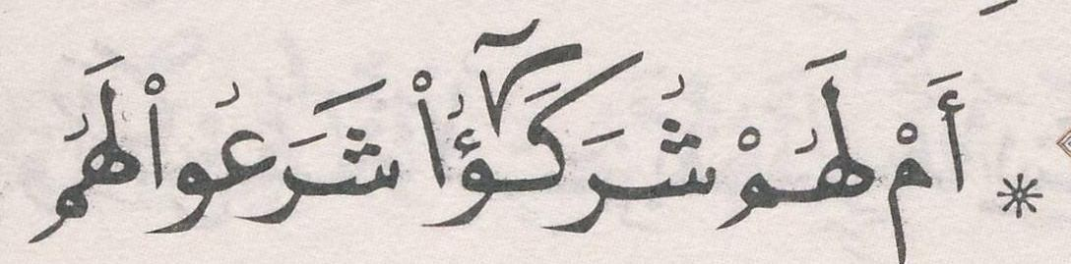 | ﺛﻣﻥ 4
ﺍﻟﺛﻣﻥ 4 ﻓﻲ ﺳﻭﺭﺓ ﺍﻟﺷﻭﺭﻯ | ﺻﻔﺣﺔ 486 | 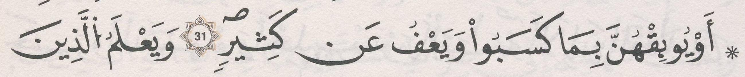 | ﺛﻣﻥ 5
ﺍﻟﺛﻣﻥ 5 ﻓﻲ ﺳﻭﺭﺓ ﺍﻟﺷﻭﺭﻯ | ﺻﻔﺣﺔ 486 | 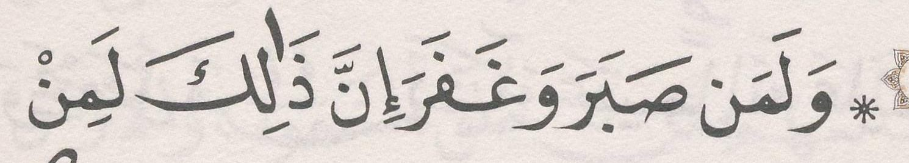 | ﺛﻣﻥ 6
ﺍﻟﺛﻣﻥ 6 ﻓﻲ ﺳﻭﺭﺓ ﺍﻟﺷﻭﺭﻯ | ﺻﻔﺣﺔ 487 | 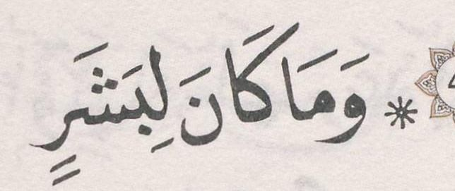 | ﺛﻣﻥ 7
[43] ﺳﻭﺭﺓ ﺍﻟﺯﺧﺭﻑ

ﺍﻟﺛﻣﻥ 1 ﻓﻲ ﺳﻭﺭﺓ ﺍﻟﺯﺧﺭﻑ | ﺻﻔﺣﺔ 489 |  | ﺛﻣﻥ 8
ﺍﻟﺛﻣﻥ 2 ﻓﻲ ﺳﻭﺭﺓ ﺍﻟﺯﺧﺭﻑ | ﺻﻔﺣﺔ 490 | 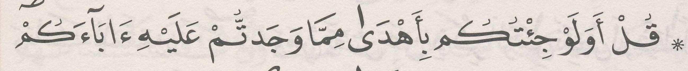 | ﺛﻣﻥ 1 | ﺣﺯﺏ 50
ﺍﻟﺛﻣﻥ 3 ﻓﻲ ﺳﻭﺭﺓ ﺍﻟﺯﺧﺭﻑ | ﺻﻔﺣﺔ 491 | 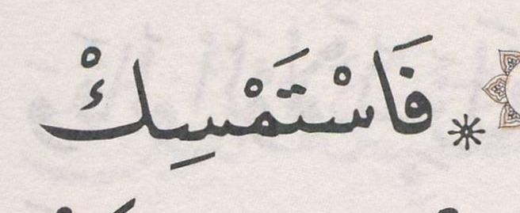 | ﺛﻣﻥ 2

ﺍﻟﺛﻣﻥ 4 ﻓﻲ ﺳﻭﺭﺓ ﺍﻟﺯﺧﺭﻑ | ﺻﻔﺣﺔ 493 | 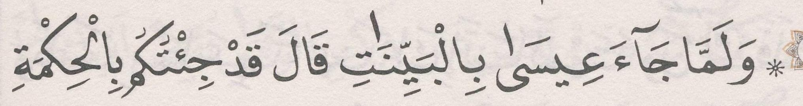 | ﺛﻣﻥ 3
ﺍﻟﺛﻣﻥ 5 ﻓﻲ ﺳﻭﺭﺓ ﺍﻟﺯﺧﺭﻑ | ﺻﻔﺣﺔ 494 | 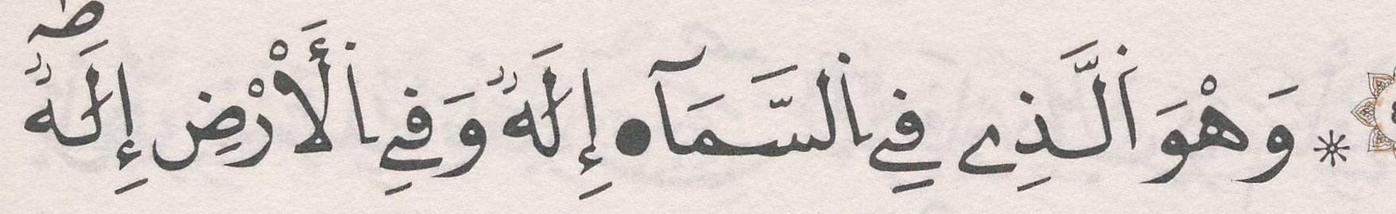 | ﺛﻣﻥ 4
[44] ﺳﻭﺭﺓ ﺍﻟﺩﺧﺎﻥ

ﺍﻟﺛﻣﻥ 1 ﻓﻲ ﺳﻭﺭﺓ ﺍﻟﺩﺧﺎﻥ | ﺻﻔﺣﺔ 496 | 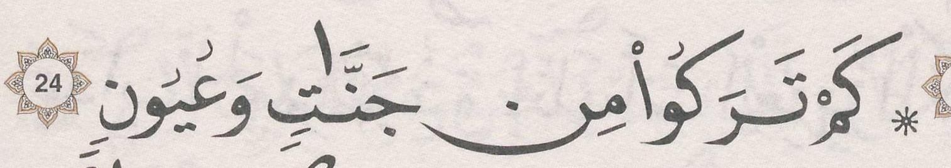 | ﺛﻣﻥ 5
ﺍﻟﺛﻣﻥ 2 ﻓﻲ ﺳﻭﺭﺓ ﺍﻟﺩﺧﺎﻥ | ﺻﻔﺣﺔ 497 | 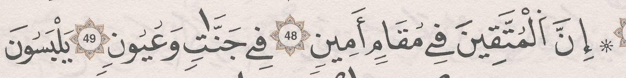 | ﺛﻣﻥ 6
[45] ﺳﻭﺭﺓ ﺍﻟﺟﺎﺛﻳﺔ

ﺍﻟﺛﻣﻥ 1 ﻓﻲ ﺳﻭﺭﺓ ﺍﻟﺟﺎﺛﻳﺔ | ﺻﻔﺣﺔ 498 | 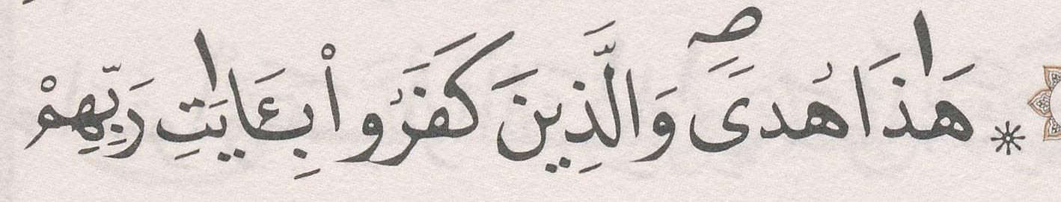 | ﺛﻣﻥ 7
ﺍﻟﺛﻣﻥ 2 ﻓﻲ ﺳﻭﺭﺓ ﺍﻟﺟﺎﺛﻳﺔ | ﺻﻔﺣﺔ 499 | 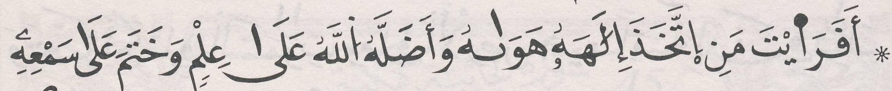 | ﺛﻣﻥ 8
[46] ﺳﻭﺭﺓ ﺍﻷﺣﻘﺎﻑ

ﺍﻟﺛﻣﻥ 1 ﻓﻲ ﺳﻭﺭﺓ ﺍﻷﺣﻘﺎﻑ | ﺻﻔﺣﺔ 501 | 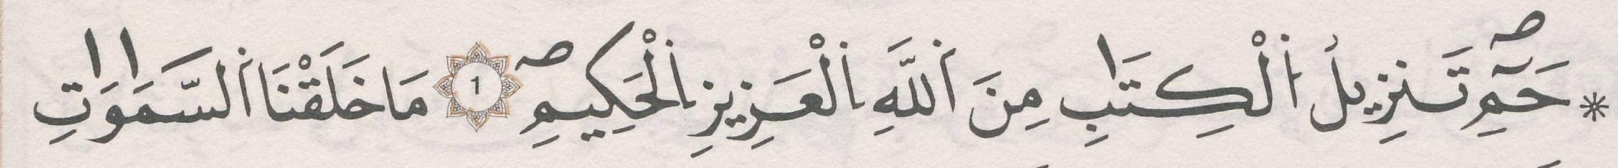 | ﺛﻣﻥ 1 | ﺣﺯﺏ 51
ﺍﻟﺛﻣﻥ 2 ﻓﻲ ﺳﻭﺭﺓ ﺍﻷﺣﻘﺎﻑ | ﺻﻔﺣﺔ 502 | 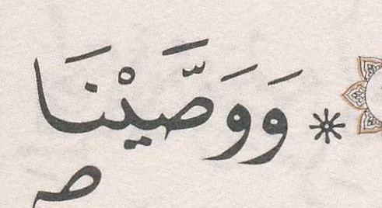 | ﺛﻣﻥ 2
ﺍﻟﺛﻣﻥ 3 ﻓﻲ ﺳﻭﺭﺓ ﺍﻷﺣﻘﺎﻑ | ﺻﻔﺣﺔ 503 | 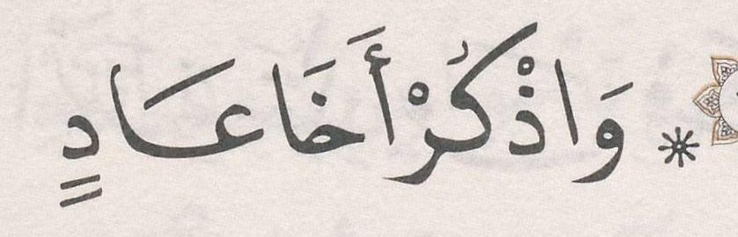 | ﺛﻣﻥ 3
ﺍﻟﺛﻣﻥ 4 ﻓﻲ ﺳﻭﺭﺓ ﺍﻷﺣﻘﺎﻑ | ﺻﻔﺣﺔ 504 | 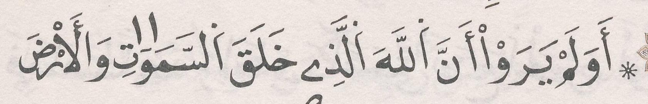 | ﺛﻣﻥ 4
[47] ﺳﻭﺭﺓ ﻣﺣﻣﺩ

ﺍﻟﺛﻣﻥ 1 ﻓﻲ ﺳﻭﺭﺓ ﻣﺣﻣﺩ | ﺻﻔﺣﺔ 506 | 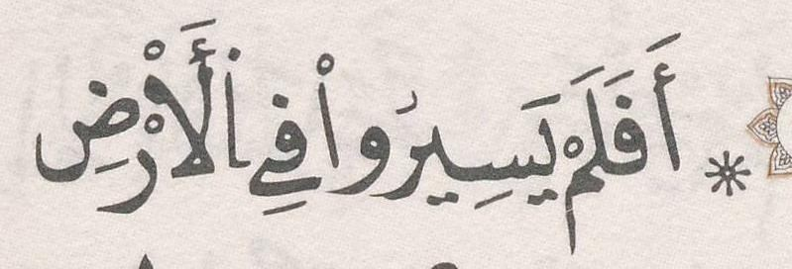 | ﺛﻣﻥ 5
ﺍﻟﺛﻣﻥ 2 ﻓﻲ ﺳﻭﺭﺓ ﻣﺣﻣﺩ | ﺻﻔﺣﺔ 507 | 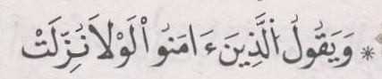 | ﺛﻣﻥ 6
ﺍﻟﺛﻣﻥ 3 ﻓﻲ ﺳﻭﺭﺓ ﻣﺣﻣﺩ | ﺻﻔﺣﺔ 508 | 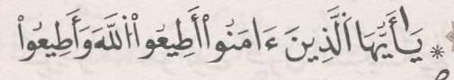 | ﺛﻣﻥ 7
[48] ﺳﻭﺭﺓ ﺍﻟﻔﺗﺢ

ﺍﻟﺛﻣﻥ 1 ﻓﻲ ﺳﻭﺭﺓ ﺍﻟﻔﺗﺢ | ﺻﻔﺣﺔ 509 | 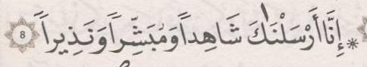 | ﺛﻣﻥ 8
ﺍﻟﺛﻣﻥ 2 ﻓﻲ ﺳﻭﺭﺓ ﺍﻟﻔﺗﺢ | ﺻﻔﺣﺔ 511 | 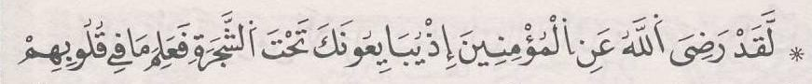 | ﺛﻣﻥ 1 | ﺣﺯﺏ 52 | ﻧﻘﺯﺓ 18
ﺍﻟﺛﻣﻥ 3 ﻓﻲ ﺳﻭﺭﺓ ﺍﻟﻔﺗﺢ | ﺻﻔﺣﺔ 512 | 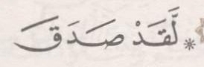 | ﺛﻣﻥ 2
[49] ﺳﻭﺭﺓ ﺍﻟﺣﺟﺭﺍﺕ

ﺍﻟﺛﻣﻥ 1 ﻓﻲ ﺳﻭﺭﺓ ﺍﻟﺣﺟﺭﺍﺕ | ﺻﻔﺣﺔ 513 |  | ﺛﻣﻥ 3

ﺍﻟﺛﻣﻥ 2 ﻓﻲ ﺳﻭﺭﺓ ﺍﻟﺣﺟﺭﺍﺕ | ﺻﻔﺣﺔ 514 | 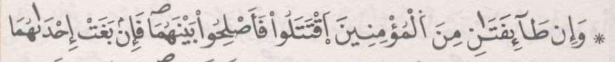 | ﺛﻣﻥ 4
ﺍﻟﺛﻣﻥ 3 ﻓﻲ ﺳﻭﺭﺓ ﺍﻟﺣﺟﺭﺍﺕ | ﺻﻔﺣﺔ 514 | 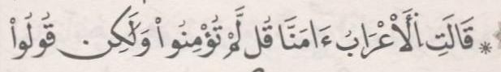 | ﺛﻣﻥ 5
[50] ﺳﻭﺭﺓ ﻕ

ﺍﻟﺛﻣﻥ 1 ﻓﻲ ﺳﻭﺭﺓ ﻕ | ﺻﻔﺣﺔ 515 | 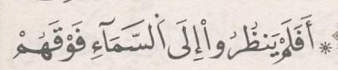 | ﺛﻣﻥ 6
ﺍﻟﺛﻣﻥ 2 ﻓﻲ ﺳﻭﺭﺓ ﻕ | ﺻﻔﺣﺔ 516 | 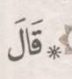 | ﺛﻣﻥ 7
[51] ﺳﻭﺭﺓ ﺍﻟﺫﺍﺭﻳﺎﺕ

ﺍﻟﺛﻣﻥ 1 ﻓﻲ ﺳﻭﺭﺓ ﺍﻟﺫﺍﺭﻳﺎﺕ | ﺻﻔﺣﺔ 517 | 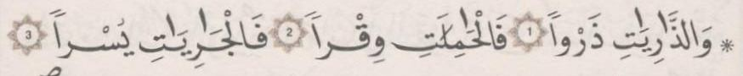 | ﺛﻣﻥ 8
ﺍﻟﺛﻣﻥ 2 ﻓﻲ ﺳﻭﺭﺓ ﺍﻟﺫﺍﺭﻳﺎﺕ | ﺻﻔﺣﺔ 519 | 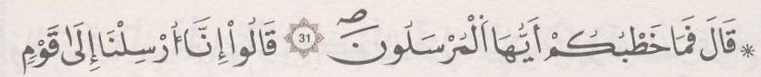 | ﺛﻣﻥ 1 | ﺣﺯﺏ 53
ﺍﻟﺛﻣﻥ 3 ﻓﻲ ﺳﻭﺭﺓ ﺍﻟﺫﺍﺭﻳﺎﺕ | ﺻﻔﺣﺔ 520 | 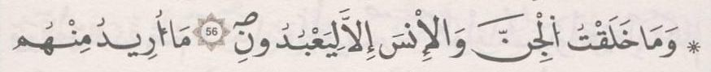 | ﺛﻣﻥ 2
[52] ﺳﻭﺭﺓ ﺍﻟﻁﻭﺭ

ﺍﻟﺛﻣﻥ 1 ﻓﻲ ﺳﻭﺭﺓ ﺍﻟﻁﻭﺭ | ﺻﻔﺣﺔ 521 | 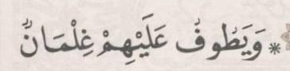 | ﺛﻣﻥ 3
ﺍﻟﺛﻣﻥ 2 ﻓﻲ ﺳﻭﺭﺓ ﺍﻟﻁﻭﺭ | ﺻﻔﺣﺔ 522 | 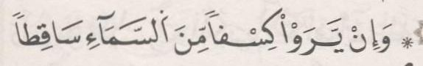 | ﺛﻣﻥ 4
[53] ﺳﻭﺭﺓ ﺍﻟﻧﺟﻡ

ﺍﻟﺛﻣﻥ 1 ﻓﻲ ﺳﻭﺭﺓ ﺍﻟﻧﺟﻡ | ﺻﻔﺣﺔ 523 | 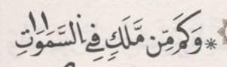 | ﺛﻣﻥ 5
ﺍﻟﺛﻣﻥ 2 ﻓﻲ ﺳﻭﺭﺓ ﺍﻟﻧﺟﻡ | ﺻﻔﺣﺔ 525 | 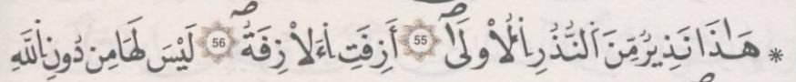 | ﺛﻣﻥ 6
[54] ﺳﻭﺭﺓ ﺍﻟﻘﻣﺭ

ﺍﻟﺛﻣﻥ 1 ﻓﻲ ﺳﻭﺭﺓ ﺍﻟﻘﻣﺭ | ﺻﻔﺣﺔ 526 | 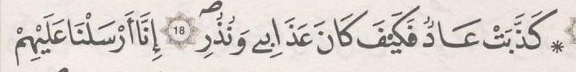 | ﺛﻣﻥ 7
ﺍﻟﺛﻣﻥ 2 ﻓﻲ ﺳﻭﺭﺓ ﺍﻟﻘﻣﺭ | ﺻﻔﺣﺔ 527 | 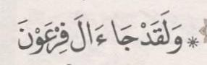 | ﺛﻣﻥ 8
[55] ﺳﻭﺭﺓ ﺍﻟﺭﺣﻣﻥ

ﺍﻟﺛﻣﻥ 1 ﻓﻲ ﺳﻭﺭﺓ ﺍﻟﺭﺣﻣﻥ | ﺻﻔﺣﺔ 528 | 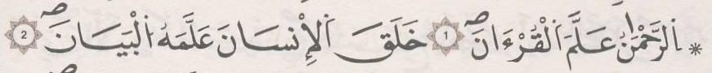 | ﺛﻣﻥ 1 | ﺣﺯﺏ 54
ﺍﻟﺛﻣﻥ 2 ﻓﻲ ﺳﻭﺭﺓ ﺍﻟﺭﺣﻣﻥ | ﺻﻔﺣﺔ 529 | 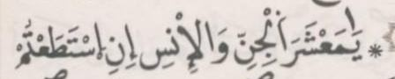 | ﺛﻣﻥ 2
ﺍﻟﺛﻣﻥ 3 ﻓﻲ ﺳﻭﺭﺓ ﺍﻟﺭﺣﻣﻥ | ﺻﻔﺣﺔ 530 | 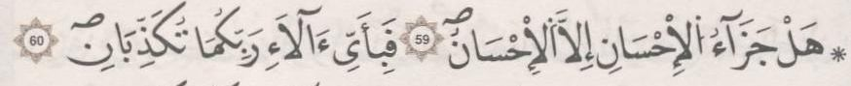 | ﺛﻣﻥ 3
[56] ﺳﻭﺭﺓ ﺍﻟﻭﺍﻗﻌﺔ

ﺍﻟﺛﻣﻥ 1 ﻓﻲ ﺳﻭﺭﺓ ﺍﻟﻭﺍﻗﻌﺔ | ﺻﻔﺣﺔ 532 | 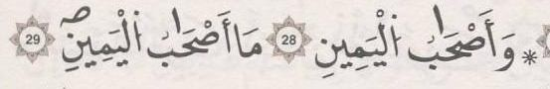 | ﺛﻣﻥ 4
ﺍﻟﺛﻣﻥ 2 ﻓﻲ ﺳﻭﺭﺓ ﺍﻟﻭﺍﻗﻌﺔ | ﺻﻔﺣﺔ 533 | 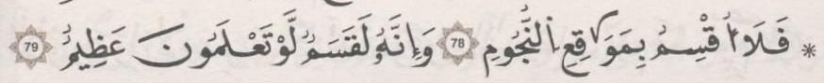 | ﺛﻣﻥ 5
[57] ﺳﻭﺭﺓ ﺍﻟﺣﺩﻳﺩ

ﺍﻟﺛﻣﻥ 1 ﻓﻲ ﺳﻭﺭﺓ ﺍﻟﺣﺩﻳﺩ | ﺻﻔﺣﺔ 535 | 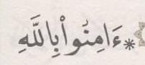 | ﺛﻣﻥ 6
ﺍﻟﺛﻣﻥ 2 ﻓﻲ ﺳﻭﺭﺓ ﺍﻟﺣﺩﻳﺩ | ﺻﻔﺣﺔ 536 | 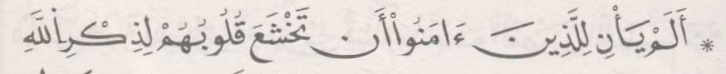 | ﺛﻣﻥ 7
ﺍﻟﺛﻣﻥ 3 ﻓﻲ ﺳﻭﺭﺓ ﺍﻟﺣﺩﻳﺩ | ﺻﻔﺣﺔ 537 | 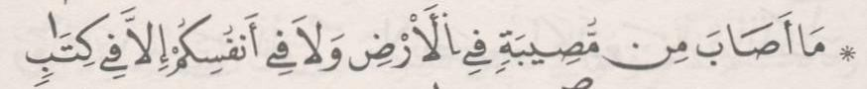 | ﺛﻣﻥ 8
[58] ﺳﻭﺭﺓ ﺍﻟﻣﺟﺎﺩﻟﺔ

ﺍﻟﺛﻣﻥ 1 ﻓﻲ ﺳﻭﺭﺓ ﺍﻟﻣﺟﺎﺩﻟﺔ | ﺻﻔﺣﺔ 539 |  | ﺛﻣﻥ 1 | ﺣﺯﺏ 55 | ﻧﻘﺯﺓ 19
ﺍﻟﺛﻣﻥ 2 ﻓﻲ ﺳﻭﺭﺓ ﺍﻟﻣﺟﺎﺩﻟﺔ | ﺻﻔﺣﺔ 540 | 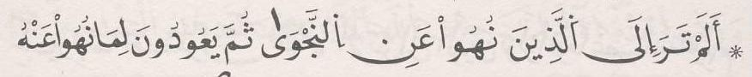 | ﺛﻣﻥ 2
ﺍﻟﺛﻣﻥ 3 ﻓﻲ ﺳﻭﺭﺓ ﺍﻟﻣﺟﺎﺩﻟﺔ | ﺻﻔﺣﺔ 541 | 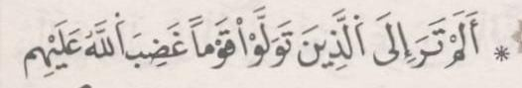 | ﺛﻣﻥ 3
[59] ﺳﻭﺭﺓ ﺍﻟﺣﺷﺭ

ﺍﻟﺛﻣﻥ 1 ﻓﻲ ﺳﻭﺭﺓ ﺍﻟﺣﺷﺭ | ﺻﻔﺣﺔ 542 | 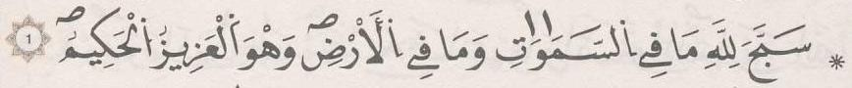 | ﺛﻣﻥ 4
ﺍﻟﺛﻣﻥ 2 ﻓﻲ ﺳﻭﺭﺓ ﺍﻟﺣﺷﺭ | ﺻﻔﺣﺔ 544 | 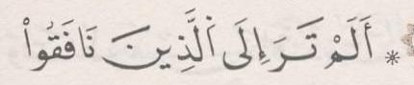 | ﺛﻣﻥ 5
[60] ﺳﻭﺭﺓ ﺍﻟﻣﻣﺗﺣﻧﺔ

ﺍﻟﺛﻣﻥ 1 ﻓﻲ ﺳﻭﺭﺓ ﺍﻟﻣﻣﺗﺣﻧﺔ | ﺻﻔﺣﺔ 546 | 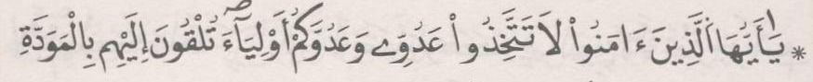 | ﺛﻣﻥ 6
ﺍﻟﺛﻣﻥ 2 ﻓﻲ ﺳﻭﺭﺓ ﺍﻟﻣﻣﺗﺣﻧﺔ | ﺻﻔﺣﺔ 547 | 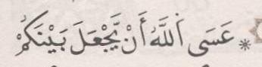 | ﺛﻣﻥ 7
[61] ﺳﻭﺭﺓ ﺍﻟﺻﻑ

ﺍﻟﺛﻣﻥ 1 ﻓﻲ ﺳﻭﺭﺓ ﺍﻟﺻﻑ | ﺻﻔﺣﺔ 548 | 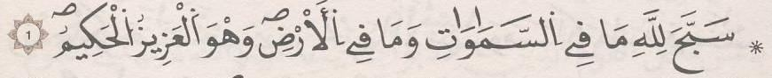 | ﺛﻣﻥ 8
[62] ﺳﻭﺭﺓ ﺍﻟﺟﻣﻌﺔ

ﺍﻟﺛﻣﻥ 1 ﻓﻲ ﺳﻭﺭﺓ ﺍﻟﺟﻣﻌﺔ | ﺻﻔﺣﺔ 550 |  | ﺛﻣﻥ 1 | ﺣﺯﺏ 56
ﺍﻟﺛﻣﻥ 2 ﻓﻲ ﺳﻭﺭﺓ ﺍﻟﺟﻣﻌﺔ | ﺻﻔﺣﺔ 551 | 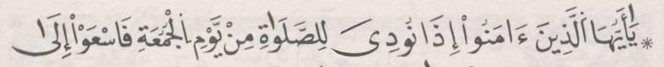 | ﺛﻣﻥ 2
[63] ﺳﻭﺭﺓ ﺍﻟﻣﻧﺎﻓﻘﻭﻥ

ﺍﻟﺛﻣﻥ 1 ﻓﻲ ﺳﻭﺭﺓ ﺍﻟﻣﻧﺎﻓﻘﻭﻥ | ﺻﻔﺣﺔ 552 | 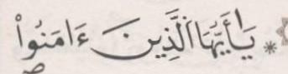 | ﺛﻣﻥ 3

[64] ﺳﻭﺭﺓ ﺍﻟﺗﻐﺎﺑﻥ

ﺍﻟﺛﻣﻥ 1 ﻓﻲ ﺳﻭﺭﺓ ﺍﻟﺗﻐﺎﺑﻥ | ﺻﻔﺣﺔ 553 | 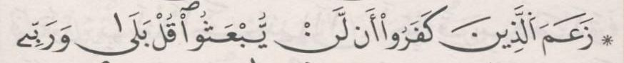 | ﺛﻣﻥ 4
ﺍﻟﺛﻣﻥ 2 ﻓﻲ ﺳﻭﺭﺓ ﺍﻟﺗﻐﺎﺑﻥ | ﺻﻔﺣﺔ 554 | 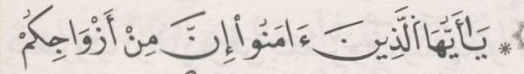 | ﺛﻣﻥ 5
[65] ﺳﻭﺭﺓ ﺍﻟﻁﻼﻕ

ﺍﻟﺛﻣﻥ 1 ﻓﻲ ﺳﻭﺭﺓ ﺍﻟﻁﻼﻕ | ﺻﻔﺣﺔ 556 | 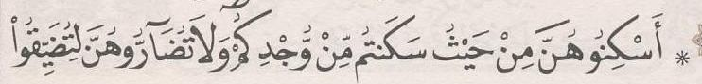 | ﺛﻣﻥ 6
ﺍﻟﺛﻣﻥ 2 ﻓﻲ ﺳﻭﺭﺓ ﺍﻟﻁﻼﻕ | ﺻﻔﺣﺔ 556 | 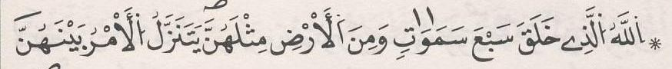 | ﺛﻣﻥ 7
[66] ﺳﻭﺭﺓ ﺍﻟﺗﺣﺭﻳﻡ

ﺍﻟﺛﻣﻥ 1 ﻓﻲ ﺳﻭﺭﺓ ﺍﻟﺗﺣﺭﻳﻡ | ﺻﻔﺣﺔ 558 | 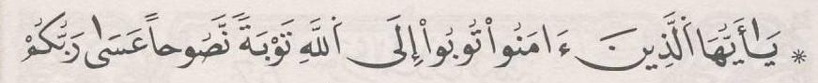 | ﺛﻣﻥ 8
[67] ﺳﻭﺭﺓ ﺍﻟﻣﻠﻙ

ﺍﻟﺛﻣﻥ 1 ﻓﻲ ﺳﻭﺭﺓ ﺍﻟﻣﻠﻙ | ﺻﻔﺣﺔ 559 | 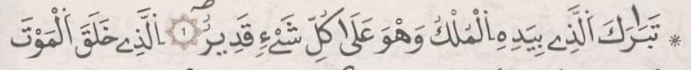 | ﺛﻣﻥ 1 | ﺣﺯﺏ 57
ﺍﻟﺛﻣﻥ 2 ﻓﻲ ﺳﻭﺭﺓ ﺍﻟﻣﻠﻙ | ﺻﻔﺣﺔ 560 | 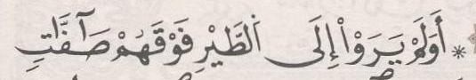 | ﺛﻣﻥ 2
[68] ﺳﻭﺭﺓ ﺍﻟﻘﻠﻡ

ﺍﻟﺛﻣﻥ 1 ﻓﻲ ﺳﻭﺭﺓ ﺍﻟﻘﻠﻡ | ﺻﻔﺣﺔ 562 | 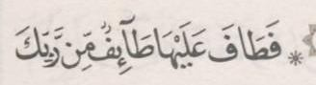 | ﺛﻣﻥ 3
[69] ﺳﻭﺭﺓ ﺍﻟﺣﺎﻗﺔ

ﺍﻟﺛﻣﻥ 1 ﻓﻲ ﺳﻭﺭﺓ ﺍﻟﺣﺎﻗﺔ | ﺻﻔﺣﺔ 563 | 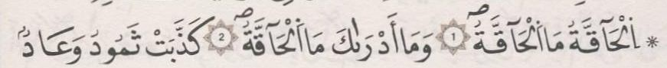 | ﺛﻣﻥ 4
ﺍﻟﺛﻣﻥ 2 ﻓﻲ ﺳﻭﺭﺓ ﺍﻟﺣﺎﻗﺔ | ﺻﻔﺣﺔ 565 | 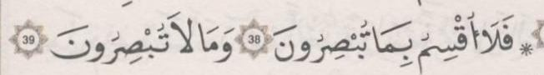 | ﺛﻣﻥ 5
[70] ﺳﻭﺭﺓ ﺍﻟﻣﻌﺎﺭﺝ

ﺍﻟﺛﻣﻥ 1 ﻓﻲ ﺳﻭﺭﺓ ﺍﻟﻣﻌﺎﺭﺝ | ﺻﻔﺣﺔ 566 | 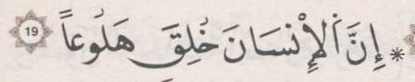 | ﺛﻣﻥ 6
ﺍﻟﺛﻣﻥ 2 ﻓﻲ ﺳﻭﺭﺓ ﺍﻟﻣﻌﺎﺭﺝ | ﺻﻔﺣﺔ 567 | 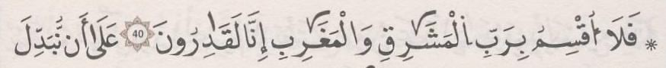 | ﺛﻣﻥ 7
[71] ﺳﻭﺭﺓ ﻧﻭﺡ

ﺍﻟﺛﻣﻥ 1 ﻓﻲ ﺳﻭﺭﺓ ﻧﻭﺡ | ﺻﻔﺣﺔ 568 | 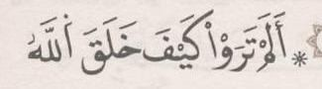 | ﺛﻣﻥ 8
[72] ﺳﻭﺭﺓ ﺍﻟﺟﻥ

ﺍﻟﺛﻣﻥ 1 ﻓﻲ ﺳﻭﺭﺓ ﺍﻟﺟﻥ | ﺻﻔﺣﺔ 569 | 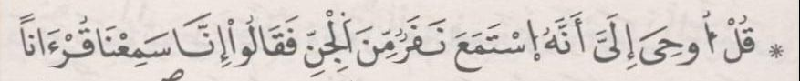 | ﺛﻣﻥ 1 | ﺣﺯﺏ 58 | ﻧﻘﺯﺓ 20

ﺍﻟﺛﻣﻥ 2 ﻓﻲ ﺳﻭﺭﺓ ﺍﻟﺟﻥ | ﺻﻔﺣﺔ 570 | 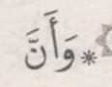 | ﺛﻣﻥ 2
[73] ﺳﻭﺭﺓ ﺍﻟﻣﺯﻣﻝ

ﺍﻟﺛﻣﻥ 1 ﻓﻲ ﺳﻭﺭﺓ ﺍﻟﻣﺯﻣﻝ | ﺻﻔﺣﺔ 572 | 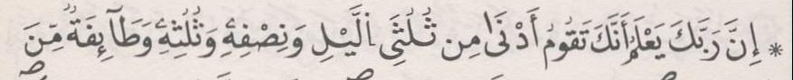 | ﺛﻣﻥ 3
[74] ﺳﻭﺭﺓ ﺍﻟﻣﺩﺛﺭ

ﺍﻟﺛﻣﻥ 1 ﻓﻲ ﺳﻭﺭﺓ ﺍﻟﻣﺩﺛﺭ | ﺻﻔﺣﺔ 573 | 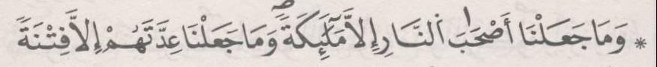 | ﺛﻣﻥ 4
[75] ﺳﻭﺭﺓ ﺍﻟﻘﻳﺎﻣﺔ

ﺍﻟﺛﻣﻥ 1 ﻓﻲ ﺳﻭﺭﺓ ﺍﻟﻘﻳﺎﻣﺔ | ﺻﻔﺣﺔ 574 | 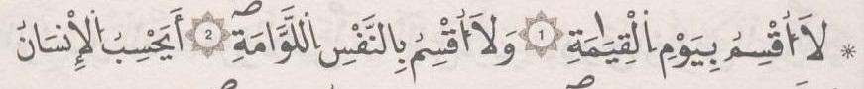 | ﺛﻣﻥ 5
[76] ﺳﻭﺭﺓ ﺍﻹﻧﺳﺎﻥ

ﺍﻟﺛﻣﻥ 1 ﻓﻲ ﺳﻭﺭﺓ ﺍﻹﻧﺳﺎﻥ | ﺻﻔﺣﺔ 575 | 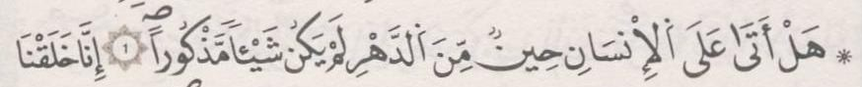 | ﺛﻣﻥ 6
ﺍﻟﺛﻣﻥ 2 ﻓﻲ ﺳﻭﺭﺓ ﺍﻹﻧﺳﺎﻥ | ﺻﻔﺣﺔ 576 | 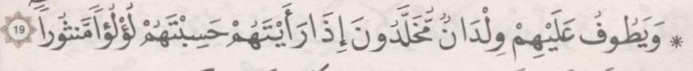 | ﺛﻣﻥ 7
[77] ﺳﻭﺭﺓ ﺍﻟﻣﺭﺳﻼﺕ

ﺍﻟﺛﻣﻥ 1 ﻓﻲ ﺳﻭﺭﺓ ﺍﻟﻣﺭﺳﻼﺕ | ﺻﻔﺣﺔ 577 | 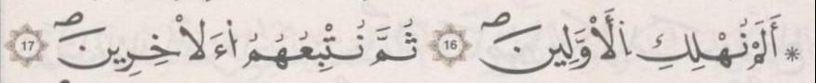 | ﺛﻣﻥ 8
[78] ﺳﻭﺭﺓ ﺍﻟﻧﺑﺄ

ﺍﻟﺛﻣﻥ 1 ﻓﻲ ﺳﻭﺭﺓ ﺍﻟﻧﺑﺄ | ﺻﻔﺣﺔ 579 | 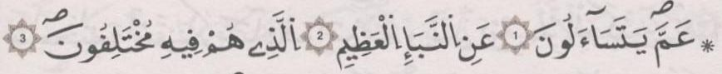 | ﺛﻣﻥ 1 | ﺣﺯﺏ 59
[79] ﺳﻭﺭﺓ ﺍﻟﻧﺎﺯﻋﺎﺕ

ﺍﻟﺛﻣﻥ 1 ﻓﻲ ﺳﻭﺭﺓ ﺍﻟﻧﺎﺯﻋﺎﺕ | ﺻﻔﺣﺔ 580 | 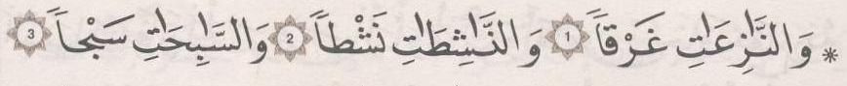 | ﺛﻣﻥ 2
ﺍﻟﺛﻣﻥ 2 ﻓﻲ ﺳﻭﺭﺓ ﺍﻟﻧﺎﺯﻋﺎﺕ | ﺻﻔﺣﺔ 581 | 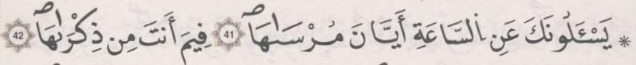 | ﺛﻣﻥ 3
[80] ﺳﻭﺭﺓ ﻋﺑﺱ

ﺍﻟﺛﻣﻥ 1 ﻓﻲ ﺳﻭﺭﺓ ﻋﺑﺱ | ﺻﻔﺣﺔ 582 | 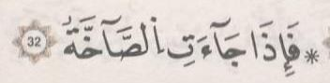 | ﺛﻣﻥ 4
[81] ﺳﻭﺭﺓ ﺍﻟﺗﻛﻭﻳﺭ

ﺍﻟﺛﻣﻥ 1 ﻓﻲ ﺳﻭﺭﺓ ﺍﻟﺗﻛﻭﻳﺭ | ﺻﻔﺣﺔ 583 | 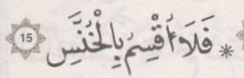 | ﺛﻣﻥ 5
[82] ﺳﻭﺭﺓ ﺍﻹﻧﻔﻁﺎﺭ

[83] ﺳﻭﺭﺓ ﺍﻟﻣﻁﻔﻔﻳﻥ

ﺍﻟﺛﻣﻥ 1 ﻓﻲ ﺳﻭﺭﺓ ﺍﻟﻣﻁﻔﻔﻳﻥ | ﺻﻔﺣﺔ 585 | 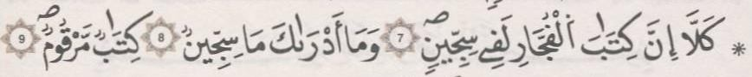 | ﺛﻣﻥ 6
[84] ﺳﻭﺭﺓ ﺍﻹﻧﺷﻘﺎﻕ

ﺍﻟﺛﻣﻥ 1 ﻓﻲ ﺳﻭﺭﺓ ﺍﻹﻧﺷﻘﺎﻕ | ﺻﻔﺣﺔ 587 | 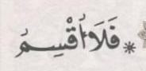 | ﺛﻣﻥ 7
[85] ﺳﻭﺭﺓ ﺍﻟﺑﺭﻭﺝ

ﺍﻟﺛﻣﻥ 1 ﻓﻲ ﺳﻭﺭﺓ ﺍﻟﺑﺭﻭﺝ | ﺻﻔﺣﺔ 588 | 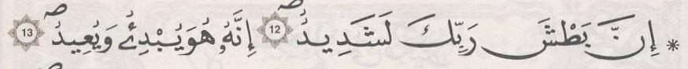 | ﺛﻣﻥ 8
[86] ﺳﻭﺭﺓ ﺍﻟﻁﺎﺭﻕ

[87] ﺳﻭﺭﺓ ﺍﻷﻋﻠﻰ

ﺍﻟﺛﻣﻥ 1 ﻓﻲ ﺳﻭﺭﺓ ﺍﻷﻋﻠﻰ | ﺻﻔﺣﺔ 589 | 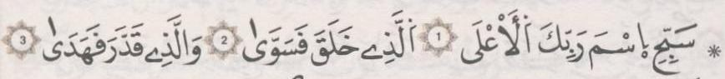 | ﺛﻣﻥ 1 | ﺣﺯﺏ 60
[88] ﺳﻭﺭﺓ ﺍﻟﻐﺎﺷﻳﺔ

ﺍﻟﺛﻣﻥ 1 ﻓﻲ ﺳﻭﺭﺓ ﺍﻟﻐﺎﺷﻳﺔ | ﺻﻔﺣﺔ 590 | 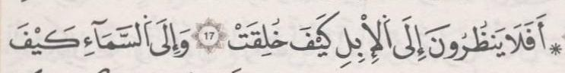 | ﺛﻣﻥ 2
[89] ﺳﻭﺭﺓ ﺍﻟﻔﺟﺭ

[90] ﺳﻭﺭﺓ ﺍﻟﺑﻠﺩ

ﺍﻟﺛﻣﻥ 1 ﻓﻲ ﺳﻭﺭﺓ ﺍﻟﺑﻠﺩ | ﺻﻔﺣﺔ 591 | 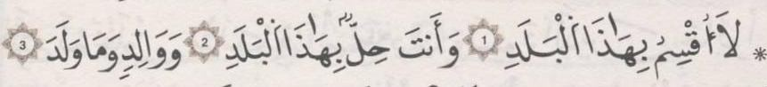 | ﺛﻣﻥ 3
[91] ﺳﻭﺭﺓ ﺍﻟﺷﻣﺱ

[92] ﺳﻭﺭﺓ ﺍﻟﻠﻳﻝ

ﺍﻟﺛﻣﻥ 1 ﻓﻲ ﺳﻭﺭﺓ ﺍﻟﻠﻳﻝ | ﺻﻔﺣﺔ 593 | 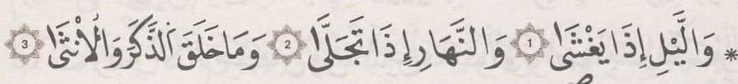 | ﺛﻣﻥ 4
[93] ﺳﻭﺭﺓ ﺍﻟﺿﺣﻰ

[94] ﺳﻭﺭﺓ ﺍﻟﺷﺭﺡ

ﺍﻟﺛﻣﻥ 1 ﻓﻲ ﺳﻭﺭﺓ ﺍﻟﺷﺭﺡ | ﺻﻔﺣﺔ 594 | 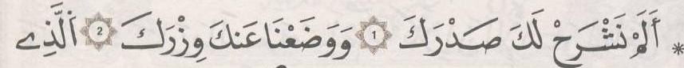 | ﺛﻣﻥ 5
[95] ﺳﻭﺭﺓ ﺍﻟﺗﻳﻥ

[96] ﺳﻭﺭﺓ ﺍﻟﻌﻠﻕ

[97] ﺳﻭﺭﺓ ﺍﻟﻘﺩﺭ

ﺍﻟﺛﻣﻥ 1 ﻓﻲ ﺳﻭﺭﺓ ﺍﻟﻘﺩﺭ | ﺻﻔﺣﺔ 596 |  | ﺛﻣﻥ 6
[98] ﺳﻭﺭﺓ ﺍﻟﺑﻳﻧﺔ

[99] ﺳﻭﺭﺓ ﺍﻟﺯﻟﺯﻟﺔ

[100] ﺳﻭﺭﺓ ﺍﻟﻌﺎﺩﻳﺎﺕ

ﺍﻟﺛﻣﻥ 1 ﻓﻲ ﺳﻭﺭﺓ ﺍﻟﻌﺎﺩﻳﺎﺕ | ﺻﻔﺣﺔ 598 | 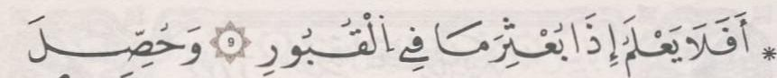 | ﺛﻣﻥ 7
[101] ﺳﻭﺭﺓ ﺍﻟﻘﺎﺭﻋﺔ

[102] ﺳﻭﺭﺓ ﺍﻟﺗﻛﺎﺛﺭ

[103] ﺳﻭﺭﺓ ﺍﻟﻌﺻﺭ

[104] ﺳﻭﺭﺓ ﺍﻟﻬﻣﺯﺓ

[105] ﺳﻭﺭﺓ ﺍﻟﻔﻳﻝ

ﺍﻟﺛﻣﻥ 1 ﻓﻲ ﺳﻭﺭﺓ ﺍﻟﻔﻳﻝ | ﺻﻔﺣﺔ 599 | 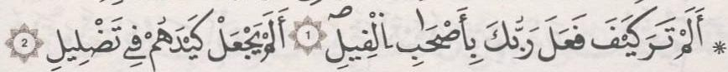 | ﺛﻣﻥ 8
[106] ﺳﻭﺭﺓ ﻗﺭﻳﺵ

[107] ﺳﻭﺭﺓ ﺍﻟﻣﺎﻋﻭﻥ

[108] ﺳﻭﺭﺓ ﺍﻟﻛﻭﺛﺭ

[109] ﺳﻭﺭﺓ ﺍﻟﻛﺎﻓﺭﻭﻥ

[110] ﺳﻭﺭﺓ ﺍﻟﻧﺻﺭ

[111] ﺳﻭﺭﺓ ﺍﻟﻣﺳﺩ

[112] ﺳﻭﺭﺓ ﺍﻹﺧﻼﺹ

[113] ﺳﻭﺭﺓ ﺍﻟﻔﻠﻕ

[114] ﺳﻭﺭﺓ ﺍﻟﻧﺎﺱ

ﻣﻭﻗﻊ: ﻣﺻﺣﻑ ﺍﻟﻘﺭﺍء ﺑﺭﻭﺍﻳﺔ ﻗﺎﻟﻭﻥ
https://albara.ramli.net/qalooon/

